Essential ingredients in Joint Species Distribution Models: influence on interpretability, explanatory and predictive power

Clément Violet

Aurélien Boyé

Mathieu Chevalier

Olivier Gauthier

Jacques Grall

Martin P. Marzloff

# Abstract

1. *Joint Species Distribution Models* (*jSDM*) are increasingly used to explain and predict biodiversity patterns. *jSDMs* account for species co-occurrence patterns and can include phylogeny or functional traits to better capture the processes shaping communities. Yet, several factors may alter the interpretability and predictive ability of *jSDMs* : missing abiotic predictors, omitting ecologically-important species, or increasing the number of model parameters by adding phylogeny and/or trait information.
2. We developed a novel framework to comprehensively assess the interpretability, explanatory and predictive power of *jSDMs* at both species and community levels. We compared performances of four alternative model formulations : (1) a *Bench*mark *jSDM* with only abiotic predictors and residual co-occurrence patterns, (2) a *jSDM* adding phylogeny to the *Bench*mark, (3) a *jSDM* adding traits to model 2, and (4) the *Bench*mark *jSDM* with additional non-target species that are not of direct interest but potentially interact with the target assemblage. Models were fitted on both presence/absence and abundance data for 99 target polychaete species sampled in two coastal habitats over 500km and 8 years, along with information on 179 non-target species and traits data for the target species.
3. For both presence/absence and abundance data, explanatory power was good for all models but their interpretability and predictive power varied. Relative to the *Bench*mark model, predictive errors on species abundances decreased by 95% or 53%, when including non-target species, or phylogeny, respectively. These differences across models relate to changes in both species-environment relationships and residual co-occurrence patterns. While considering trait data did not improve explanatory or predictive power, it facilitated interpretation of trait-mediated species response to environmental gradients.
4. This study demonstrates that any *jSDM* formulation comes with tradeoffs between either explaining or predicting the occurrence or abundance of species. Hence, it highlights the need to compare alternative model formulations using the original and comprehensive assessment framework proposed in this study. Overall, this work contributes to a better understanding of *jSDM*s’ performances across multiple facets and provides insights and tools for model selection based on specific objectives and available data.

# Introduction

Community ecology aims at describing, explaining, and predicting changes in communities (Tredennick *et al.* 2021). Understanding the processes that determine species distribution is a prerequisite to characterize and predict community structure and associated ecological dynamics, which is critical to inform effective management or restoration measures in a rapidly changing world (Dietze *et al.* 2018 ; Brudvig & Catano 2022). *Joint Species Distribution Models* (*jSDM*) are particularly well-suited tools to address these challenges, whether to characterize the processes that shape observed communities (Warton *et al.* 2015 ; Ovaskainen *et al.* 2017a), or to predict future changes in species assemblages (Norberg *et al.* 2019 ; Pollock *et al.* 2020).

*jSDMs* are multivariate (i.e. multi-species) extensions of *Species Distribution Models* (*SDMs*), which have been broadly applied over the past decades - across all terrestrial and marine realms - to understand and predict both species occurrences (Elith *et al.* 2006 ; Norberg *et al.* 2019) and species abundances (Howard *et al.* 2014 ; Waldock *et al.* 2022) using a set of covariates (e.g. climatic variables). Relative to *SDMs*, *jSDMs* explanatory power can benefit from accounting for species assembly rules (Ovaskainen *et al.* 2017b). In particular, relative to single-species *SDMs* that only consider the abiotic niche of species (i.e. the Grinellian niche), *jSDM* can theoretically also account for interspecific interactions (i.e. the Eltonian niche).

In *jSDMs*, the variability in community composition not explained by covariates is captured by a residual covariance matrix representing species co-occurrence patterns potentially representing biotic interactions (Ovaskainen *et al.* 2017b). This feature is highly attractive to ecologists because it provides a way to disentangle the relative influence of abiotic and biotic processes on biodiversity patterns (Godsoe *et al.* 2017) while also improving model’s predictive power (Giannini *et al.* 2013 ; Staniczenko *et al.* 2017). However, in practice, inferring and interpreting residual co-occurrence patterns using *jSDMs* remains challenging for several reasons (Blanchet *et al.* 2020 ; Holt 2020).

First, while *jSDMs* have been applied to a large number of species presence/absence datasets (Norberg *et al.* 2019 ; Wilkinson *et al.* 2019 ; Wilkinson *et al.* 2021), simulation studies showed that inferred co-occurrence networks do not necessarily provide evidence for species interactions (Dormann *et al.* 2018 ; Blanchet *et al.* 2020) but only capture spatial and temporal associations between species (Keil *et al.* 2021). Some authors speculated that *jSDMs* applied to abundance data - instead of presence/absence data - could provide a better proxy for biotic interactions (Blanchet *et al.* 2020 ; Momal *et al.* 2020). Accordingly, *jSDM* have increasingly been applied to abundance data (Hui 2016 ; Ovaskainen *et al.* 2017b ; Chiquet *et al.* 2021). While challenges related to modelling abundance data was recently explored in the context of species distribution modelling (Waldock *et al.* 2022), the predictive and the explanatory power of *jSDM* fitted to abundance data remains relatively untested compared to presence/absence data (Norberg *et al.* 2019 ; Wilkinson *et al.* 2021).

Second, regardless of the type of data considered (i.e. presence/absence or abundance), several factors may limit or affect the interpretability and predictive ability of *jSDM*. For instance, co-occurrence patterns estimated in *jSDM* are affected by unaccounted environmental variables implying that *jSDMs* cannot fully separate the environmental and the biotic niche of species (Blanchet *et al.* 2020 ; Poggiato *et al.* 2021). Beyond missing environmental predictors, accounting for extra species that can influence the target community (e.g. competitors) is key to improve *jSDMs*’ inference and predictions. However, because many ecological studies only focus on particular taxonomic groups (Pollock *et al.* 2014 ; Häkkilä *et al.* 2018) and disregard non-target taxa, co-occurrence patterns estimated from *jSDMs* are almost always skewed by missing ecological actors (Momal *et al.* 2021). How this bias affects the predictive ability of jSDM remains untested.

Finally, similar to *SDMs*, *jSDMs* can theoretically be extended to include additional sources of information about modelled species (Niku *et al.* 2019 ; Ovaskainen *et al.* 2017b). For instance, accounting for phylogenetic relationships between species (Ives & Helmus 2011) or for the link between functional traits and environmental responses (Pollock *et al.* 2012) can improve both the explanatory and the predictive powers of *SDMs* (Morales-Castilla *et al.* 2017 ; Vesk *et al.* 2021). These findings support the hypothesis that similar species, in terms of traits and/or recent evolutionary history, usually share similar environmental preferences. While inclusion of species-specific information in *jSDMs* should yield similar benefits (Ovaskainen *et al.* 2017b), the relative influence of additional sources of information on their interpretability and predictive power remains untested (Norberg *et al.* 2019 ; Wilkinson *et al.* 2019 ; Abrego *et al.* 2022).

Overall, many practical questions remain concerning the application of *jSDMs* to ecological community monitoring data, in particular related to inclusion of additional sources of information within the models. While some comparative assessments of *jSDM* performance exists (e.g. Norberg *et al.* (2019) ; Wilkinson *et al.* (2021)), including some comparison of the benefit of trait and phylogenetic data in some phyla (e.g. Abrego *et al.* (2022)), there has been no formal assessment of the relative importance of species-specific information (trait and/or phylogeny) compared to the role of missing species. Furthermore, comparative assessments have rarely been performed on both presence/absence and abundance data. To a few exceptions (Waldock *et al.* 2022), most assessments were made considering presence/absence data (Norberg *et al.* 2019 ; Wilkinson *et al.* 2019) and mostly focused on predictive power (Norberg *et al.* 2019 ; Wilkinson *et al.* 2019), hence disregarding the interpretability/explanatory aspects of the models (Tredennick *et al.* 2021). Yet, *jSDMs* are increasingly fitted on abundance data (Brimacombe *et al.* 2021) and used for explanatory purposes (Abrego *et al.* 2017). Hence, there is a mismatch between current understanding of *jSDMs* performance and their application by ecologists. In practice, most *jSDM* applications consider a single model structure and do not explore the effects of including additional sources of information. Perhaps this shortcoming relates to the high-dimensionality of *jSDMs* which makes their comparison challenging.

In this study, we developed a multi-faceted assessment framework to evaluate the extent to which alternative parameterization of *jSDM* can lead to a better interpretability or predictability at the species and community levels. To illustrate its usefulness, we applied this general framework to a case study presenting typical features of community ecology datasets. Specifically, by comparing predictions obtained from a *Bench*mark model excluding additional sources of information (i.e. a classical *jSDM*), we tested the effect of (1) including phylogeny alone and in combination with trait data, (2) incorporating monitoring information related to non-target species and (3) considering abundance instead of presence/absence data. We hypothesized that all these sources of information should improve *jSDM* predictive and explanatory powers, but did not assume a priori that a given modeling strategy would lead to greater improvements in model performances.

# Materials & Methods

We used the *HMSC* (*Hierarchical Modeling of Species Communities*) framework applied to a long-term monitoring dataset. The following subsections sequentially describe our workflow (as illustrated in Fig. 1): (1) the *HMSC* framework, (2) the data used in this study, (3) data splitting between train and test datasets to assess the explanatory and predictive powers of models, respectively, (4) the rationales for the suite of alternative models considered and, (5) a multi-faceted framework developed to assess tradeoffs in jSDMs’ performances in relation to different study purposes.

## *Hierarchical Modelling of Species Community* (*HMSC*)

*HMSC* is a multivariate hierarchical generalized linear mixed model using Bayesian inference (Ovaskainen & Abrego 2020). It has two parts: one for fixed effects and another for random effects. The fixed part models the species’ realized niche, where each dimension of the niche is a covariate (e.g. temperature; Fig. 1). Including trait data can improve species niche estimates by accounting for trait-environment relationships, where species with similar traits are expected to respond similarly along environmental gradients (Ovaskainen *et al.* 2017b). Including phylogenetic data can help capture residual ecological information not included in the available trait data, as phylogenetically-close species tend to share similar traits and niches (Wiens *et al.* 2010). Alongside traits, phylogeny can improve niche estimates for rare species by borrowing information from similar species (Ovaskainen *et al.* 2017b ; Ovaskainen *et al.* 2017a ; Ovaskainen & Abrego 2020). The random part of *HMSC* relies on latent variables, i.e. covariates that capture residual variance, including missing environmental features or biotic interactions (Ovaskainen *et al.* 2017b ; Ovaskainen *et al.* 2017a ; Ovaskainen & Abrego 2020). The H matrix (site loadings) estimates missing covariate values, while the $Λ$ matrix (species loadings) represents species’ response to these missing covariates (Fig. 1).

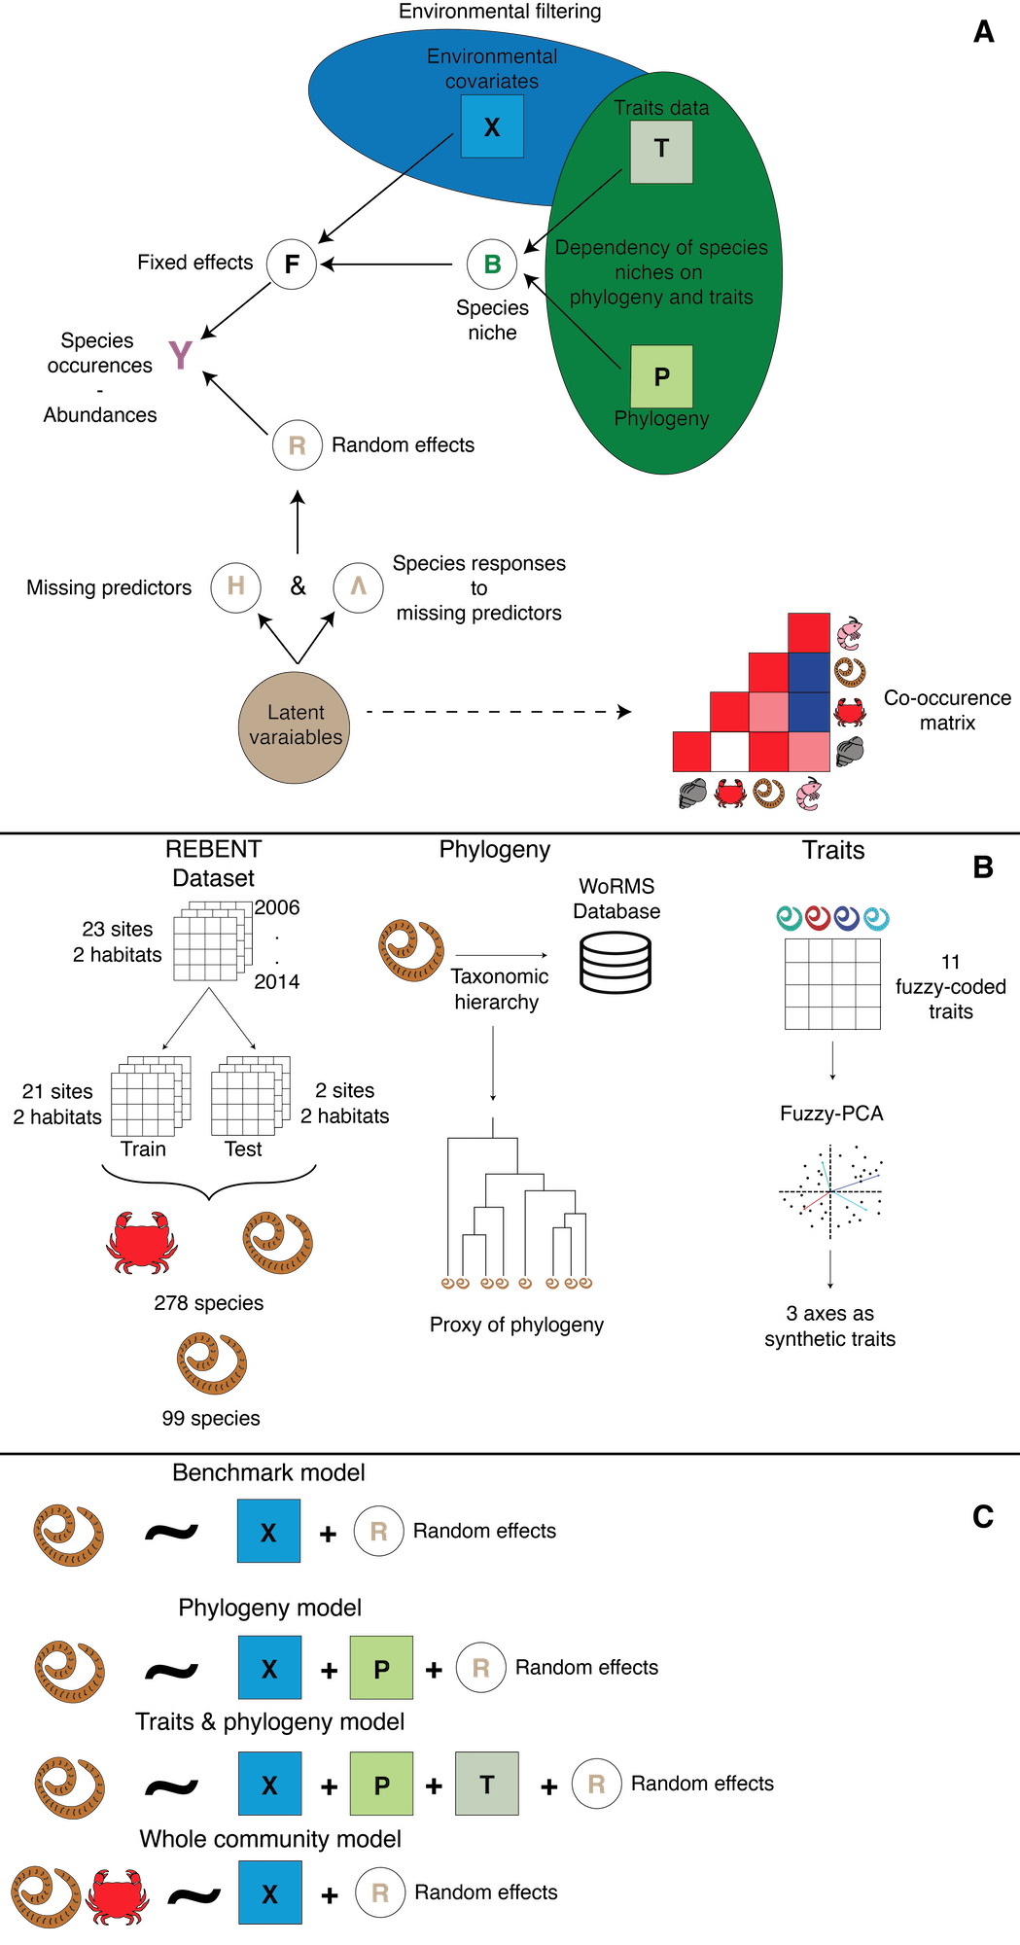

Figure 1: Study workflow. A. Hierarchical Model of Species Community (HMSC) structure, incorporating environmental variables, phylogeny, and species-specific traits. B. Data pre-processing: partitioning community data into train and test datasets, estimating phylogenetic distance (using taxonomic classification), and dimension reduction of species-trait matrix using fuzzy-PCA. C. Summary of the four alternative model structures fitted to presence/absence and abundance data: the Benchmark, Phylogeny, Traits & Phylogeny models only consider the targeted polychaetes, while the Whole Community model includes additional species potentially interacting with the target assemblage. Random effects for sampling year, site, and habitat were included in all models.

## Datasets

### Faunistic data

The *REBENT* program ([rebent.ifremer.fr](https://rebent.ifremer.fr)) is an ongoing monitoring of benthic macrofauna across multiple stations along Brittany’s coastline (Western France). Here, we used data from Boyé *et al.* (2019), covering 23 sites and two intertidal soft-bottom habitats: bare sands and seagrass meadows (Fig. S1) where infaunal communities were monitored yearly using the same protocol between 2006 and 2014. A detailed description of the sampling methodology is provided in (Boyé *et al.* 2017 ; Boyé *et al.* 2019). At each site, three faunal samples (0.03 m $​^{2}$ cores) were taken at each of three fixed sampling points distributed 200 m apart. These samples were then pooled together to estimate abundances at the site level. For each sampling event, individuals were identified to the lowest taxonomic level possible (mostly species level; for simplicity we hereafter refer to “species”).

Overall, across a total of 375 sampling units (i.e. unique combination of years, sites and habitats), 152,583 individuals belonging to 519 species were collected and identified. To avoid convergence issues and poor model inference, we filtered out species occurring less than four times (across the 180 samples used as train set, see below), resulting in the removal of 241 species. The remaining 278 species included 99 polychaete species (the targeted assemblage) and 179 non-target species of bivalves, molluscs, and amphipoda, which may predate or compete with polychaetes (Grall *et al.* 2006 ; Jankowska *et al.* 2019). We chose to focus on polychaetes as this taxonomic group exhibits diverse lifestyles (Jumars *et al.* 2015), can be used to monitor the health of benthic habitats (Giangrande *et al.* 2005), and because trait data and ecological information were available from previous studies (Boyé *et al.* 2019).

### Traits and phylogeny data

Traits data were retrieved from (Boyé *et al.* 2019) for the 99 polychaete species present in the train set (see below). The 11 fuzzy-coded traits available (see Boyé *et al.* (2019) for details) were synthetized using a fuzzy-PCA, with the *fpca* function from the *ade4* R package (Thioulouse *et al.* 2018). The first three axes, which account for 59% of the total variance of the trait matrix, were included in the model as synthetic traits data (Fig. 1). The first axis distinguishes mobile predatory species from sessile microphages; the second axis differentiates semelparous species from iteroparous species; and, the third axis separates burrowers from tube-dwellers (Fig. S2).

Phylogeny was not available, hence we followed common practices (Ovaskainen & Abrego 2020) and retrieved the taxonomic classification of these 99 polychaetes through the WoRMS database ([www.marinespecies.org](https://www.marinespecies.org); january 2020) and used this information as a proxy for phylogenetic relationships (Fig. 1 ; Ovaskainen & Abrego (2020)). Phylogenetic distances were then estimated using the ape R package (Paradis & Schliep 2019).

### Environmental data

Following Boyé *et al.* (2019) (see Appendix A for details about data sources), we selected seven environmental variables to characterise the ecological niche of each species. These seven variables quantify different components of coastal environmental variability including hydrology (sea water temperature, salinity and current velocity), sedimentology (mud and organic matter content), substrate heterogeneity (Trask index) and local wave exposure (fetch). For each of these seven variables, the first- and second-degree polynomials were computed to account for non-linear responses.

## Comparison of alternative model structures

The first model (denoted *Bench*) only considers data for the 99 target polychaete species and the 7 environmental covariates (Fig. 1). The second model (denoted *Ph*) adds phylogenetic data to the *Bench* model (Fig. 1). The third model (denoted *TrPh*) adds traits data to the *Ph* model. The fourth model (denoted *WhC*) has the same structure as the *Bench* model but includes data on the whole community (278 species, including 179 additional non-target species; Fig. 1). *WhC* excludes traits (unavailable for the non-target taxa) and phylogenetic data for faster computation. Each model was fitted twice, either with presence/absence or abundance data, using probit and lognormal Poisson distributions respectively. All models include the same random effects (Fig. 1): temporal, spatial (sites), and habitats (bare vs seagrass).

## Model fitting

We estimated model parameters by running 5 chains using a MCMC sampling algorithm over 375,000 iterations. The first 125,000 iterations were discarded as burn-in while the remaining were thinned every 250 iterations yielding 1,000 posterior samples per chain for an overall total of 5,000 posterior samples for each parameter. We assessed convergence for each model parameter using both potential scale reduction factor (Gelman & Rubin 1992) and effective sample size as reported in supplementary materials (Appendix B). All models were fitted using the DATARMOR supercomputing facility.

## Assessing model performance and interpretability

For independent assessment of models’ predictive performance, the dataset was split into a train and a test set, instead of using strict cross-validation procedure that would have considerably increase the computational burden (see also Norberg *et al.* (2019)). The train dataset consisted of 180 sampling units (21 sites; one or two habitats, and six to nine years per site; Fig. S1). The test set comprised 35 sampling units covering a 9-year period at two specific sites with both seagrass and bare sand habitats. These sites were chosen as representative of both regional macrofaunal species diversity (all the species observed in the test set are also observed in the train set) and mean environmental conditions (which limits model extrapolation outside of the trained parameter space; Fig. S3-S4; Boyé *et al.* (2017) ; Boyé *et al.* (2022) ; Toumi *et al.* (2023)).

To assess *jSDM’s* performance, we used a set of complementary metrics to evaluate both their explanatory and predictive abilities on the train and test dataset, respectively (Table 1). AUC and RMSE, calculated only for the 99 target species (i.e. polychaetes) even for the *WhC* model that includes a total of 278 species, were used to assess overall and species-level performance for presence/absence and abundance models, respectively. Relationships between observed and predicted mean species abundances across all sites were also visualized for abundance models.

Along with the raw AUC and RMSE values, we also visualized and quantified changes relative to the *Bench* model for the *Ph*, *TrPh* and *WhC* models. For abundance models, we computed the overall relative change in mean RMSE across species as:

$$\text{Relative change}=\frac{\text{mean}\left({\text{RMSE}}_{\text{ focal model}}\right)-\text{mean}\left({\text{RMSE}}_{\text{Bench}}\right)}{\text{mean}\left({\text{RMSE}}_{\text{Bench}}\right)}×100 \left(1\right)$$

AUC and RMSE only partially capture model accuracy at the community scale (Table 1). To explore this aspect, we focused on differences between predicted and observed assemblage richness and total abundances (for abundance models). We also compared observed and predicted Sørensen (for presence/absence) and Bray-Curtis (abundance) pairwise-dissimilarity matrices to explore how well $β$-diversity patterns were reproduced by the models. For these three metrics, we computed relative change for both the train and test datasets between mean predicted and mean observed values as follows:

$$\text{Relative change}=\frac{\text{mean}\left({\text{Metric}}_{\text{ predict}}\right)-\text{mean}\left({\text{Metric}}_{\text{ obs}}\right)}{\text{mean}\left({\text{Metric}}_{\text{ obs}}\right)}×100 \left(2\right)$$

where “Metric” is a community-based measure (e.g. species richness, total abundance, dissimilarity matrices) estimated from model predictions or observations at the sample level (i.e. unique combination of site, habitat and year; or, pairs of samples for dissimilarity). To evaluate model interpretability, we calculated the amount of explained variance per species and the proportion that can be attributed to environmental covariates (fixed effects) and random effects. We compared the overall relative change in the proportion of variance explained by the covariates and by the random effects for the *Ph*, *TrPh* and *WhC* relative to the *Bench* model (by comparing mean values across species similarly to Eq. 1). We also propose a novel way of exploring species-environment relationships (Table 1) by classifying the response curves estimated from the different models based on their shapes, considering both their direction (decline, null, or increase) and their acceleration (decelerated, constant, or accelerated) (Rigal *et al.* 2020). Finally, we compared the residual co-occurrence patterns associated with each random effect of the *Bench* model with those of the best performing model (*WhC*). We quantified differences in magnitude and sign of residual species-species correlations using the following index:

$$δ=\left|corr_{\text{ b}\text{est model}}-corr_{\text{ Benchmark}}\right|×sign\left(corr_{\text{ best model}}×corr_{\text{ Benchmark}}\right) \left(3\right)$$

**Table 1.** Multi-assessment framework providing a list of useful metrics to assess, interpret or compare jSDMs across different ecological facets (rows) at the species, community or overall level. Underlined metrics are used in this study.

|  | Model outputs | Example of derived-metrics for model interpretation | Example of derived-metrics for model evaluation | | Example of performance measures to assess the explanatory/predictive power of models**[1]** | |
| --- | --- | --- | --- | --- | --- | --- |
|  |  |  | Presence/Absence | Abundance | Presence/Absence | Abundance |
| Species level | Abundance, occurrence probability, environmental coefficients | Variable importance (e.g. LIME, SHAP[2]), Response curve[3], Heatmap of environmental coefficients, Variance partitioning | Number of Presence/Absence, Proportion of occupied sites | Total abundance, site-specific abundance | AUC, Kappa, F1-Score | RMSE, MAE, R2, Correlation between predicted and observed values |
| Alpha diversity | Site-specific community composition | Diversity index (e.g. Shannon entropy, Simpson-Gini index), Total abundance, Total richness, Proportion of rare/abundant species | | | Differences between predicted and observed values, RMSE, MAE, R2, Correlations (e.g. Kendall, Pearson) between observed and predicted alpha or beta diversity indices | |
| Beta diversity | Pairwise dissimilarity (e.g. Jaccard/Bray-Curtis)[4],[5], Total Beta diversity, Turnover, Nestedness, Local Contribution to Beta Diversity (LCBD), Species Contribution to Beta Diversity (SCBD) | | |
| Overall assessment  (all sites) | Regional community composition | Diversity index (e.g. Shannon entropy, Simpson-Gini index), Total abundance, Total richness, Proportion of rare/abundant species | | | Average over all species: AUC, Kappa, F1-Score | Average over all species: RMSE, MAE, R2, Correlation between predicted and observed values |
| Residual correlation matrix | Co-occurrence network analysis (e.g centrality, number of degrees) | Comparison with observed or reconstructed networks (expert-based or estimated e.g. based on trophic analyses)[6], using e.g. correlations. residual correlation index (δ), | | | |
| Trait-based regressioncoefficients | Traits-environment response curves, Heatmap of traits-environment coefficients | Qualitatively, based on literature and/or expert knowledge[7] | | | |

# Results

Both MCMC convergence and effective sample size of the different *jSDMs* were satisfactory (see Appendix D).

## Model Fit & Predictive power

### Species level

Presence/absence models showed excellent explanatory power with mean AUCs above 0.9 on the train dataset, but lower predictive power with mean AUCs around 0.66 on the test set (Fig. S17). Both explanatory (mean AUC between 0.92 and 0.93) and predictive (mean AUC between 0.64 and 0.66) power were overall similar across models (Fig. 2, Fig. S17). Within the target species assemblage, predictions improved for 41 species and worsened for 36 species (out of the 99 target species, which implies marginal changes for the remaining 22) in the *WhC* model relative to the benchmark. In comparison in the *Ph* or the *TrPh* models, predictions only improved for 26 and 27 species, respectively, and worsened for 49 and 48 species, respectively.

Abundance models also showed a satisfactory explanatory power with a mean RMSE close to nine for all models, given a mean abundance in the train dataset of 307.31 ± 583.58 (mean ± sd). Overall, all models underpredicted species abundances (Fig. S18-19). While explanatory power was similar across models, larger variations were observed for predictive power. The *Bench* model had a mean RMSE of 126.67 (for a mean abundance in the test dataset of 700.57 ± 818.66; Fig S17). The Ph model performed better (mean RMSE of 62.23; -50.87% compared to the *Bench*; Fig. S17) whereas the *TrPh* model did worse (mean RMSE of 139.21; +9.90%; Fig. S17). The best model was the *WhC* with a mean RMSE of 6.59 (-94.80% compared to the *Bench*, Fig. S17). Out of the 99 target species, the *WhC* model predictions improved for 57 species but declined for 15 species relative to the Bench. Conversely, performance gain for the *Ph* and *TrPh* models were poor relative to the Bench, as predictions improved for 38 and 31 species, respectively, but declined for 40 and 46 species, respectively.

We further investigated this gain in predictive power of the *WhC* model fitted to abundance data by examining the relationships between changes in predictive power and the occurrence or abundance of the species. On the test set, performance of the *WhC* model most improved relative to the *Bench* model for rare species (correlation with average species abundance: Kendall’s $τ=0.12$, $\text{p-value}<0.05$; Fig. S20). However, we found no patterns between change in RMSE relative to the Bench model and proportion of presence (Kendall’s $ττ=0.12$, $\text{p-value}=0.09$; Fig S21).

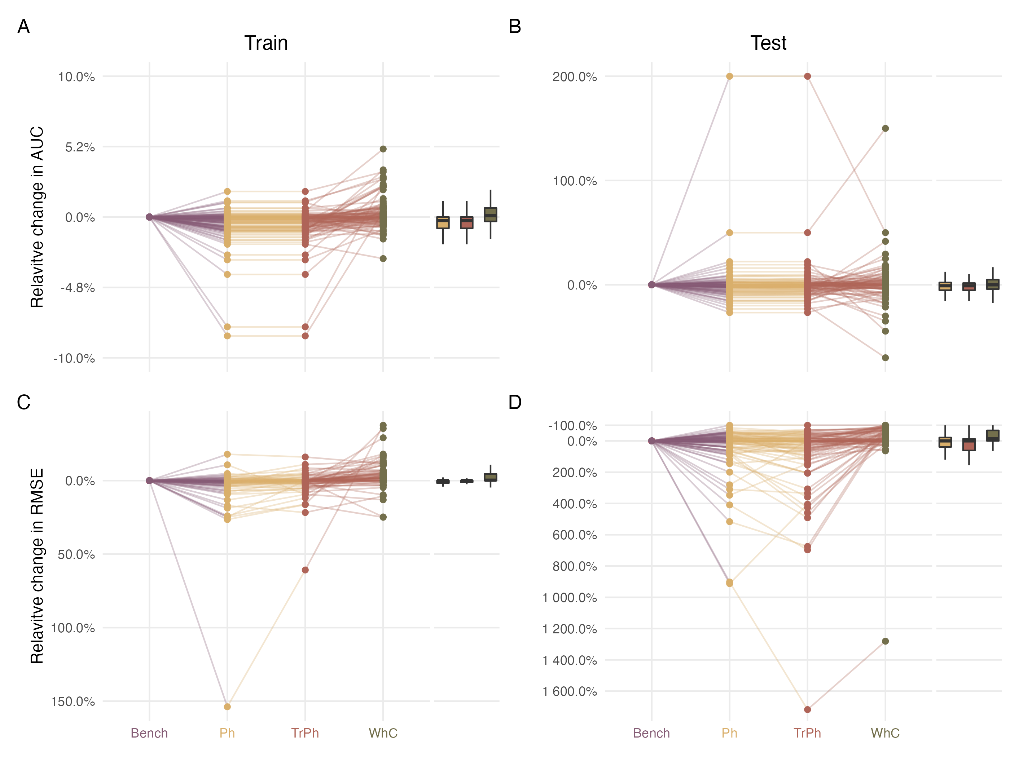

Figure 2: Change in explanatory and predictive power of three model structures (yellow for Phylogeny (Ph), red for Traits and phylogeny (TrPh), and green for Whole community (WhC) models) relative to the Benchmark model (Bench; purple). Changes are expressed as percentages relative to the benchmark fitted on presence/absence (top row) or abundance (bottom row) data. Points above the zero line indicate performance gain.

### Community level

In terms of alpha diversity, the *Bench*, the *Ph* and *TrPh* models fitted on abundance data all underpredicted mean species richness of the train set by 4 species on average (-29.2% compared to observed data; Fig. 3). In contrast, the *WhC* model overpredicted mean richness by 11 species on average (+80% compared with observed data). Similar results were found on the test dataset with the *Bench*, *Ph* and *TrPh* models underpredicting richness by 5 species (-24.9 %) on average whereas the *WhC* model overpredicted richness by 7 species (+35.8% compared with observed data). Similar results were found for models fitted on presence/absence data (Fig. S22).

All models overall underpredicted mean total abundance relative to the train dataset (Fig. 3), by 153 individuals for the *Bench* model (-49.8% compared to observed data) and by 159 and 155 individuals (-51.7% and -50.4%) for the *Ph* and *TrPh* models, respectively. The *WhC* model only underpredicted total abundance by 22 individuals (-7.12% compared to observed data). Relative to the test dataset, the *Bench*, the *Ph* and the *TrPh* models overpredicted mean total abundance by 1642 (+234% compared to observations), 465 (+66.3%), and 1969 individuals (+281%), respectively. In contrast, the *WhC* model underpredicted mean total abundance of the test data samples by 404 individuals on average (-57.6%).

Mean beta diversity patterns in the train dataset were overall well captured by all models fitted on abundance or presence/absence data (Fig. 3). Observed dissimilarities were slightly overpredicted by all abundance models: by 0.057 for the *Bench* (+7.3% compared with observed data), 0.050 for the *Ph* (+6.4%), 0.054 for the *TrPh* (+6.9%) and 0.070 for the *WhC* models (+8.9%). Differences for presence/absence models were of similar order but all models underpredicted mean pairwise dissimilarities between samples (Fig. S22). On the test dataset, beta diversity patterns were rather poorly captured by the models fitted on abundance data. The Bench model overpredicted the pairwise dissimilarities by 0.364 on average (+67.1% compared with observed data), the *Ph* model by 0.365 (+67.4%), the *TrPh* model by 0.375 (+69.1%) and the *WhC* model by 0.338 (+62.4%). Similar results were observed for presence/absence models with slightly smaller overpredictions (Fig. S22).

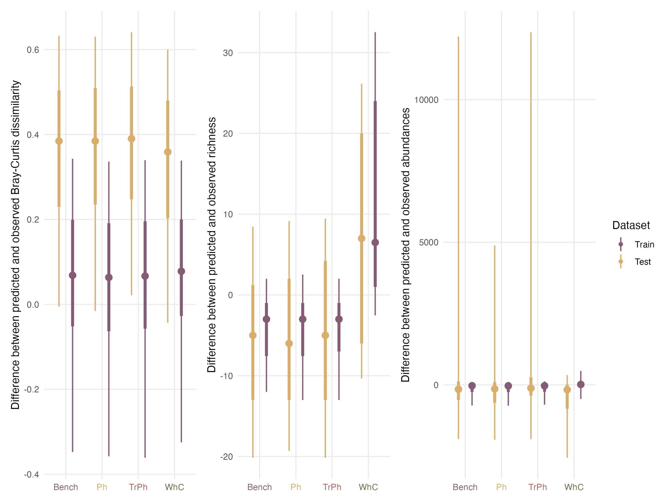

Figure 3: Comparison of model performances with regards to their ability to predict community structures when fitted with abundance data for the train (purple) and test (yellow) dataset. Left: differences in pairwise dissimilarities estimated on the observed and the predicted assemblages. Centre: differences in species richness between observed and predicted assemblages. Right: differences in total abundance between observed and predicted assemblages.

## Variance partitioning

The mean amount of total variance explained across the 99 polychaetes varied between 21 and 23% for models fitted with presence/absence data and between 18 and 30% for abundance-based models (Fig. S23). For all models, environmental variables, rather than random effects, accounted for most (more than 68% ± 18%; mean ± s.d.) of the explained variance (Fig. S24). However, a larger part of variance is explained by random effects in the *WhC* model compared to the other models, including the Bench (Fig. S24). Compared to the *Bench* model fitted with abundance data, the relative change in the part of variance explained by random effects across the 99 species decreased by 17.00% for the *Ph* model, 10.90% for the *TrPh* model and increased by 224% for the *WhC* model (Fig. 4). Similar results with smaller relative changes were obtained across presence/absence models (Fig. 4 ; Fig. S23-24).

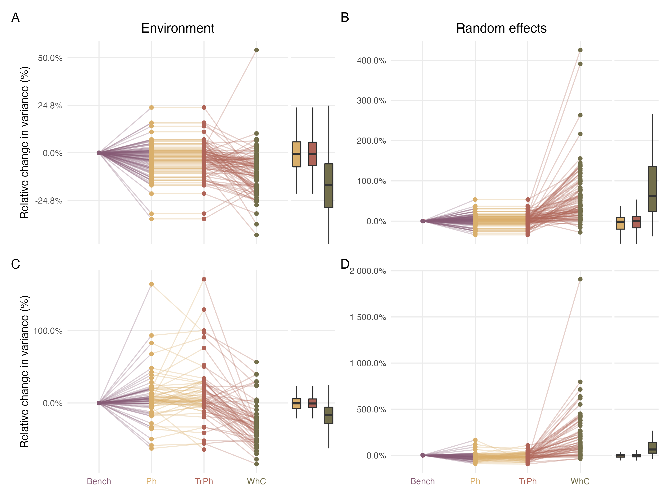

Figure 4: Change in explained variance related to environmental predictors (left column) and random effects (right column) for three alternative model structures (yellow for Phylogeny (Ph), red for Traits and phylogeny (TrPh), and green for Whole community (WhC) models) relative to the Benchmark model (Bench; purple). Percentage changes were computed relative to the Benchmark model fitted with presence/absence (top panels) or abundance (bottom panels) data. Positive values indicate an increase in the proportion of variance explained by the focal model compared to the Benchmark model. See Figure S23 and S24 for the raw percentages, expressed as percentages of explained variance or total amount of variance respectively.

## Species niche estimated

For abundance models, the large majority (>60%) of flat response curves indicated a lack of meaningful species-environment relationships (Fig. 5). This proportion reached 83% for the *WhC* model. The prevalence of flat relationships did not appear to be related to convergence issues (Fig. S15-16) or to be driven by a specific covariate (Fig. S25). Convex or concave response curves were rare in abundance models. Significant relationships primarily included constant or accelerated declines, representing approximately 10% and 15% of response curves in the *Bench*, *TrPh*, and *Ph* models (Fig. 5). In the *WhC* model, these percentages decreased to 7% and 6%, respectively (Fig. 5). Similar findings were observed for presence/absence models (Fig. S26; Fig. S27).

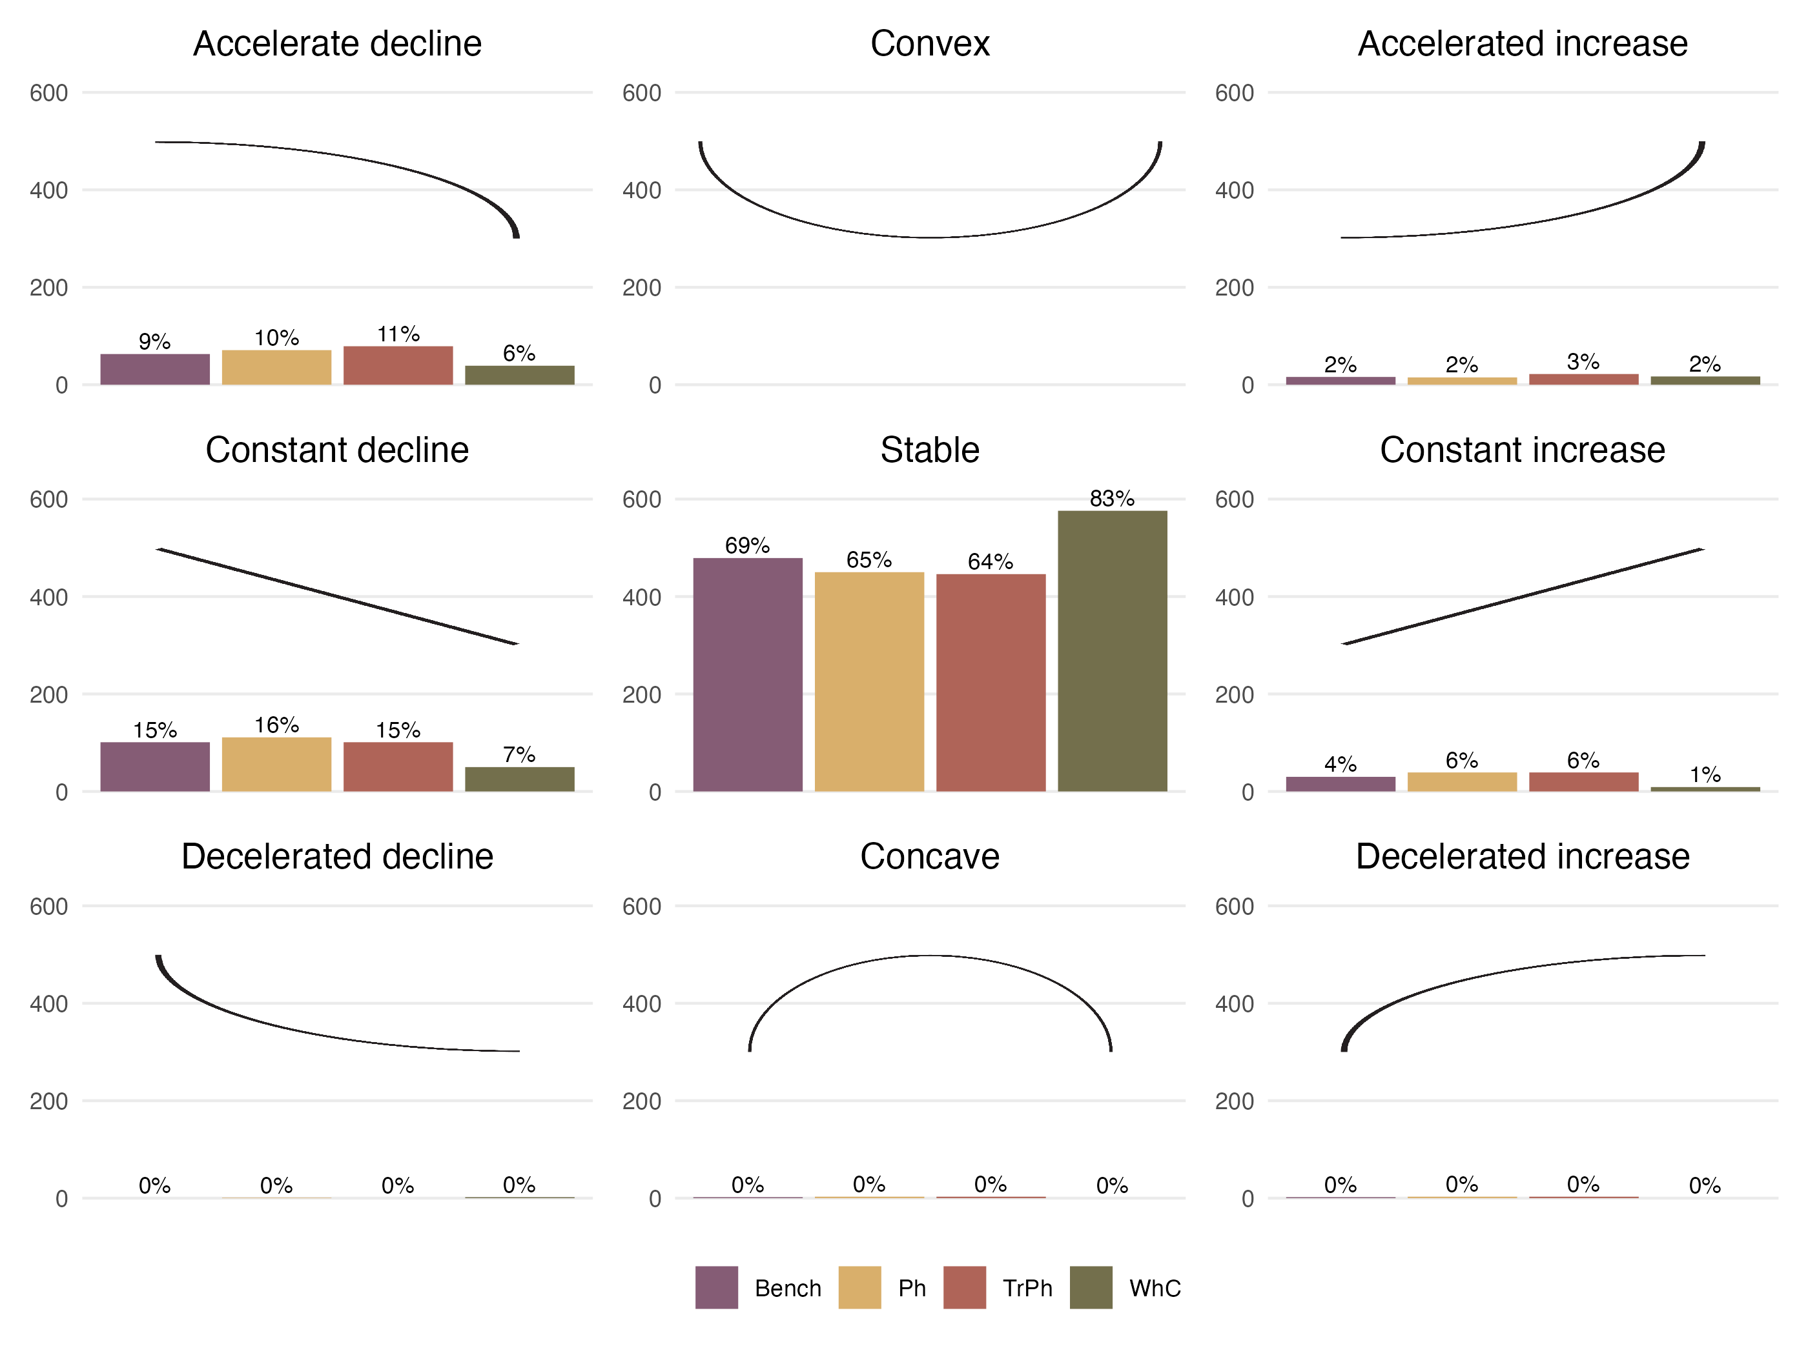

Figure 5: Number (y-axis) and proportion (computed across all coefficients for each model, as indicated above individual bars) of response curves (i.e. one for each species-predictor combination according to the typology (nine shapes highlighted by the black curve in each panel) defined by Rigal et al. (2020). Results are presented for the different model structures

Both abundance and presence/absence *TrPh* models (which include species functional traits) reveal some meaningful trait-environment relationships between the first fuzzy-PCA axis and the seven environmental predictors. This suggests that the occurrence of certain traits is likely favored (or hindered) under certain environmental conditions (Fig. S28). For instance, mobile predatory species showed larger declines in abundance as fetch increases than sessile suspensivores (Fig. S28). Moreover, increase in organic matter concentration and decrease in current velocities were associated with higher abundances of suspensive feeders.

## Exploring the residual correlation

Residual species-species correlations were compared between the *Bench* model and the *WhC* model, only for the 99 target species, using both presence/absence (Fig S29) and abundance data (Fig. 6). We only focus this comparison on the *WhC* model (rather than other models) because of its higher predictive performance and higher proportion of explained variance by random effects (Fig. 4). Residual correlations estimated from both models were highly correlated, both for presence/absence and abundance data (Fig. 6 and Fig. S29). However, agreement between models varied across different random effects from a moderate correlation between residuals associated with the Habitat random effects (${\text{R}}^{2}=0.57$) or with the Site random effects (${\text{R}}^{2}=0.64$), to a high correlation between residuals related to the Year random effects (${\text{R}}^{2}=0.95$). The $δ$ index main modal distribution, which is centered on zero, confirms an overall agreement between residual correlations estimated from both models in relation to the Year random effects with a marginal proportion of sign changes (0.45% of sign changes related to correlation greater than 0.25; Fig. 6 B) only related to low species-species residual correlations (<0.25; Fig. 6 A and Fig. S29). In contrast, the $δ$ index highlights inconsistencies in both magnitude and signs changes between residuals associated with the Habitat and the Site (12.2% and 9.11% of sign changes related to correlation greater than 0.25) random effects. Similar results were obtained for presence/absence models (Fig. S29).

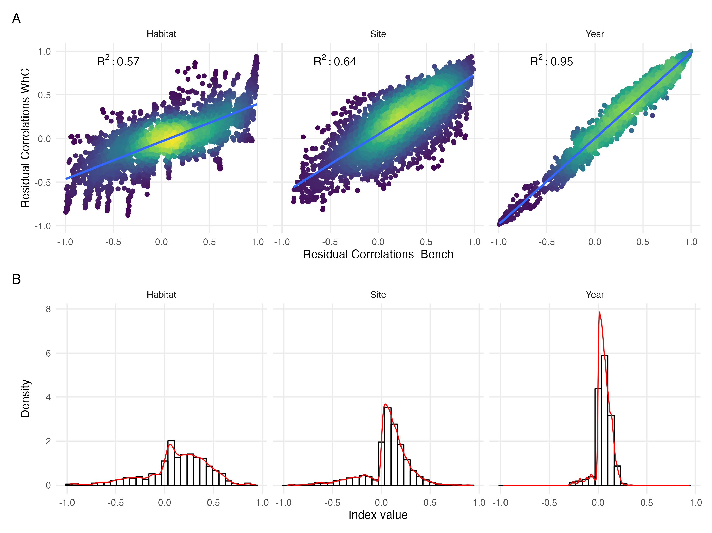

Figure 6: (A) Comparison of residual species-species correlations associated with the three random effects estimated by the Whole Community Model (WhC; y-axis) and the Benchmark model (Bench; x-axis) fitted on abundance data. The colour scale highlights the density of points in each scatter plot. (B) Distribution of the $δ$ index characterizing change in sign (negative values indicate sign change) and magnitude (higher absolute values indicate higher numerical difference) between residual correlations estimated by the WhC model and the Bench model adjusted with abundance data for the three random effects (Habitat, Site, Year).

# Discussion

Case studies in community ecology typically rely on partial and heterogeneous observations (Pollock *et al.* 2020) but also on incomplete knowledge of target species ecological features (e.g. traits, phylogeny; Tyler *et al.* (2012)). This study investigated how *jSDM* performance varies depending on the type of information included (i.e. phylogeny, traits or data on non-target species) using a multi-assessment framework (spanning interpretability, inference and prediction, for both species- and community-level metrics, Table 1) enabling a thorough evaluation of model performance.

We found that *jSDMs*’ performance, in particular predictive power of abundance models at the species level, mostly increased when including information related to the 179 non-target species sampled alongside with the 99 polychaetes of interest. However, improvement in species-level predictions does not directly translate into enhanced performance at the community level. The *WhC* model did not improve estimates of beta diversity or total abundance relative to the other models and largely overpredicted species richness, as previously suggested (Zurell *et al.* 2018). Given *HMSC* hierarchical structure (Poggiato *et al.* 2021), inclusion of monitoring data related to other species likely improves model performance for the target assemblage by capturing relevant drivers that are not explicitly considered. For instance, it can help describe target species’ realized niches by accounting for ecological processes related to environmental conditions (including trait-mediated responses) or biotic interactions that are not explicitly captured otherwise (Ovaskainen *et al.* 2017b). In our case, main differences between residual correlations estimated by the *Benchmark model* and the *Whole community* model relate to spatial random effects (i.e. site and habitat). In contrast, the temporal random effect yielded similar residual co-occurrences in both models. This suggests that including non-target species in our case, mostly helped capture spatial variability in species associations across sites and habitats.

Importantly, while we show that including non-target species can improve predictive performance, in particular for rare species, benefits of accounting for non-target species might vary depending on robustness of non-target species monitoring data (e.g. detection issues), their role within the ecosystem (e.g. engineer species are likely more influential on local communities than rare transient species), or processes shaping the target assemblage (if influence of abiotic factors dominates, then adding other species will have marginal consequences on model performance). While the list of additional species to consider can be prioritized based on existing knowledge in well-studied ecosystems, such information is often unavailable. Furthermore, a specific investigation, that might rely on simulated datasets to overcome limitations related to real world datasets (DiRenzo *et al.* 2022), would be required to determine specific criteria, as well as optimal number of non-target species to include. While species communities and assemblages are largely defined arbitrarily (Stroud *et al.* 2015), a systematic assessment of *jSDM* performance as increasing the number and types (for instance based on their functional or trophic roles) of non-target species would be valuable to optimise model performance for the species of management interests.

*jSDMs* have already been used to model the distribution of a wide variety of species ranging from micro-organisms (Minard *et al.* 2019) to megafauna (Brimacombe *et al.* 2021) inhabiting many different ecosystems. Here, while we studied assemblages associated with two specific coastal habitats, i.e. seagrass and sand, that have original characteristics as they are located at the land-sea interface (Boyé *et al.* 2019), our case study reflects typical aspects of applied ecological research. These include issues related to data limitation and availability but also typical features of ecological communities (e.g. prevalence of rare and transient species; Magurran & Henderson (2003)) ; Snell Taylor *et al.* (2018)). Valuable insights on trait-environment relationships are scarce in our study, which reflects how contributions of functional ecology in *jSDMs* are likely limited by trait data quality and availability (Tyler *et al.* 2012 ; Juan *et al.* 2022). For instance, we found an interaction between trophic modalities (i.e. microphagous versus macrophagous diet) and fetch (Fig. S15), indicating that organisms that filter on small particles are less likely to occur in wave-exposed sites where high levels of sediment resuspension can block their filtering systems (Manning *et al.* 2014). Yet, the limited number of informative trait-environment relationships or species-environment relationships either suggest that neutral processes may shape polychaete assemblages (Boyé *et al.* 2019); or rather highlight a mismatch between trait data, environmental data, and the ecological processes at play (Juan *et al.* 2022). For instance, environmental variables only capture mean climatological conditions, but fail to quantify variability in the coastal environment, such as extreme events and seasonal or annual variability. Likewise, the list of available fuzzy-coded traits only partially captures species capacity to adapt to environmental variability (Juan *et al.* 2022). Thus, effectiveness of inclusion of traits in *jSDMs* is likely to be limited, or to rely on effort to collect relevant trait information. In our case, while including traits does not improve model predictive power, it somehow enhances our understanding of species responses along environmental gradients. Hence, if the goal is not prediction but inference (Tredennick *et al.* 2021), including traits and proxies of phylogeny can facilitate *jSDM* interpretation.

This paper lays out an original framework to systematically compare multiple facets of alternative *jSDM* formulations (i.e. including phylogeny, traits or additional species) on model interpretability, explanatory and predictive power (Table 1). Using a set of complementary metrics, we specifically assess performance of alternative model formulations fitted to presence-absence or abundance data at the species and community levels. Our framework goes beyond existing guidelines proposed to assess the performance of *jSDM* fitted on presence-absence data (Wilkinson *et al.* 2021) or that focus on the predictive power of abundance-based models (e.g. Waldock *et al.* (2022)). It specifically compares the performance (both explanatory and predictive) and interpretability of alternative models’ formulations accounting for the multiple and high-dimensional components that are typical of *jSDMs*, namely: (1) species and community level predictions including alpha and beta diversity metrics and ranking of predictions according to species prevalence/abundance; (2) species-environment relationships where we transposed the framework initially developed for time series by Rigal *et al.* (2020) into an effective tool to classify response curves according to 9 categories across high numbers of species (e.g. 99 in our case study); (3) trait-environment relationships; and (4) residual species-species correlations associated with random effects thanks to a new index that summarizes both changes in the sign and magnitude of the residual correlations.

Overall, our results provide new insights into the most appropriate strategies for *jSDM* fitting, according to modelling objectives (Tredennick *et al.* 2021) and available data. While the four models considered had similar explanatory power, adding extra information to standard *jSDMs* that only consider abiotic predictors can prove useful in cases. For instance, adding monitoring data for other non-target species can substantially increase model predictive power by modifying inferred species-environment relationships and residual correlation matrices. Similarly, adding traits or phylogeny can improve model interpretability. Future studies will be key to consolidate our findings on simulated case studies (Zurell *et al.* 2010 ; DiRenzo *et al.* 2022), or across contrasted ecosystems, for instance dominated either by environmental filtering, or by competitive processes. Generalizing this approach across ecosystems will further help prioritize data collection effort on the long term. For this purpose, we recommend using a multi-model inference framework similar to the one used in this study to systematically assess trade-offs associated with alternative jSDMs formulations.

## Author Contributions

MPM conceived the project with inputs from CV, AB, MC. CV analysed data and led manuscript write-up. All authors had significant inputs to the manuscript and approved this final version.

## Acknowledgments

We are grateful to Marion Maguer and Vincent Le Garrec who conducted fieldwork and laboratory analyses, as well as to supporting students and staff involved in the REBENT monitoring programme coordinated by Sandrine Derrien (MNHN) and its funding partners (Agence de l’eau Loire-Bretagne, Région Bretagne, DREAL Bretagne). The authors would also like to acknowledge the Pôle de Calcul et de Données Marines (PCDM) for providing DATARMOR storage and computational resources. <https://pcdm.ifremer.fr>. MPM is the recipient of an ANR early career grant ANR-21-CE02-0006.

Abrego, N., Bässler, C., Christensen, M. & Heilmann-Clausen, J. (2022). Traits and phylogenies modulate the environmental responses of wood-inhabiting fungal communities across spatial scales. *Journal of Ecology*, 110, 784–798.

Abrego, N., Dunson, D., Halme, P., Salcedo, I. & Ovaskainen, O. (2017). Wood-inhabiting fungi with tight associations with other species have declined as a response to forest management. *Oikos*, 126.

Blanchet, F.G., Cazelles, K. & Gravel, D. (2020). Co-occurrence is not evidence of ecological interactions. *Ecology Letters*, 23, 1050–1063.

Boyé, A., Gauthier, O., Becheler, R., Le Garrec, V., Hily, C., Maguer, M., *et al.* (2022). Drivers and limits of phenotypic responses in vulnerable seagrass populations: Zostera marina in the intertidal. *Journal of Ecology*, 110, 144–161.

Boyé, A., Legendre, P., Grall, J. & Gauthier, O. (2017). Constancy despite variability: Local and regional macrofaunal diversity in intertidal seagrass beds. *Journal of Sea Research*, 130, 107–122.

Boyé, A., Thiébaut, Éric, Grall, J., Legendre, P., Broudin, C., Houbin, C., *et al.* (2019). Trait-based approach to monitoring marine benthic data along 500 km of coastline. *Diversity and Distributions*, 25, 1879–1896.

Brimacombe, C., Bodner, K. & Fortin, M.-J. (2021). Inferred seasonal interaction rewiring of a freshwater stream fish network. *Ecography*, 44, 219–230.

Brudvig, L.A. & Catano, C.P. (2022). Prediction and uncertainty in restoration science. *Restoration Ecology*, e13380.

Chiquet, J., Mariadassou, M. & Robin, S. (2021). The poisson-lognormal model as a versatile framework for the joint analysis of species abundances. *Frontiers in Ecology and Evolution*, 9.

Dietze, M.C., Fox, A., Beck-Johnson, L.M., Betancourt, J.L., Hooten, M.B., Jarnevich, C.S., *et al.* (2018). Iterative near-term ecological forecasting: Needs, opportunities, and challenges. *Proceedings of the National Academy of Sciences*, 115, 1424–1432.

DiRenzo, G.V., Hanks, E. & Miller, D.A.W. (2022). A practical guide to understanding and validating complex models using data simulations. *Methods in Ecology and Evolution*.

Dormann, C.F., Bobrowski, M., Dehling, D.M., Harris, D.J., Hartig, F., Lischke, H., *et al.* (2018). Biotic interactions in species distribution modelling: 10 questions to guide interpretation and avoid false conclusions. *Global Ecology and Biogeography*, 27, 1004–1016.

Elith, J., H. Graham, C., P. Anderson, R., Dudı́k, M., Ferrier, S., Guisan, A., *et al.* (2006). Novel methods improve prediction of species’ distributions from occurrence data. *Ecography*, 29, 129–151.

Gelman, A. & Rubin, D.B. (1992). Inference from iterative simulation using multiple sequences. *Statistical Science*, 7, 457–472.

Giangrande, A., Licciano, M. & Musco, L. (2005). Polychaetes as environmental indicators revisited. *Marine Pollution Bulletin*, 50, 1153–1162.

Giannini, T.C., Chapman, D.S., Saraiva, A.M., Alves-dos-Santos, I. & Biesmeijer, J.C. (2013). Improving species distribution models using biotic interactions: A case study of parasites, pollinators and plants. *Ecography*, 36, 649–656.

Godsoe, W., Franklin, J. & Blanchet, F.G. (2017). Effects of biotic interactions on modeled species’ distribution can be masked by environmental gradients. *Ecology and Evolution*, 7, 654–664.

Grall, J., Le Loc’h, F., Guyonnet, B. & Riera, P. (2006). Community structure and food web based on stable isotopes (δ15N and δ13C) analysis of a north eastern atlantic maerl bed. *Journal of Experimental Marine Biology and Ecology*, 338, 1–15.

Häkkilä, M., Abrego, N., Ovaskainen, O. & Mönkkönen, M. (2018). Habitat quality is more important than matrix quality for bird communities in protected areas. *Ecology and Evolution*, 8, 4019–4030.

Holt, R.D. (2020). Some thoughts about the challenge of inferring ecological interactions from spatial data. *Biodiversity Informatics*, 15, 61–66.

Howard, C., Stephens, P.A., Pearce-Higgins, J.W., Gregory, R.D. & Willis, S.G. (2014). Improving species distribution models: The value of data on abundance. *Methods in Ecology and Evolution*, 5, 506–513.

Hui, F.K.C. (2016). Boral – bayesian ordination and regression analysis of multivariate abundance data in r. *Methods in Ecology and Evolution*, 7, 744–750.

Ives, A.R. & Helmus, M.R. (2011). Generalized linear mixed models for phylogenetic analyses of community structure. *Ecological Monographs*, 81, 511–525.

Jankowska, E., Michel, L.N., Lepoint, G. & Włodarska-Kowalczuk, M. (2019). Stabilizing effects of seagrass meadows on coastal water benthic food webs. *Journal of Experimental Marine Biology and Ecology*, 510, 54–63.

Juan, S. de, Bremner, J., Hewitt, J., Törnroos, A., Mangano, M.C., Thrush, S., *et al.* (2022). Biological traits approaches in benthic marine ecology: Dead ends and new paths. *Ecology and Evolution*, 12, e9001.

Jumars, P.A., Dorgan, K.M. & Lindsay, S.M. (2015). Diet of worms emended: An update of polychaete feeding guilds. *Annual Review of Marine Science*, 7, 497–520.

Keil, P., Wiegand, T., Tóth, A.B., McGlinn, D.J. & Chase, J.M. (2021). Measurement and analysis of interspecific spatial associations as a facet of biodiversity. *Ecological Monographs*, 91, e01452.

Magurran, A.E. & Henderson, P.A. (2003). Explaining the excess of rare species in natural species abundance distributions. *Nature*, 422, 714–716.

Manning, L.M., Peterson, C.H. & Bishop, M.J. (2014). Dominant macrobenthic populations experience sustained impacts from annual disposal of fine sediments on sandy beaches. *Marine Ecology Progress Series*, 508, 1–15.

Minard, G., Tikhonov, G., Ovaskainen, O. & Saastamoinen, M. (2019). The microbiome of the melitaea cinxia butterfly shows marked variation but is only little explained by the traits of the butterfly or its host plant. *Environmental Microbiology*, 21, 4253–4269.

Momal, R., Robin, S. & Ambroise, C. (2020). Tree-based inference of species interaction networks from abundance data. *Methods in Ecology and Evolution*, 11, 621–632.

Momal, R., Robin, S. & Ambroise, C. (2021). Accounting for missing actors in interaction network inference from abundance data. *Journal of the Royal Statistical Society: Series C (Applied Statistics)*, 70, 1230–1258.

Morales-Castilla, I., Davies, T.J., Pearse, W.D. & Peres-Neto, P. (2017). Combining phylogeny and co-occurrence to improve single species distribution models. *Global Ecology and Biogeography*, 26, 740–752.

Niku, J., Hui, F.K.C., Taskinen, S. & Warton, D.I. (2019). Gllvm: Fast analysis of multivariate abundance data with generalized linear latent variable models in r. *Methods in Ecology and Evolution*, 10, 2173–2182.

Norberg, A., Abrego, N., Blanchet, F.G., Adler, F.R., Anderson, B.J., Anttila, J., *et al.* (2019). A comprehensive evaluation of predictive performance of 33 species distribution models at species and community levels. *Ecological Monographs*, e01370.

Ovaskainen, O. & Abrego, N. (2020). *Joint species distribution modelling: With applications in r*. Ecology, biodiversity and conservation. Cambridge University Press.

Ovaskainen, O., Tikhonov, G., Dunson, D., Grøtan, V., Engen, S., Sæther, B.-E., *et al.* (2017a). How are species interactions structured in species-rich communities? A new method for analysing time-series data. *Proceedings of the Royal Society B: Biological Sciences*, 284, 20170768.

Ovaskainen, O., Tikhonov, G., Norberg, A., Guillaume Blanchet, F., Duan, L., Dunson, D., *et al.* (2017b). How to make more out of community data? A conceptual framework and its implementation as models and software. *Ecology Letters*, 20, 561–576.

Paradis, E. & Schliep, K. (2019). Ape 5.0: An environment for modern phylogenetics and evolutionary analyses in r. *Bioinformatics*, 35, 526–528.

Poggiato, G., Münkemüller, T., Bystrova, D., Arbel, J., Clark, J.S. & Thuiller, W. (2021). On the interpretations of joint modeling in community ecology. *Trends in Ecology & Evolution*.

Pollock, L.J., Morris, W.K. & Vesk, P.A. (2012). The role of functional traits in species distributions revealed through a hierarchical model. *Ecography*, 35, 716–725.

Pollock, L.J., O’Connor, L.M.J., Mokany, K., Rosauer, D.F., Talluto, M.V. & Thuiller, W. (2020). Protecting biodiversity (in all its complexity): New models and methods. *Trends in Ecology & Evolution*, 35, 1119–1128.

Pollock, L.J., Tingley, R., Morris, W.K., Golding, N., O’Hara, R.B., Parris, K.M., *et al.* (2014). Understanding co-occurrence by modelling species simultaneously with a joint species distribution model (JSDM). *Methods in Ecology and Evolution*, 5, 397–406.

Rigal, S., Devictor, V. & Dakos, V. (2020). A method for classifying and comparing non-linear trajectories of ecological variables. *Ecological Indicators*, 112, 106113.

Snell Taylor, S.J., Evans, B.S., White, E.P. & Hurlbert, A.H. (2018). The prevalence and impact of transient species in ecological communities. *Ecology*, 99, 1825–1835.

Staniczenko, P.P.A., Sivasubramaniam, P., Suttle, K.B. & Pearson, R.G. (2017). Linking macroecology and community ecology: Refining predictions of species distributions using biotic interaction networks. *Ecology Letters*, 20, 693–707.

Stroud, J.T., Bush, M.R., Ladd, M.C., Nowicki, R.J., Shantz, A.A. & Sweatman, J. (2015). Is a community still a community? Reviewing definitions of key terms in community ecology. *Ecology and Evolution*, 5, 4757–4765.

Thioulouse, J., Dray, S., Dufour, A., Siberchicot, A., Jombart, T. & Pavoine, S. (2018). *Multivariate analysis of ecological data with ade4*. Springer.

Toumi, C., De Cáceres, M., Grall, J., Boyé, A., Thiébaut, É., Maguer, M., *et al.* (2023). Long-term coastal macrobenthic community trajectory analysis reveals habitat-dependent stability patterns. *Ecography*, e06489.

Tredennick, A.T., Hooker, G., Ellner, S.P. & Adler, P.B. (2021). A practical guide to selecting models for exploration, inference, and prediction in ecology. *Ecology*, 102, e03336.

Tyler, E.H.M., Somerfield, P.J., Berghe, E.V., Bremner, J., Jackson, E., Langmead, O., *et al.* (2012). Extensive gaps and biases in our knowledge of a well-known fauna: Implications for integrating biological traits into macroecology. *Global Ecology and Biogeography*, 21, 922–934.

Vesk, P.A., Morris, W.K., Neal, W.C., Mokany, K. & Pollock, L.J. (2021). Transferability of trait-based species distribution models. *Ecography*, 44, 134–147.

Waldock, C., Stuart-Smith, R.D., Albouy, C., Cheung, W.W.L., Edgar, G.J., Mouillot, D., *et al.* (2022). A quantitative review of abundance-based species distribution models. *Ecography*, 2022.

Warton, D.I., Blanchet, F.G., O’Hara, R.B., Ovaskainen, O., Taskinen, S., Walker, S.C., *et al.* (2015). So many variables: Joint modeling in community ecology. *Trends in Ecology & Evolution*, 30, 766–779.

Wiens, J.J., Ackerly, D.D., Allen, A.P., Anacker, B.L., Buckley, L.B., Cornell, H.V., *et al.* (2010). Niche conservatism as an emerging principle in ecology and conservation biology. *Ecology letters*, 13, 1310–1324.

Wilkinson, D.P., Golding, N., Guillera-Arroita, G., Tingley, R. & McCarthy, M.A. (2019). A comparison of joint species distribution models for presence–absence data. *Methods in Ecology and Evolution*, 10, 198–211.

Wilkinson, D.P., Golding, N., Guillera-Arroita, G., Tingley, R. & McCarthy, M.A. (2021). Defining and evaluating predictions of joint species distribution models. *Methods in Ecology and Evolution*, 12, 394–404.

Zurell, D., Berger, U., Cabral, J.S., Jeltsch, F., Meynard, C.N., Münkemüller, T., *et al.* (2010). The virtual ecologist approach: Simulating data and observers. *Oikos*, 119, 622–635.

Zurell, D., Pollock, L.J. & Thuiller, W. (2018). Do joint species distribution models reliably detect interspecific interactions from co-occurrence data in homogenous environments? *Ecography*, 41, 1812–1819.

# Appendix A - Data Sources and Descriptions of the Datasets

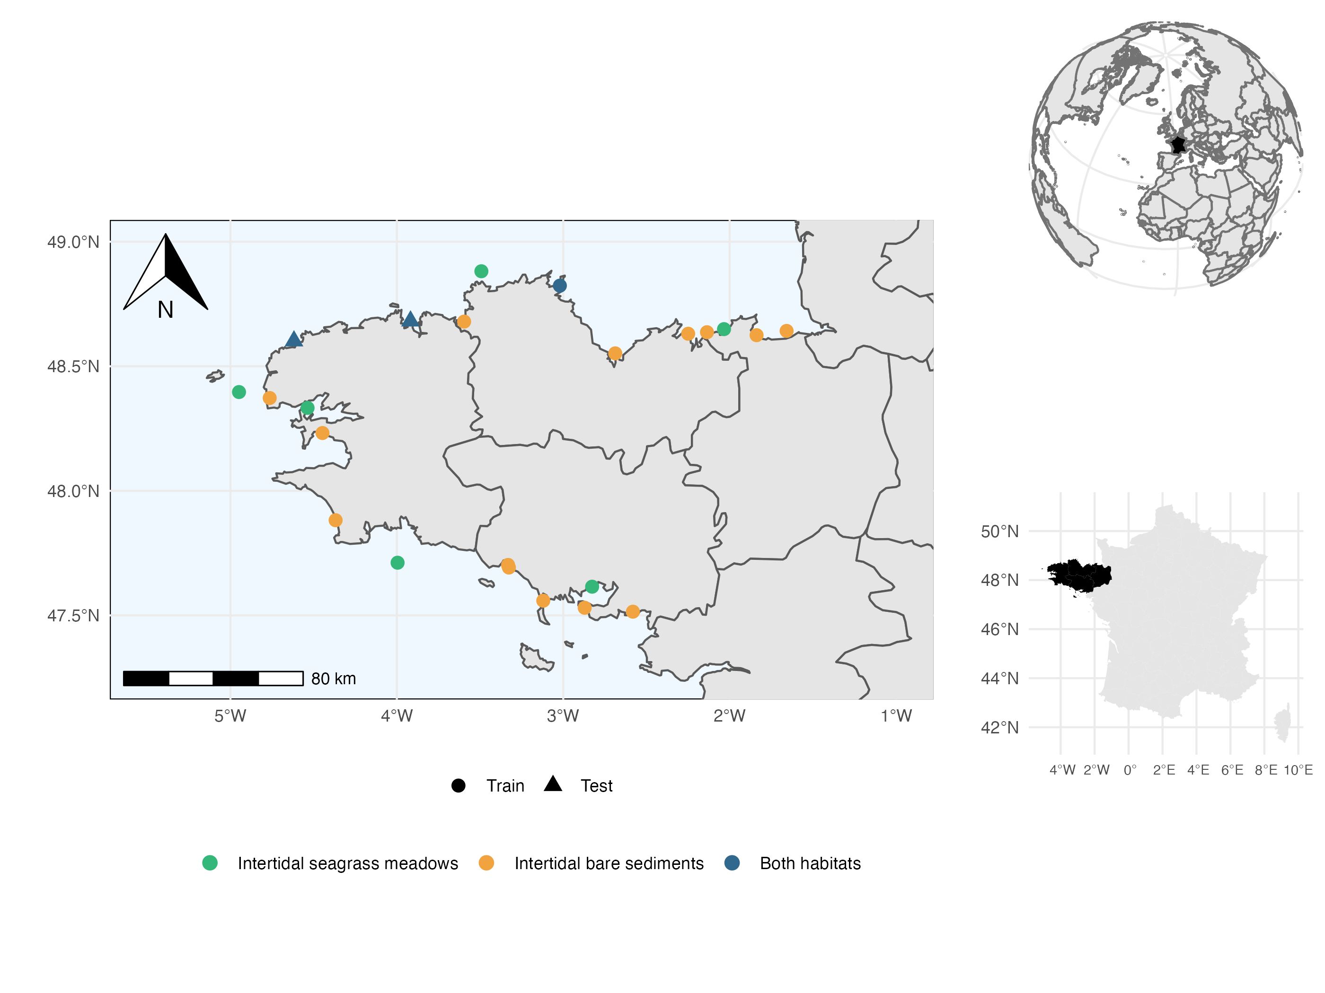

Figure 1: Map of the sampled sites. Point shapes vary according to their contribution to model training set (circles ; used to evaluate model explanatory power) as opposed to the two sites retained for independent model testing (triangles ; used to evaluate model predictive power). Point colours vary according to the presence or absence of the two habitats in each site. The two test sites include the two habitats (i.e. seagrass and bare sand) and were chosen because they occur in environmental conditions that can be considered average at the scale of the region (thereby limiting extrapolation of the model) but still harbour different communities, representative of the known diversity gradient across the region.

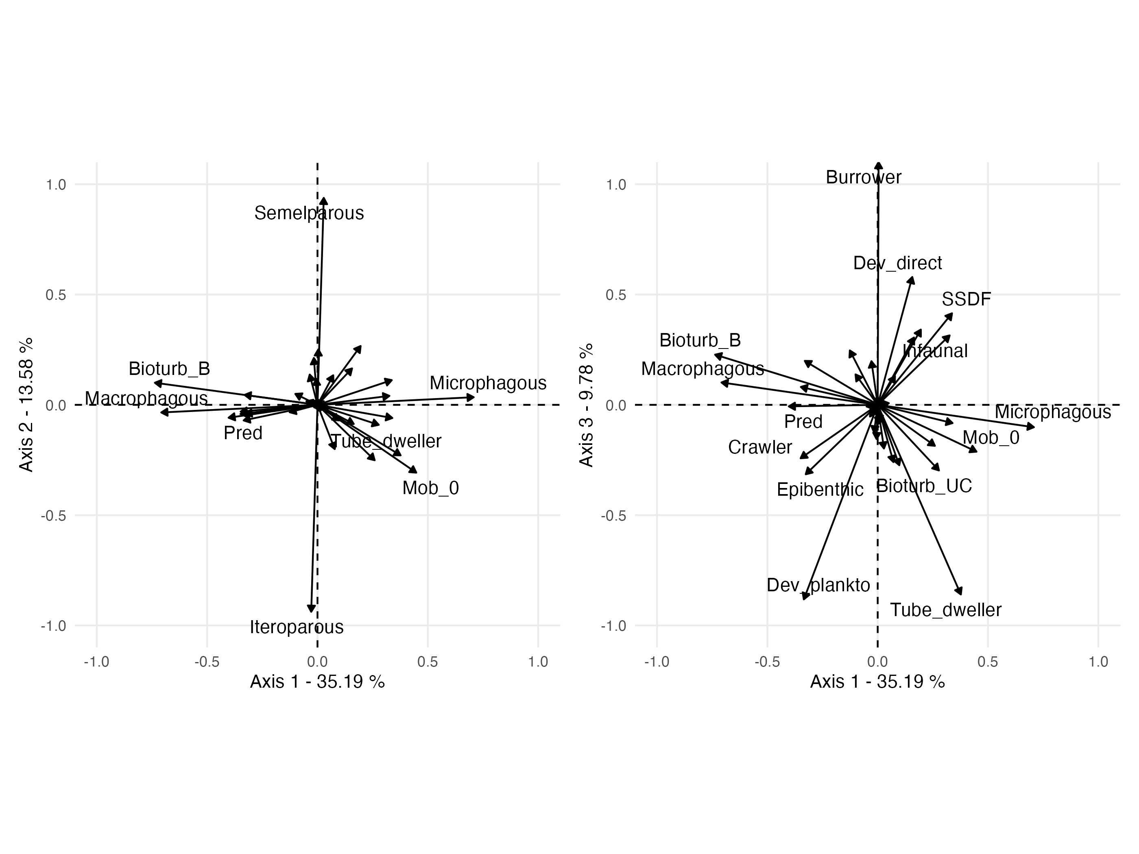

Figure 2: Fuzzy PCA of the species-by-trait matrix. The first three axes represent 58.55% of the total variance. The first axis distinguishes sessile microphagous species (top positive values) from mobile macrophagous predatory species (bottom negative values). The second axis is a gradient of reproductive strategies (semelparous vs iteroparous). The third axis distinguishes burrowers with direct development from tube-dwellers with planktonic development. For abbreviations and meaning of the trait modalities, see Boyé et al. (2019).

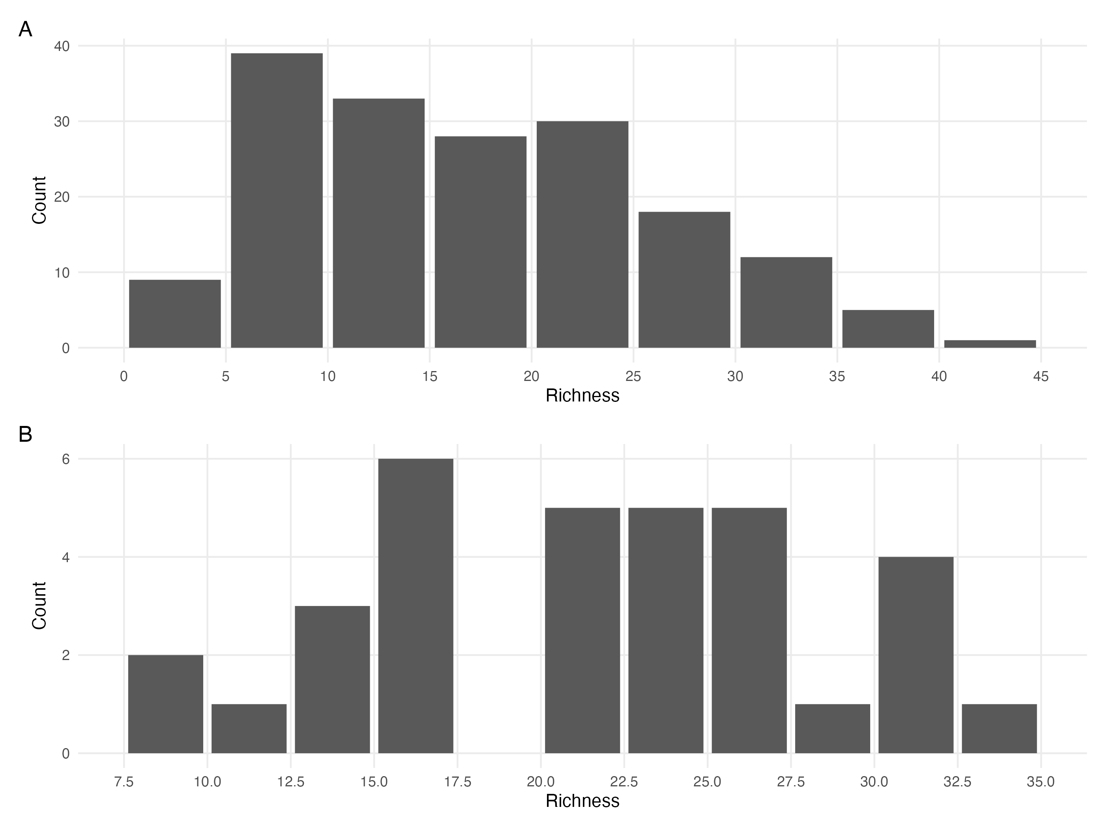

Figure 3: A. Distribution of the number of species in the samples (site times habitat times year) of the train dataset. B. Distribution of the number of species in the samples (site times habitat times year) of the test dataset.

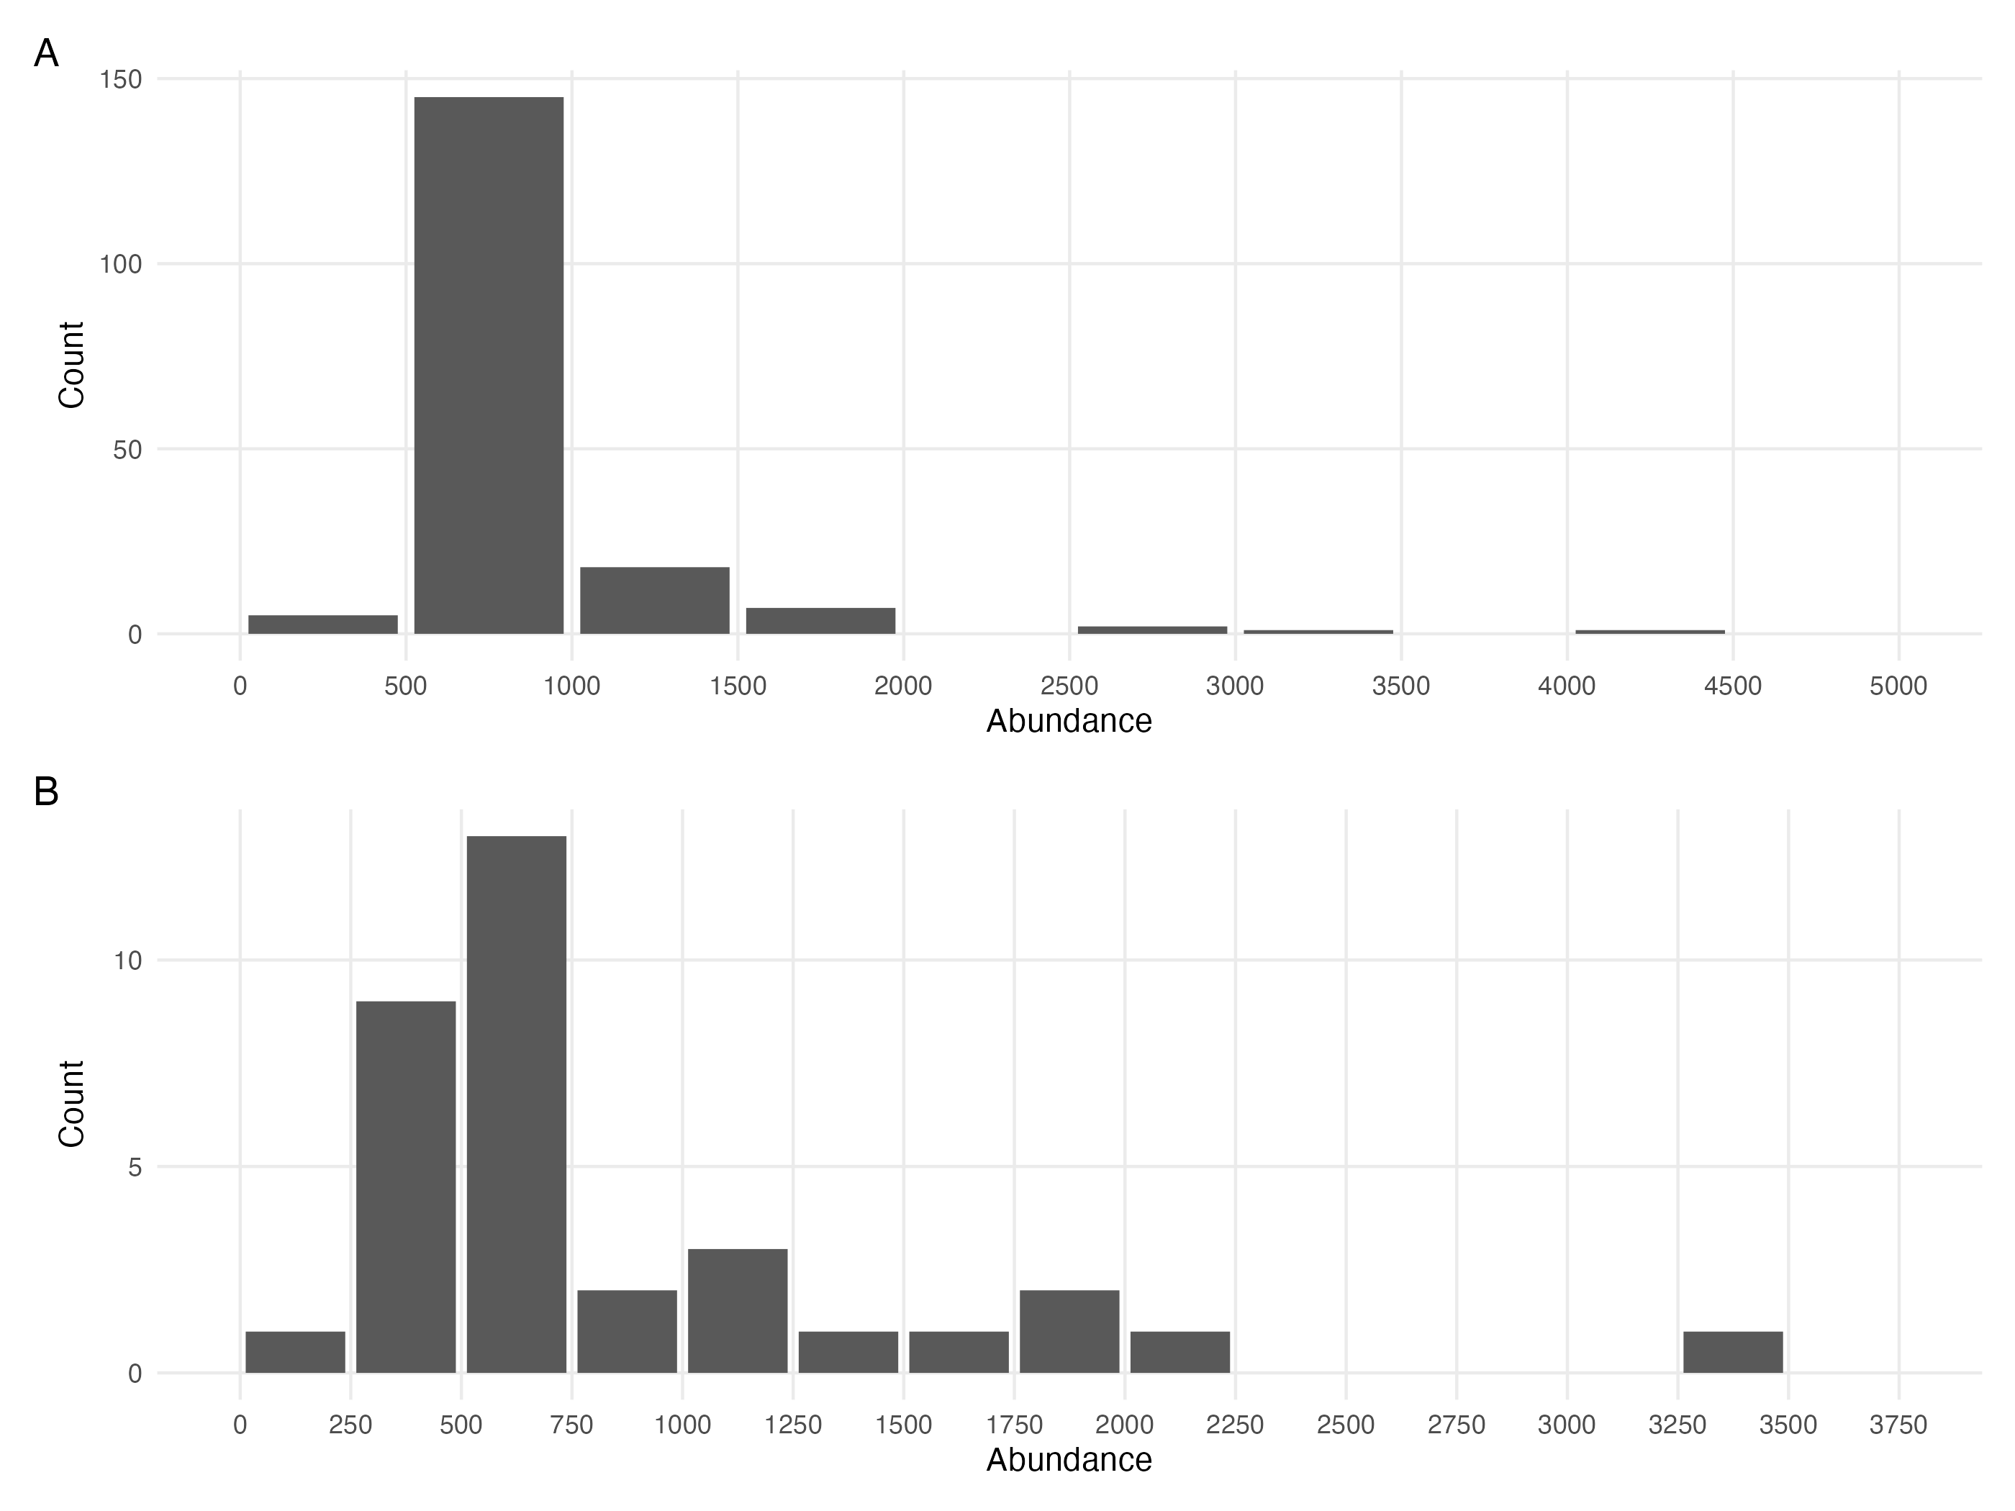

Figure 4: A. Distribution of the total number of individuals (abundance) in the samples (site times habitat times year) of the train dataset. B. Distribution of the total number of individuals (abundance) in the samples (site times habitat times year) of the test dataset.

## Environmental data acquisition

The models used in this study incorporate a dataset consisting of seven environmental variables related to oceanography, hydrography, and granulometry obtenained from Boyé (2019) The oceanographic variables include the standard deviation of salinity, surface water temperature, mean velocity of currents, and fetch, which were obtained from the PREVIMER database (Lecornu & Roeck 2009) based on the MARS3D model (Lazure & Dumas 2008). The variables were averaged by extracting daily data for the sampled year at the site coordinates and the eight adjacent cells. The fetch was calculated as the average length of nine radiating fetch segments with a maximum distance of 300km. The granulometry variables were derived from sediment cores that were taken along with associated fauna. The cores were dried, separated into 15 fractions, and the Trask index was calculated as the ratio of the 25th to 75th percentile of the grain distribution. Organic matter mass was estimated through the loss of mass after combustion in an oven.

# Appendix B - Model Convergence

## Environmental coefficients

Table 1: Potential scale reduction factors (PSRF) and effective sample sizes (ESS) for environmental regression parameters (i.e beta coefficients) estimated estimated for the four different models (Bench, Ph, TrPh, WhC) fitted either to abundance or presence-absence data. For further details see Fig. S5 to Fig. S12.

| Model | Data Type | Number of coefficients | PSRF (mean $±$ sd) | ESS (mean $±$ sd) |
| --- | --- | --- | --- | --- |
| Benchmark | Abundance | 1485 | 1.18 $±$ 0.267 | 701 $±$ 576 |
| Benchmark | Presence/Absence | 1485 | 1.00 $±$ 0.002 | 4967 $±$ 417 |
| Phylogeny | Abundance | 1485 | 1.18 $±$ 0.204 | 566 $±$ 420 |
| Phylogeny | Presence/Absence | 1485 | 1.00 $±$ 0.001 | 4947 $±$ 408 |
| Traits & Phylogeny | Abundance | 1485 | 1.21 $±$ 0.317 | 489 $±$ 358 |
| Traits & Phylogeny | Presence/Absence | 1485 | 1.00 $±$ 0.008 | 11459 $±$ 2649 |
| Whole Community | Abundance | 4170 | 1.21 $±$ 0.287 | 739 $±$ 631 |
| Whole Community | Presence/Absence | 4170 | 1.00 $±$ 0.002 | 4962 $±$ 406 |

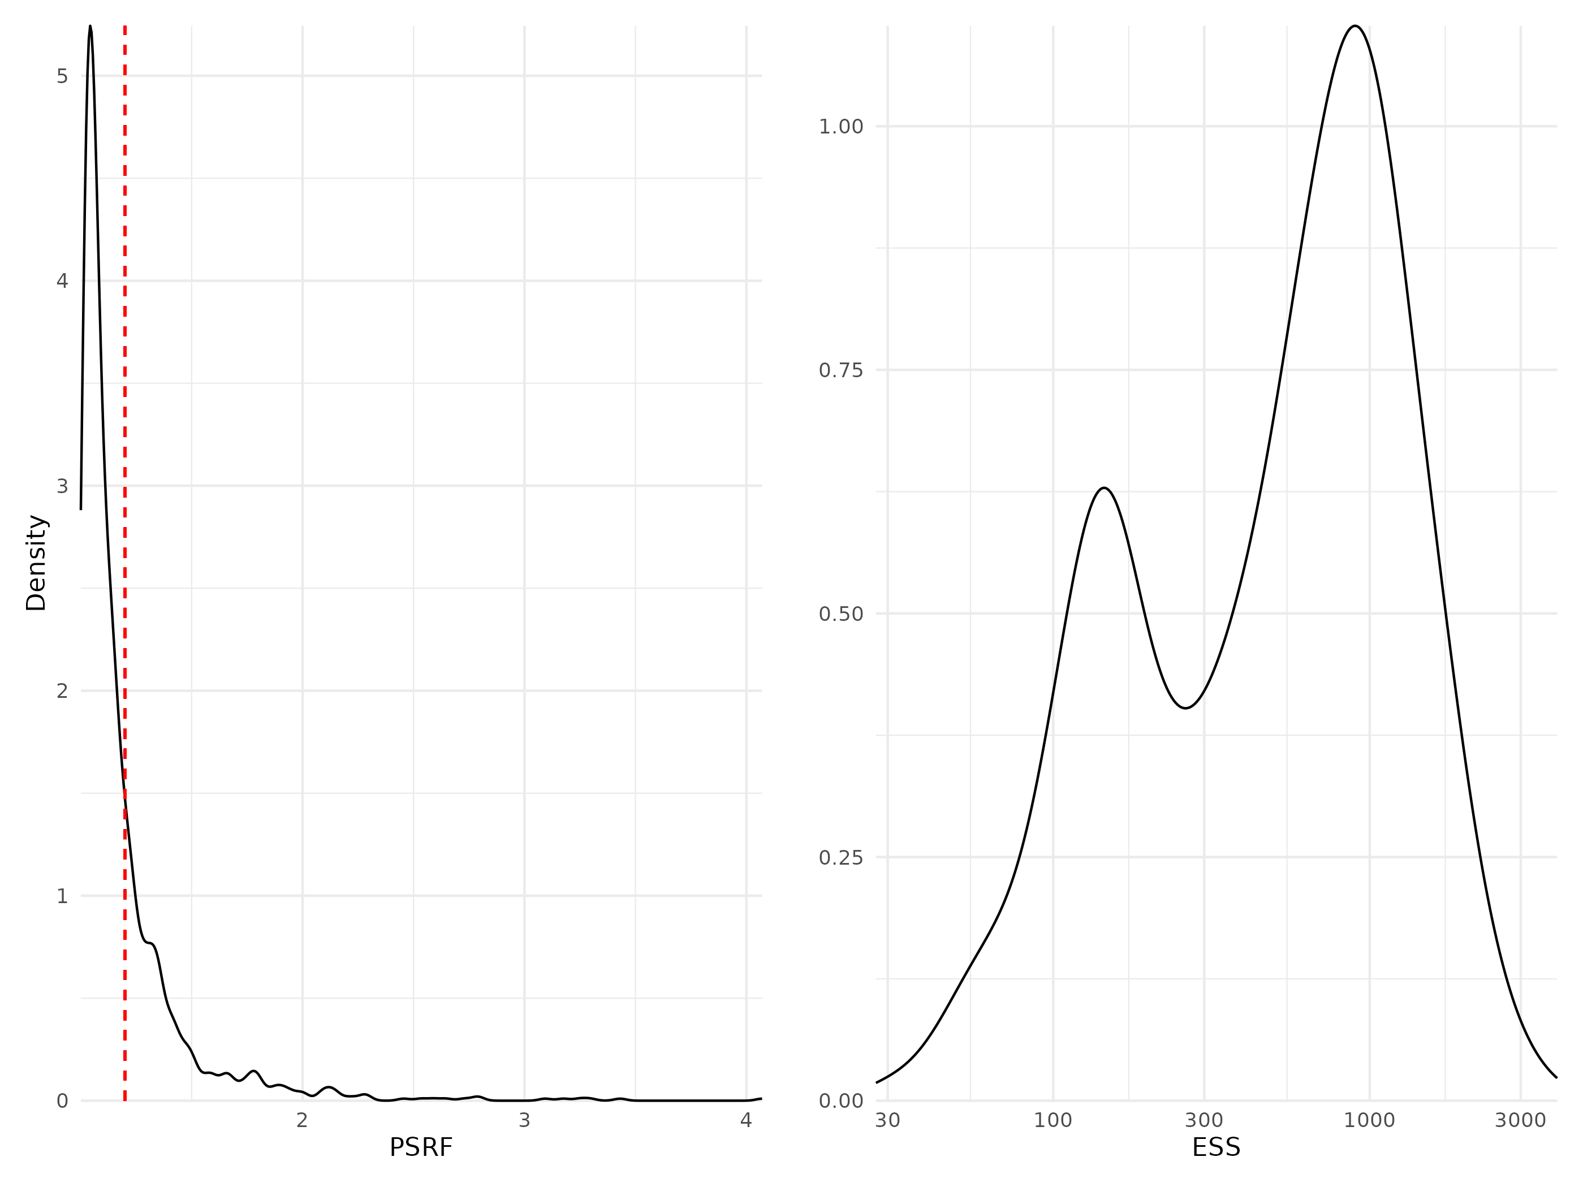

Figure 5: Density curves of potential scale reduction factors (PSRF see Brooks & Gelman (1998); left panel) and effective sample sizes (ESS; right panel) for Beta regression parameters (i.e environmental coefficients) estimated for the benchmark model fitted with abundance data. For PSRF, values greater than 1.2 (dotted red line) indicate potential convergence issues. ESS estimates the number of independent samples used to estimate each parameter (the more the better).

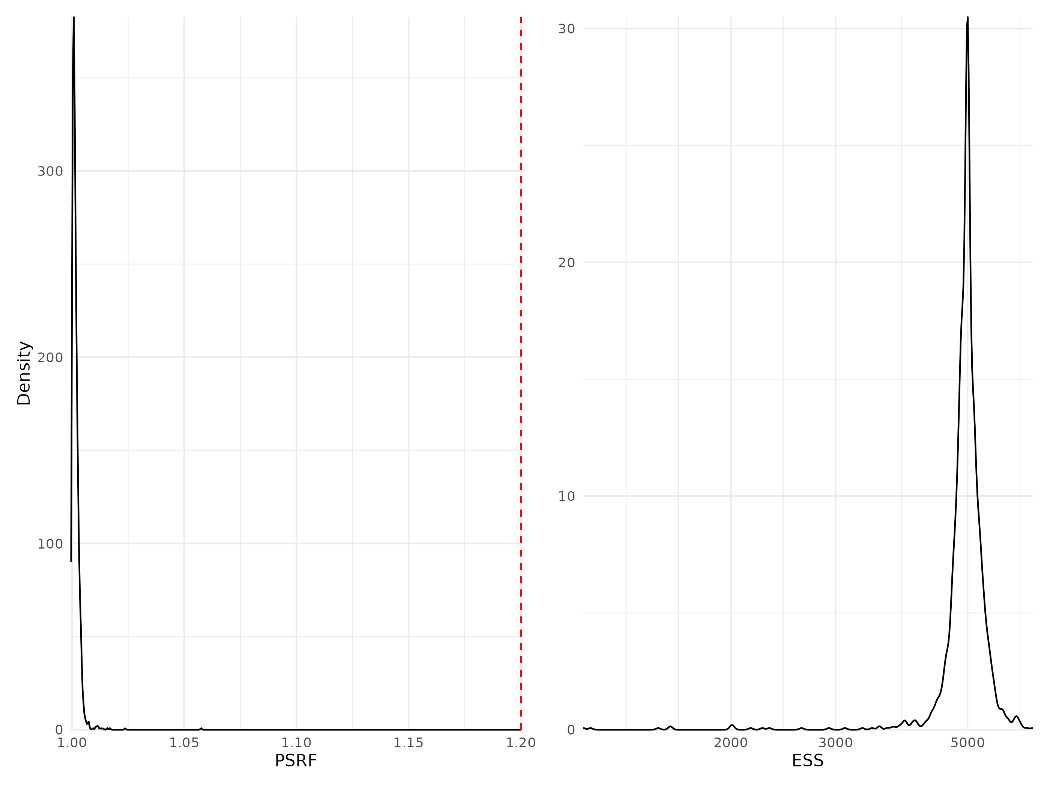

Figure 6: Density curves of potential scale reduction factors (PSRF see Brooks & Gelman (1998); left panel) and effective sample sizes (ESS; right panel) for Beta regression parameters (i.e environmental coefficients) estimated for the benchmark model fitted with presence/absence data. For further details see Fig. S5.

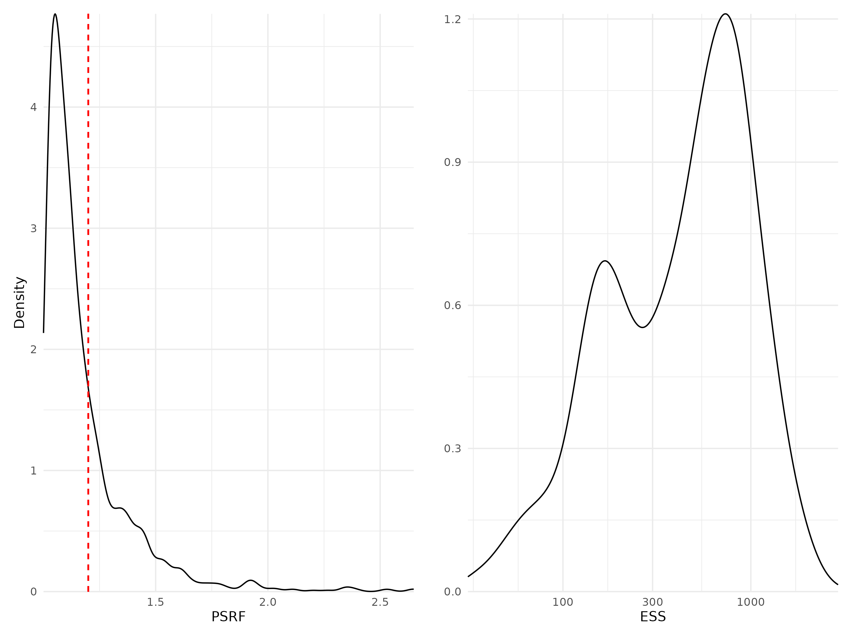

Figure 7: Density curves of potential scale reduction factors (PSRF see Brooks & Gelman (1998); left panel) and effective sample sizes (ESS; right panel) for Beta regression parameters (i.e environmental coefficients) estimated for the phylogeny model fitted with abundance data. For further details see Fig. S5.

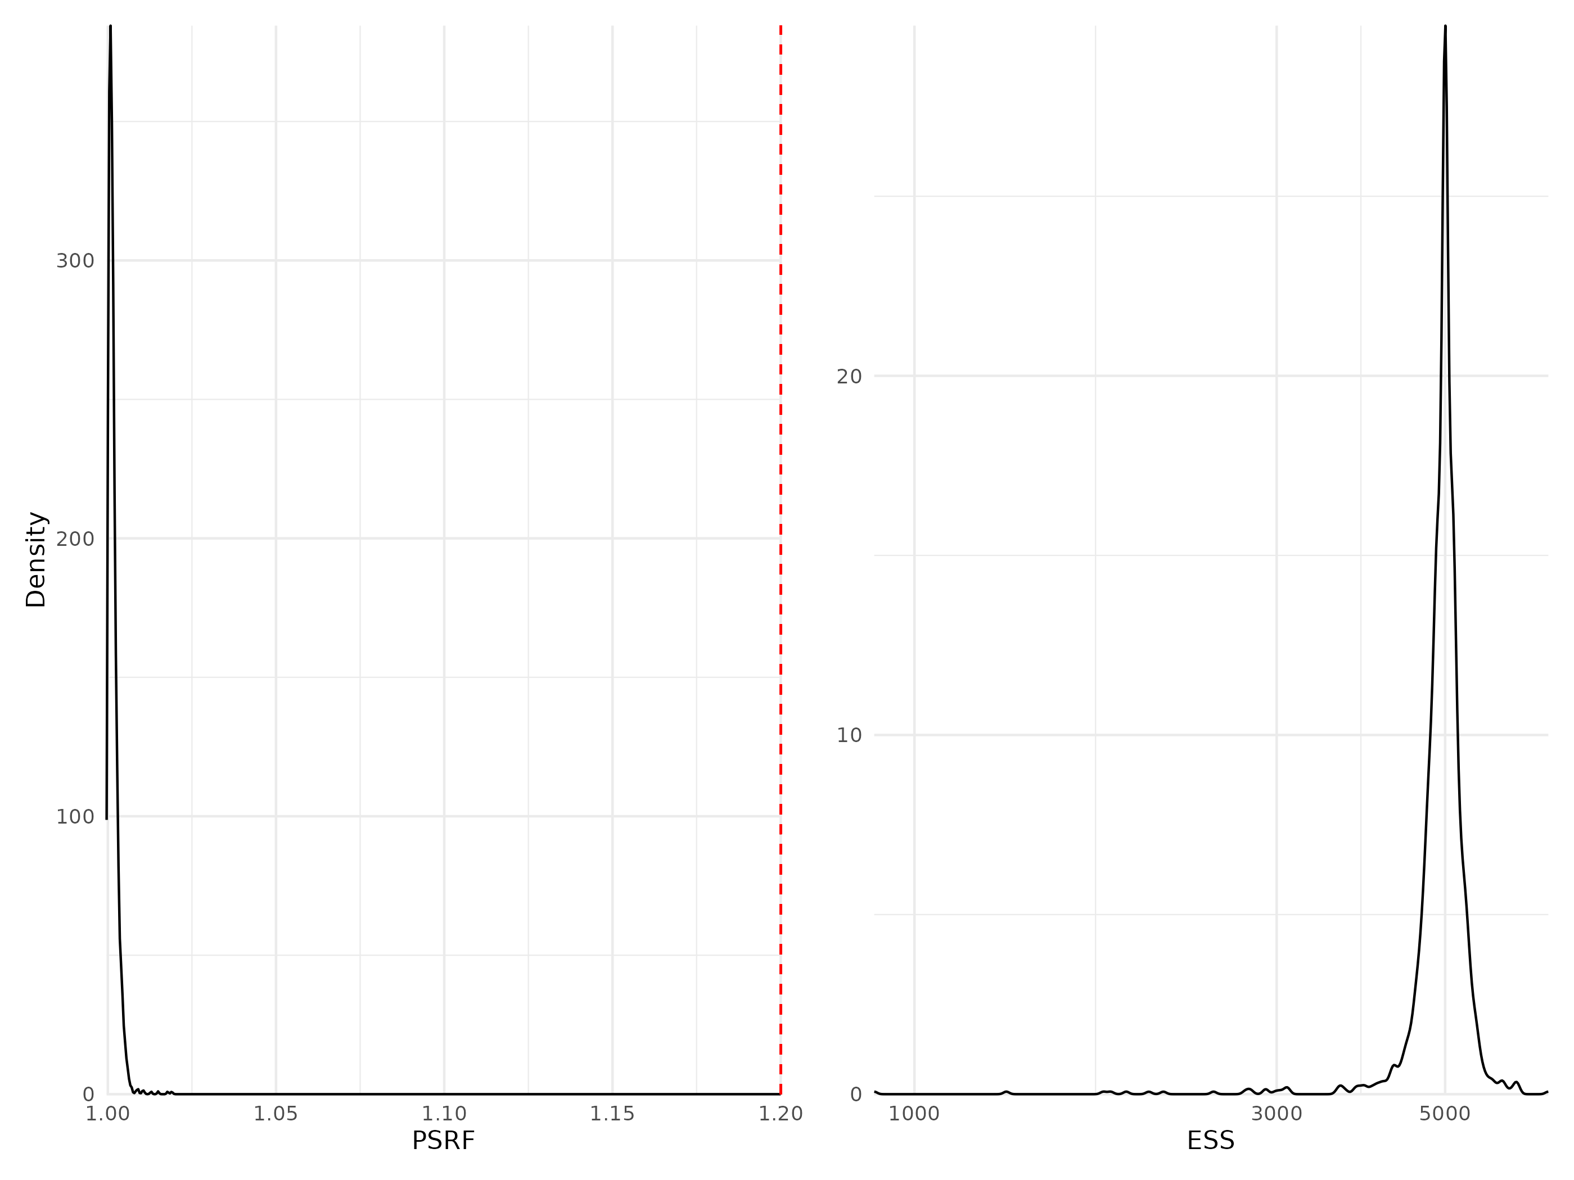

Figure 8: Density curves of potential scale reduction factors (PSRF see Brooks & Gelman (1998); left panel) and effective sample sizes (ESS; right panel) for Beta regression parameters (i.e environmental coefficients) estimated for the phylogeny model fitted with presence/absence data. For further details see Fig. S5.

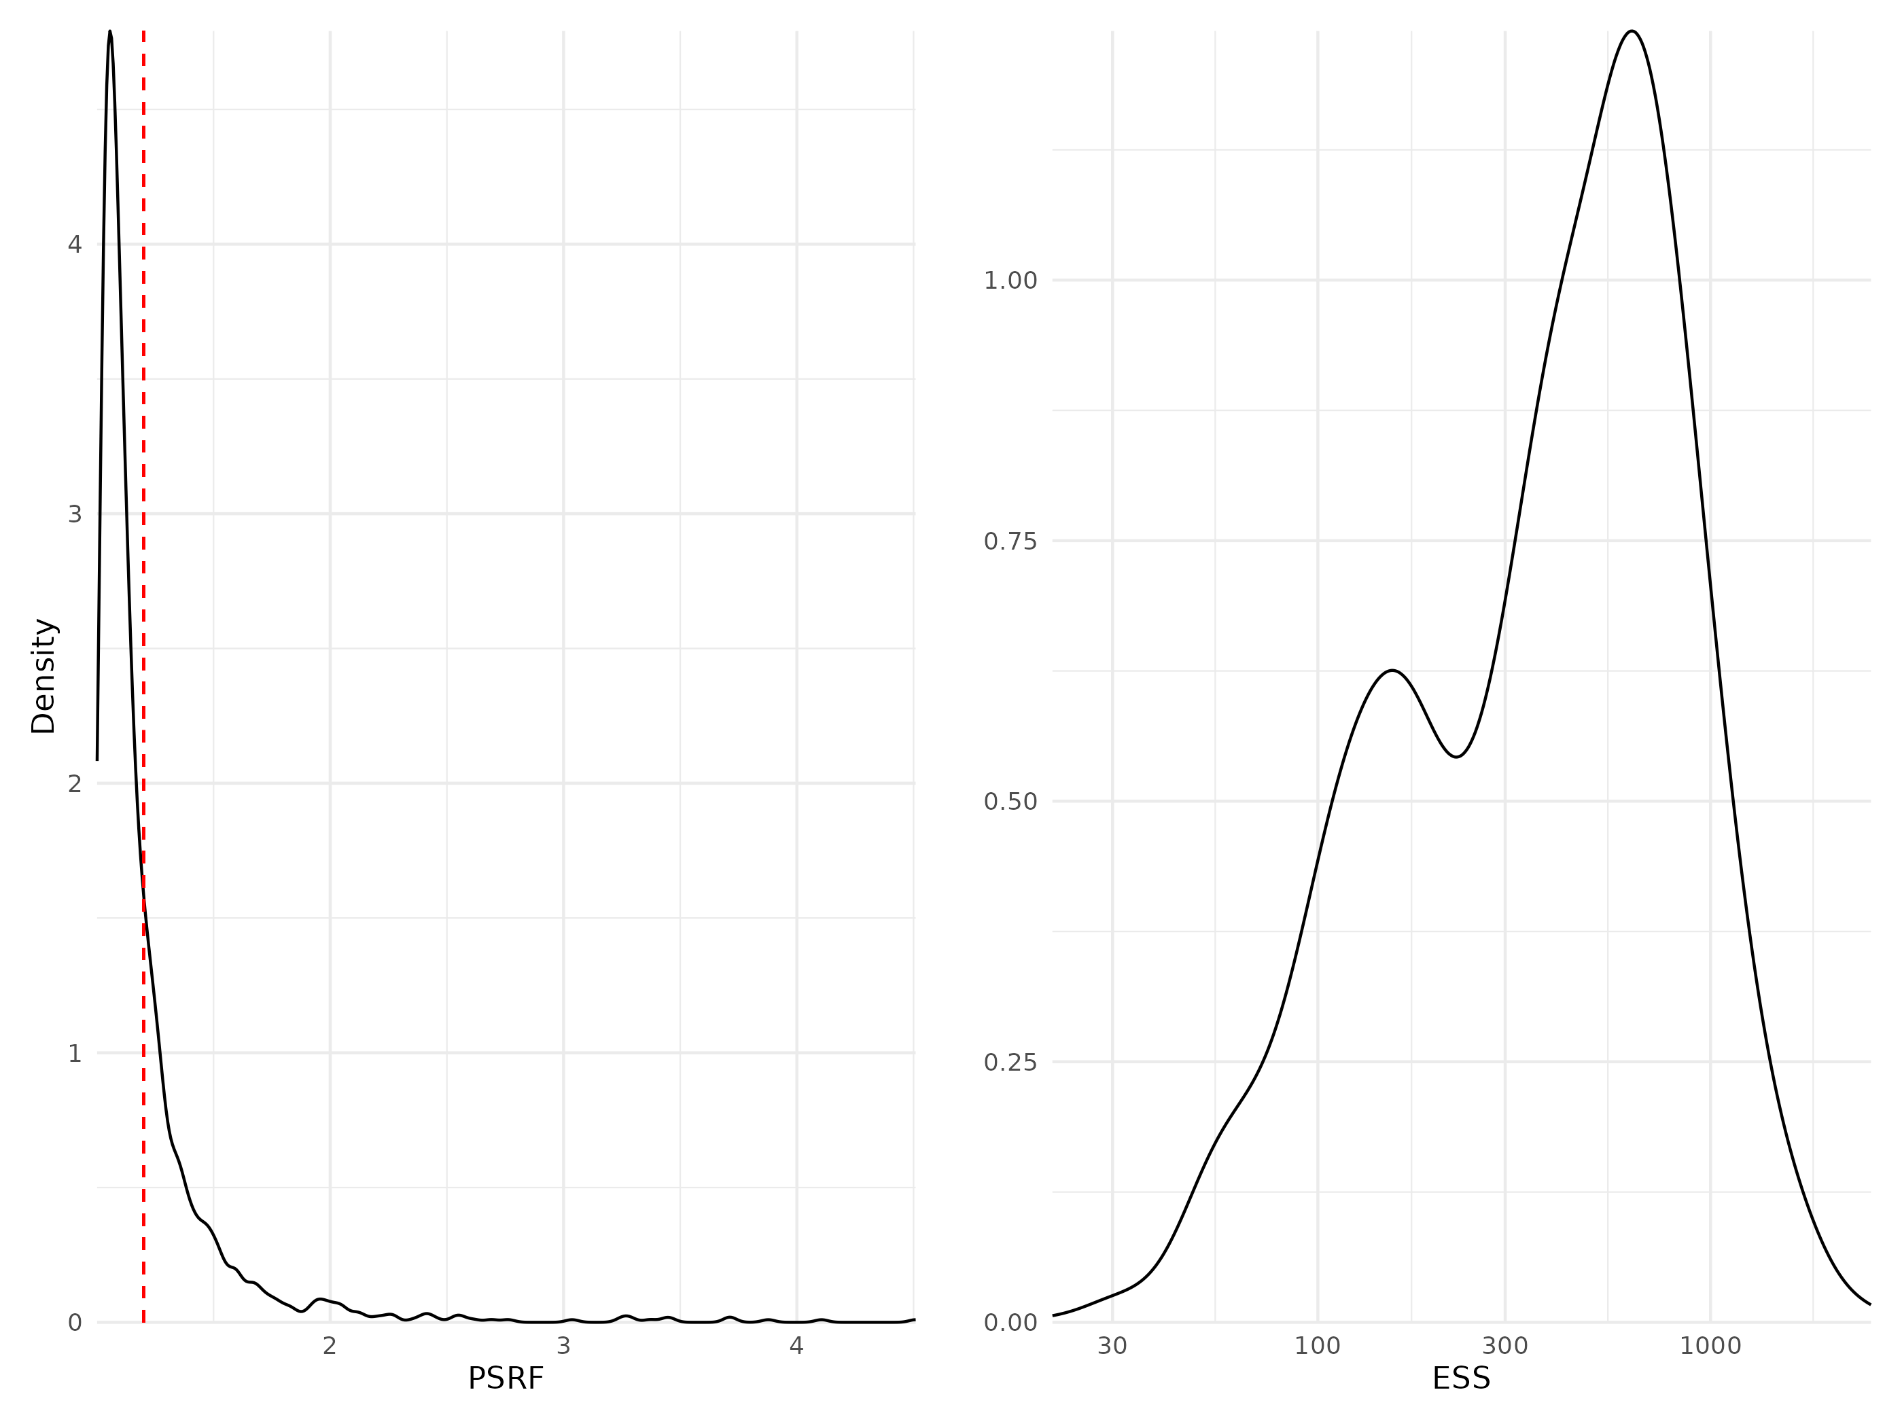

Figure 9: Density curves of potential scale reduction factors (PSRF see Brooks & Gelman (1998); left panel) and effective sample sizes (ESS; right panel) for Beta regression parameters (i.e environmental coefficients) estimated for the traits & phylogeny model fitted with abundance data. For further details see Fig. S5.

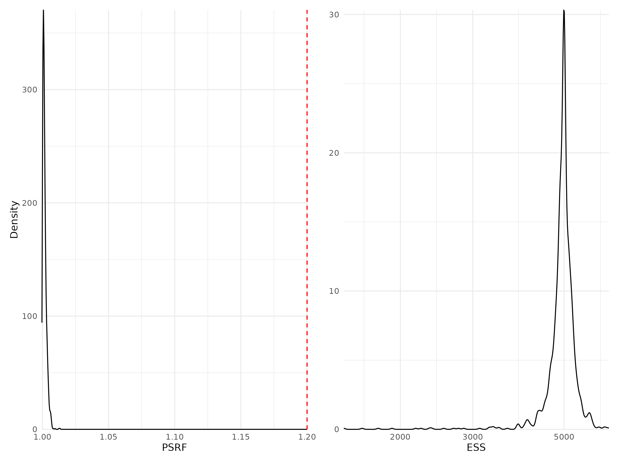

Figure 10: Density curves of potential scale reduction factors (PSRF see Brooks & Gelman (1998); left panel) and effective sample sizes (ESS; right panel) for Beta regression parameters (i.e environmental coefficients) estimated for the traits & phylogeny model fitted with presence/absence data. For further details see Fig. S5.

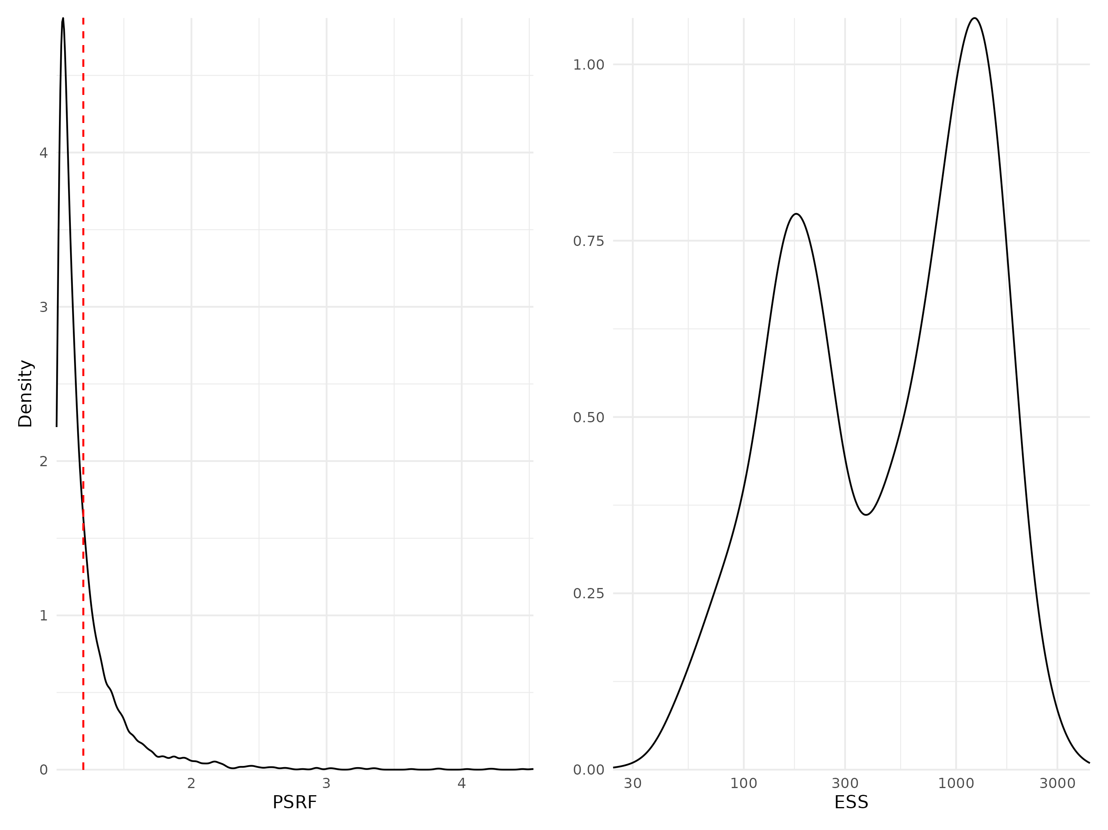

Figure 11: Density curves of potential scale reduction factors (PSRF see Brooks & Gelman (1998); left panel) and effective sample sizes (ESS; right panel) for Beta regression parameters (i.e environmental coefficients) estimated for the whole community model fitted with abundance data. For further details see Fig. S5.

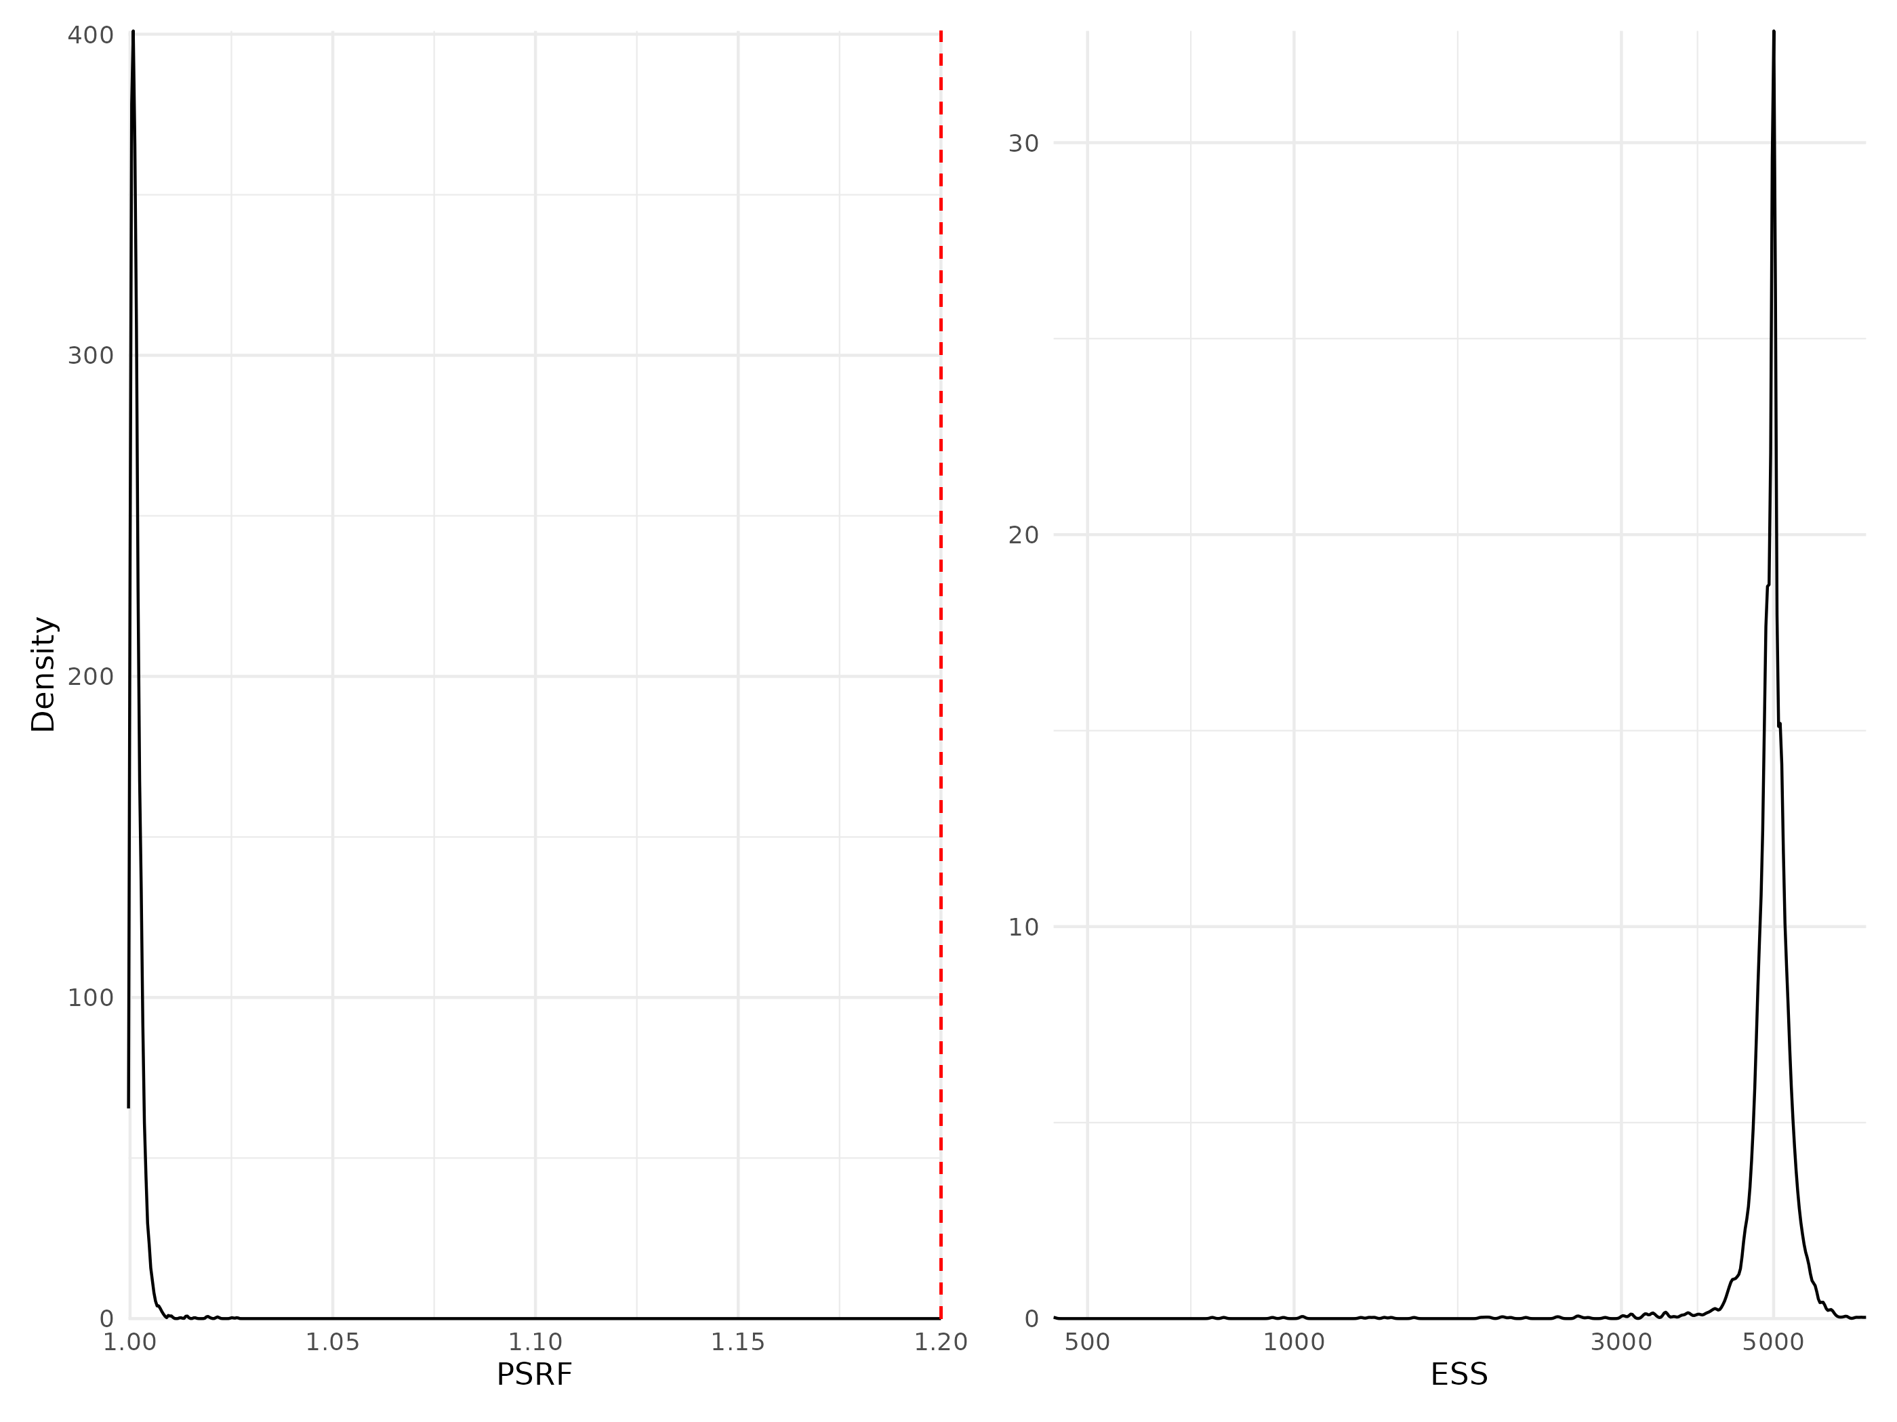

Figure 12: Density curves of potential scale reduction factors (PSRF see Brooks & Gelman (1998); left panel) and effective sample sizes (ESS; right panel) for Beta regression parameters (i.e environmental coefficients) estimated for the whole community model fitted with presence/absence data. For further details see Fig. S5.

## Traits coefficients

Table 2: Potential scale reduction factors (PSRF) and effective sample sizes (ESS) for traits regression parameters (i.e gamma coefficients) estimated for the model including trait information fitted either to abundance or presence-absence data. For further details see Fig. S13 to Fig. S14.

| Model | Data type | Number of coefficients | PSRF (mean $±$ sd) | ESS (mean $±$ sd) |
| --- | --- | --- | --- | --- |
| Traits & Phylogeny | Abundance | 60 | 1.08 $±$ 0.092 | 1232 $±$ 1209 |
| Traits & Phylogeny | Presence/Absence | 60 | 1.00 $±$ 0.001 | 13227 $±$ 1897 |

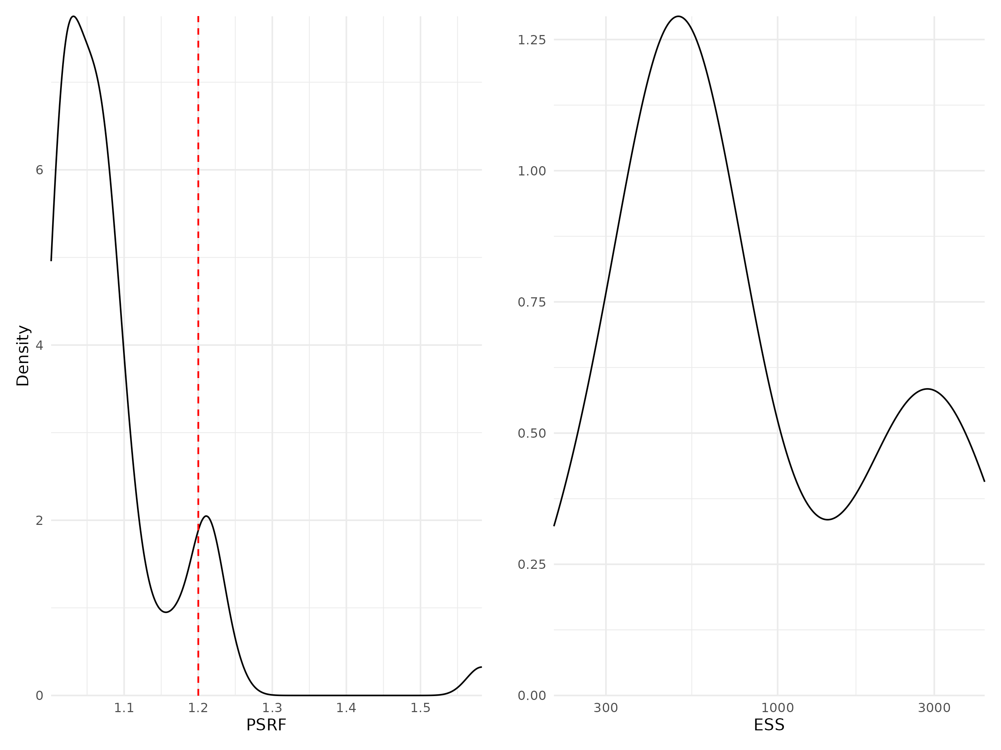

Figure 13: Density curves of potential scale reduction factors (PSRF see Brooks & Gelman (1998); left panel) and effective sample sizes (ESS; right panel) for Gamma regression parameters (i.e coefficients associated with trait-environment interactions, modeling how species traits influence their niches) estimated for the traits & phylogeny model fitted with abundance data. For further details see Fig. S5.

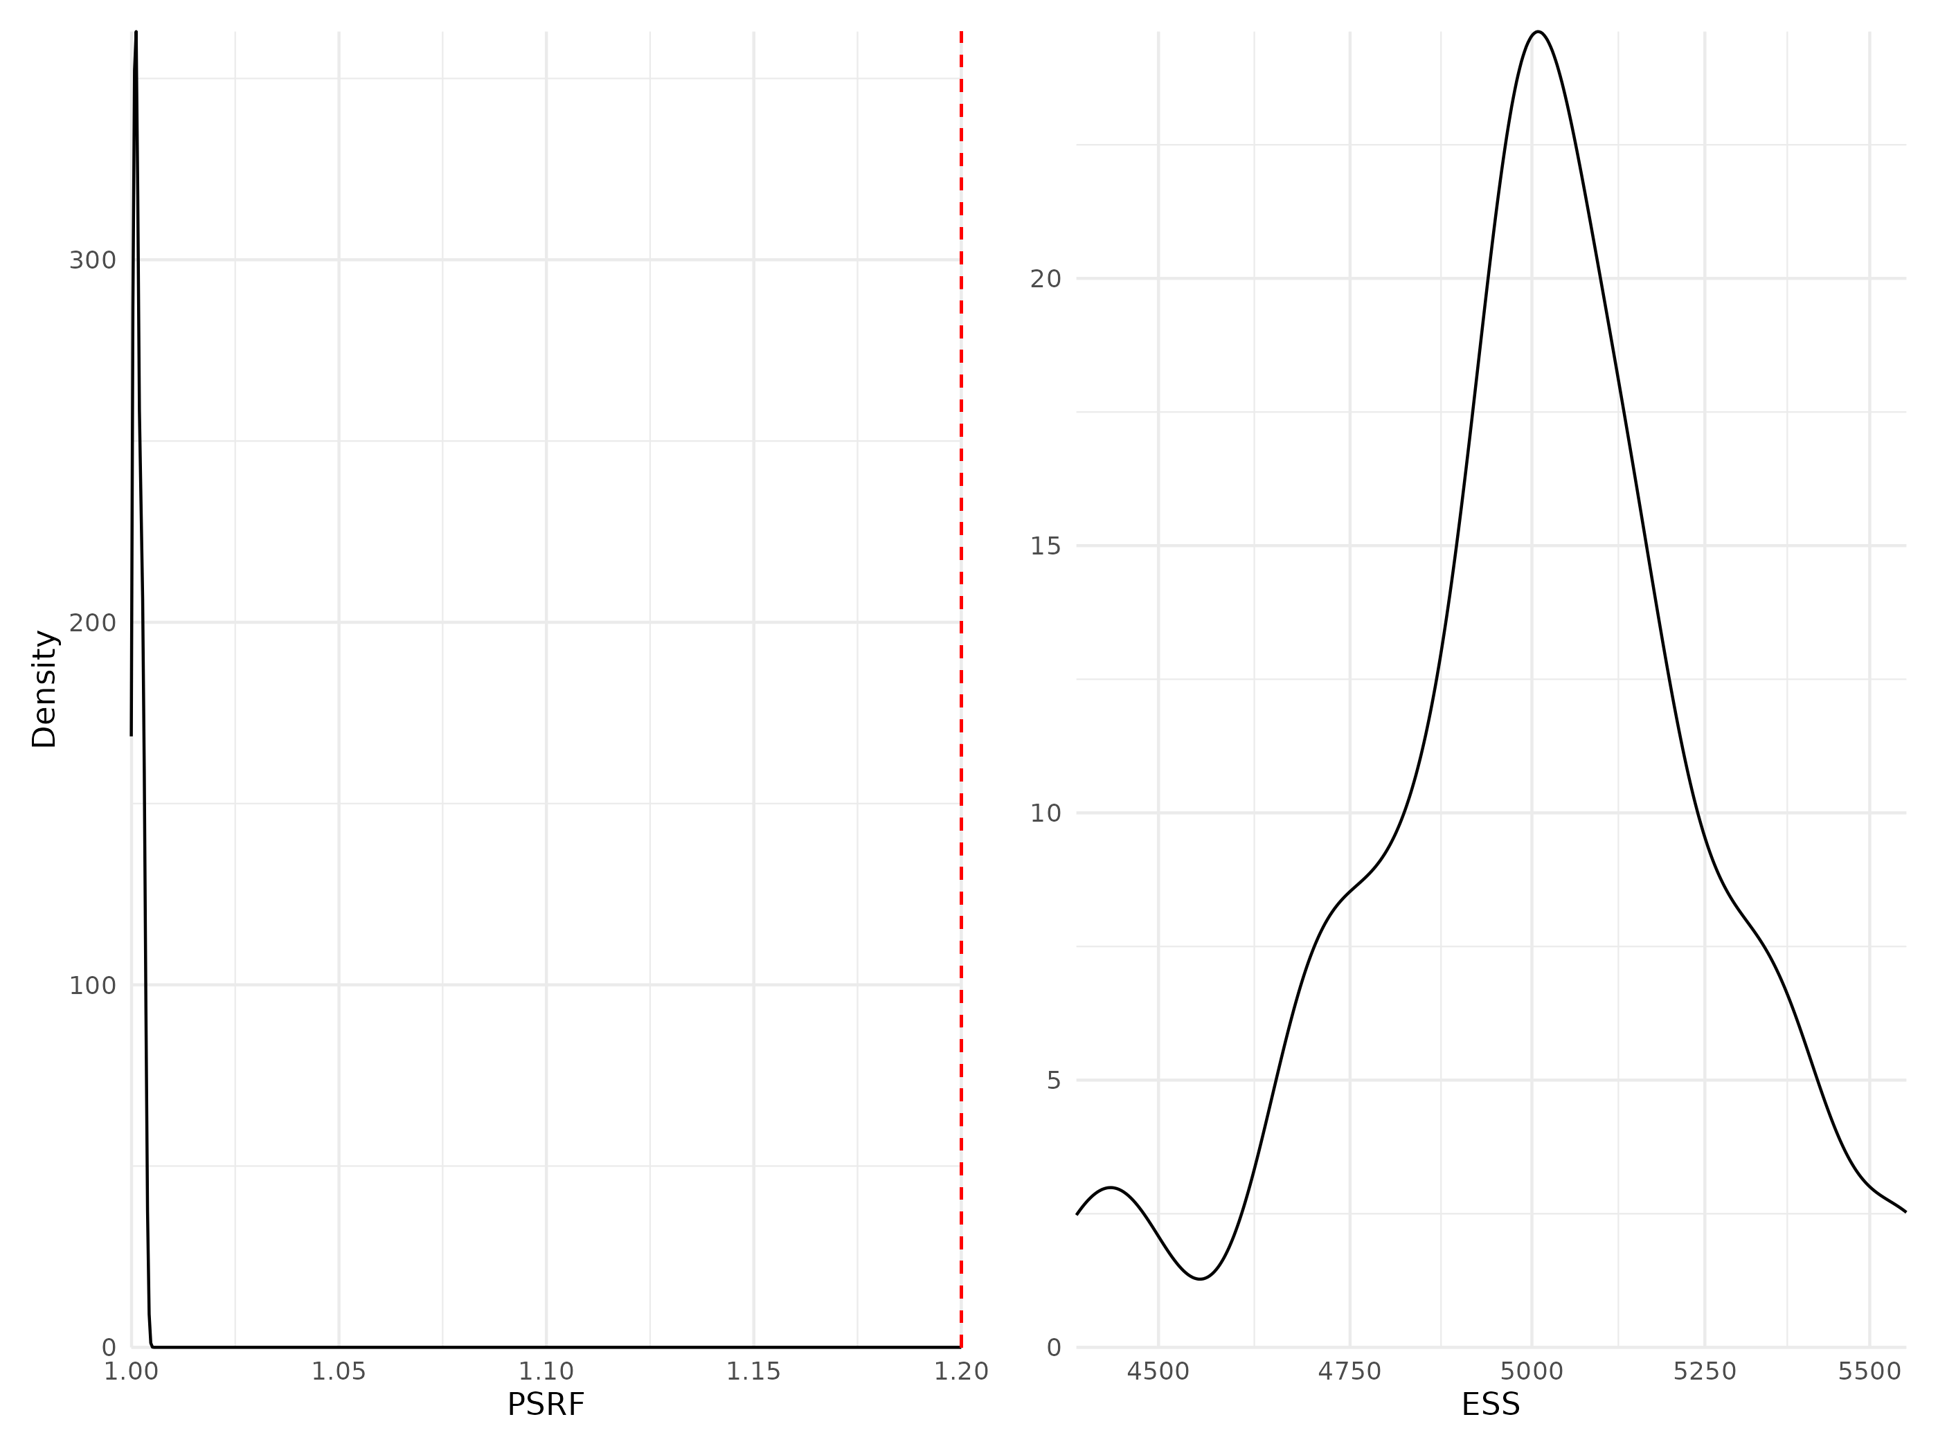

Figure 14: Density curves of potential scale reduction factors (PSRF see Brooks & Gelman (1998); left panel) and effective sample sizes (ESS; right panel) for Gamma regression parameters (i.e coefficients associated with trait-environment interactions, modeling how species traits influence their niches) estimated for the traits & phylogeny model fitted with presence/absence data. For further details see Fig. S5.

## Phylogeny coefficients

Table 3: Potential scale reduction factors (PSRF) and effective sample sizes (ESS) for rho regression parameters (i.e phylogeny coefficient) estimated for the two models including phylogenetic information (TrPh and Ph).

| Model | Data type | Number of coefficients | PSRF | ESS |
| --- | --- | --- | --- | --- |
| Phylogeny | Abundance | 1 | 1.07 | 649 |
| Phylogeny | Presence/Absence | 1 | 1.00 | 9349 |
| Traits & Phylogeny | Abundance | 1 | 1.15 | 757 |
| Traits & Phylogeny | Presence/Absence | 1 | 1.00 | 5000 |

## Link between model convergence and species response curves

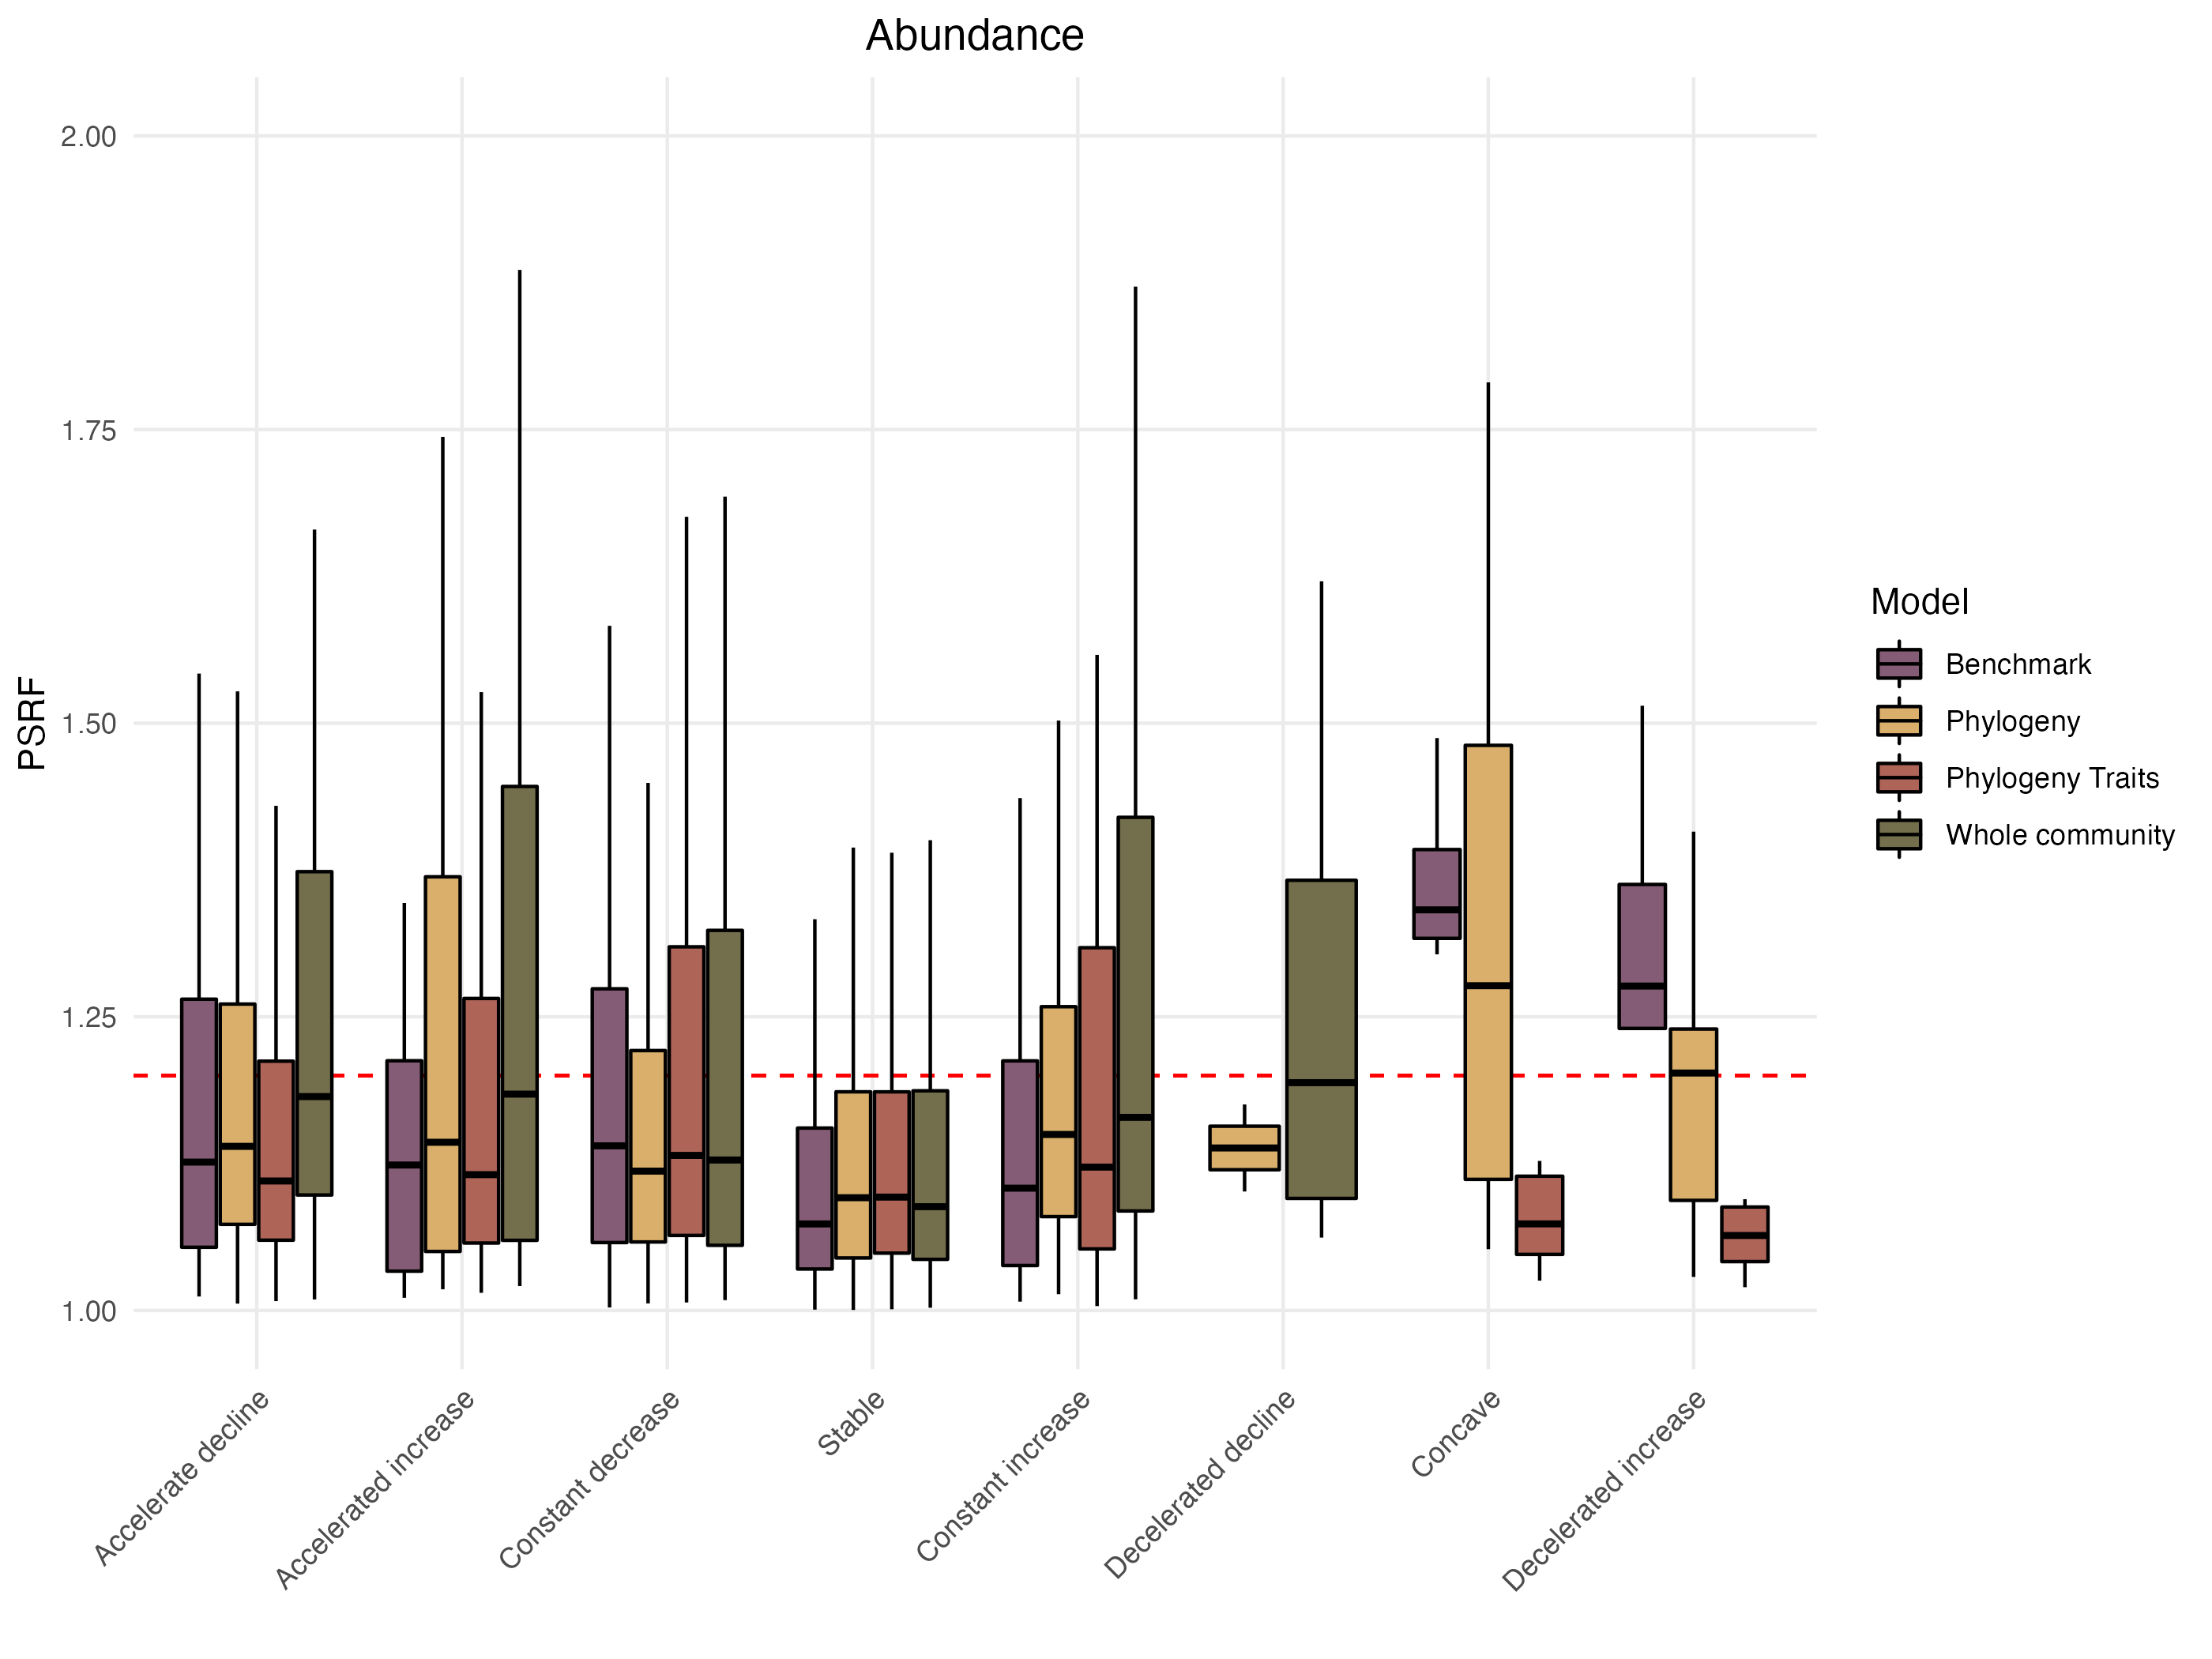

Figure 15: Distribution of the Potential scale reduction factors (PSRF) as a function of the different shapes of the response curves classified following the methodology proposed by Rigal et al. (2020) methods (see section “Assessing model performance and interpretability” for more details on the calculation methodology). Results for models fitted with abundance data.

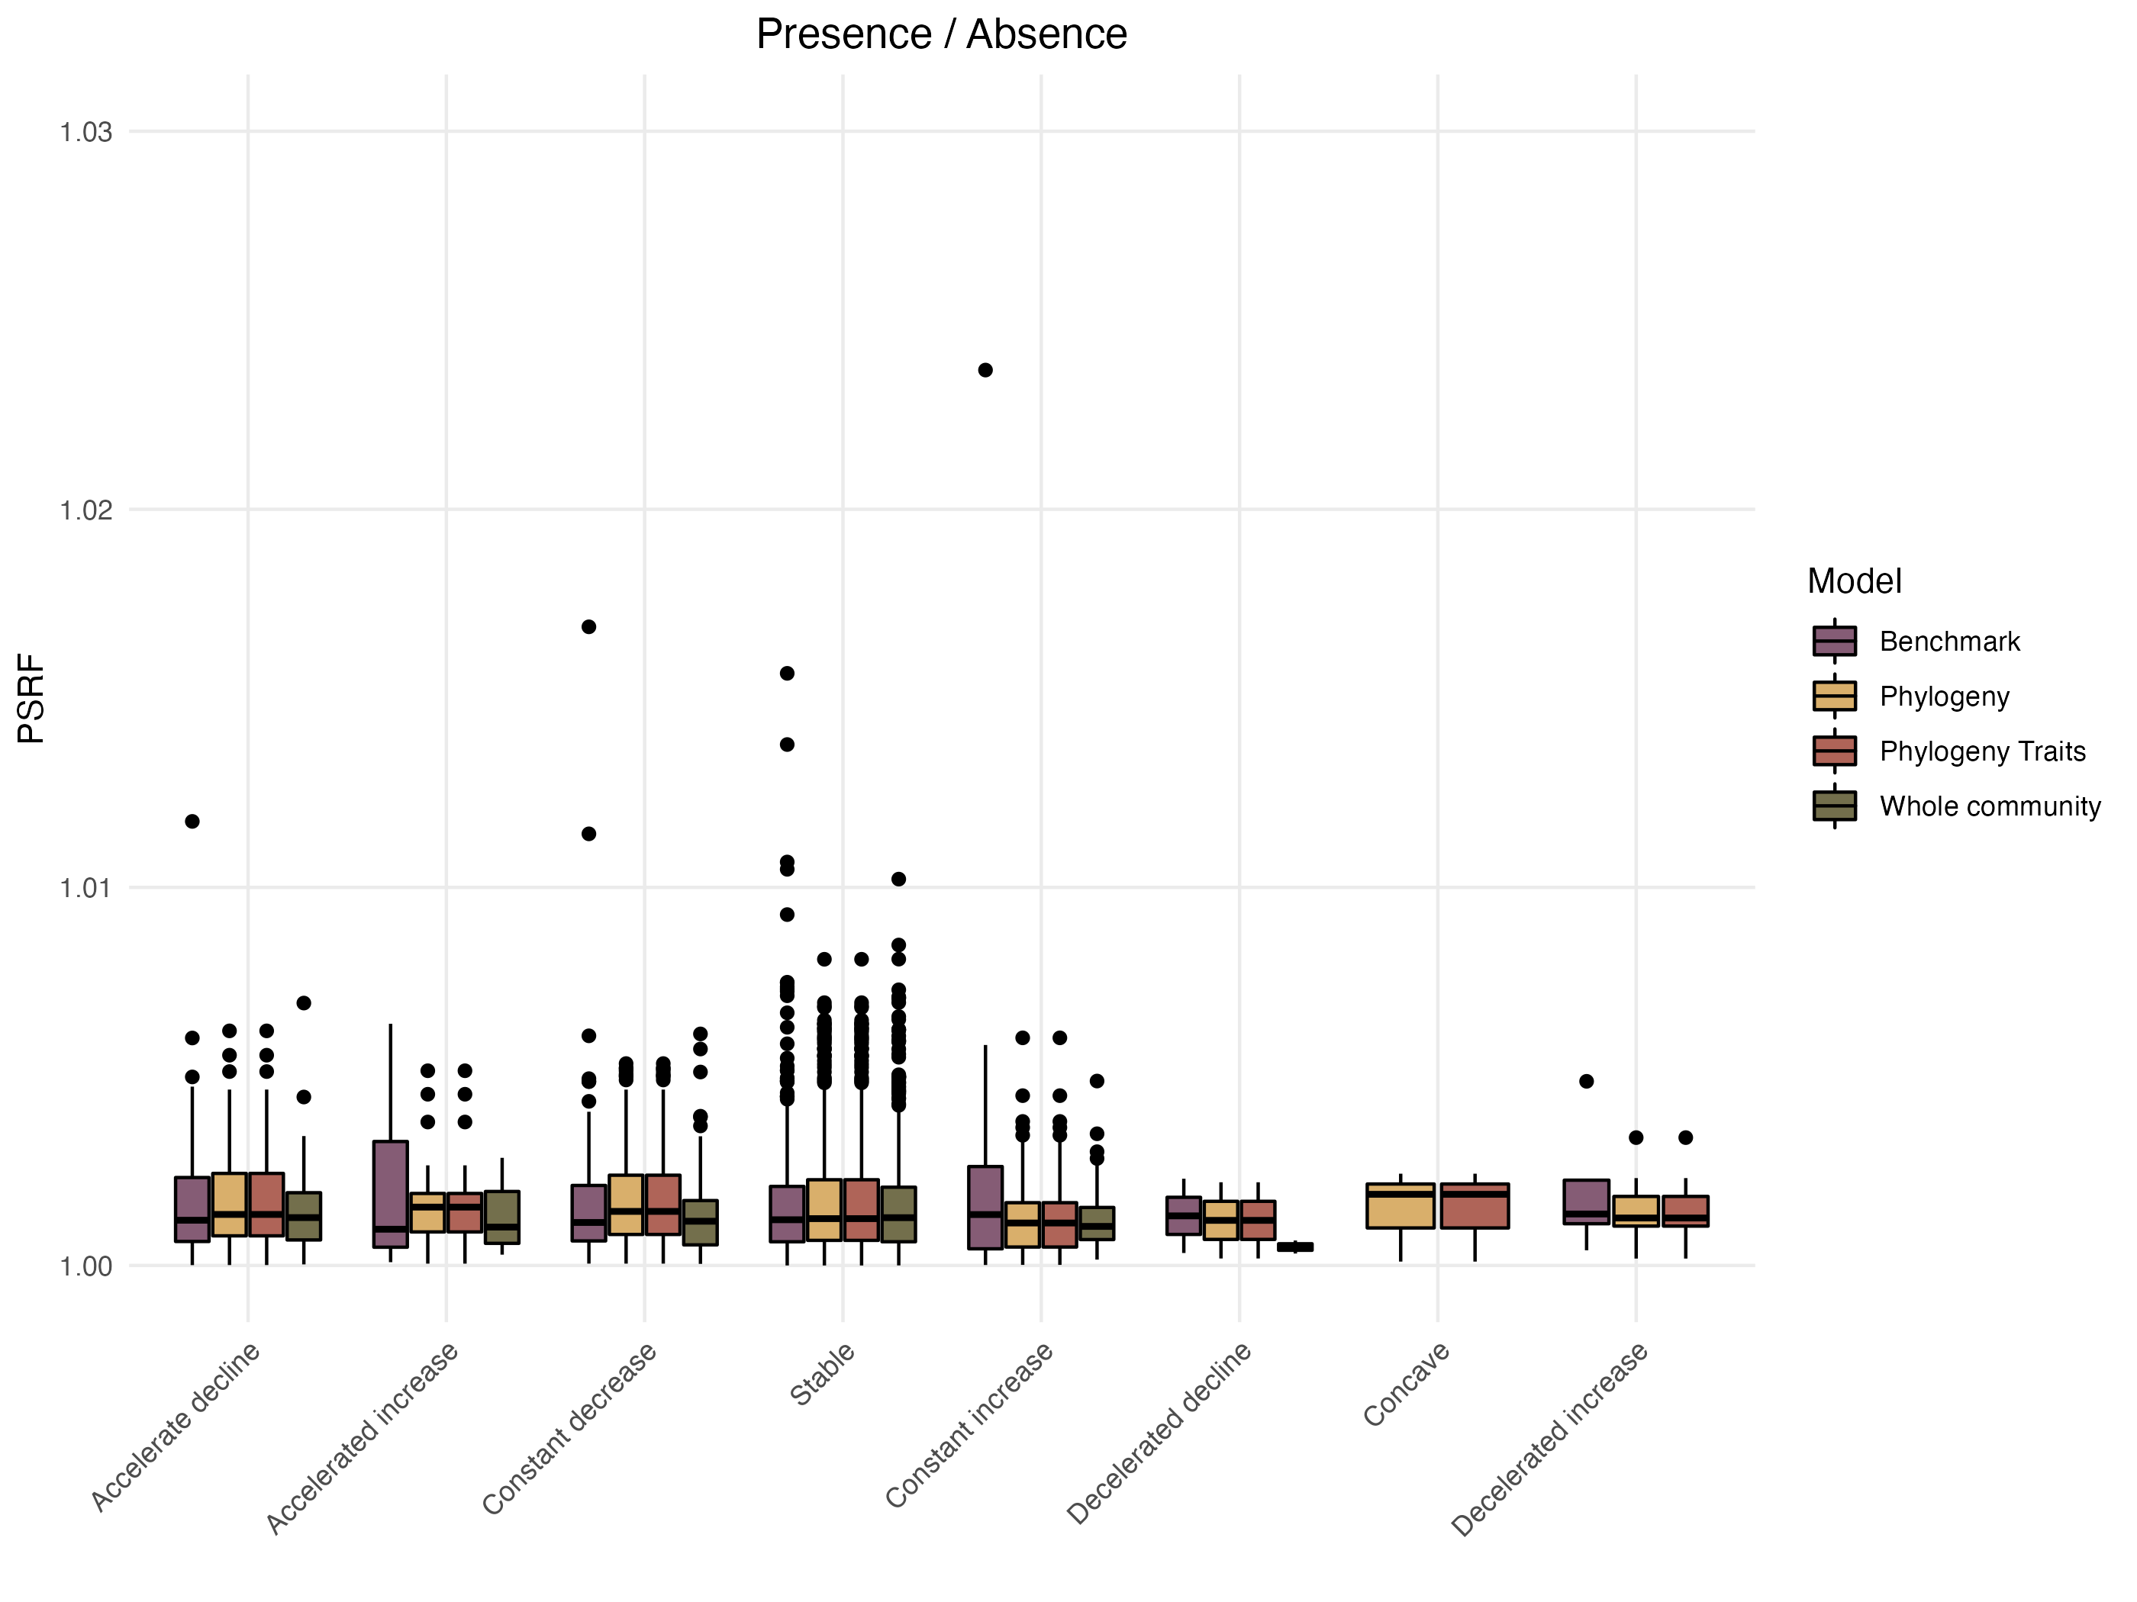

Figure 16: Distribution of the Potential scale reduction factors (PSRF) as a function of the different shapes of the response curves classified following the methodology proposed by Rigal et al. (2020) methods (see section “Assessing model performance and interpretability” section for more details on the calculation methodology). Results for models fitted with presence/absence data.

# Appendix C - Complementary Results

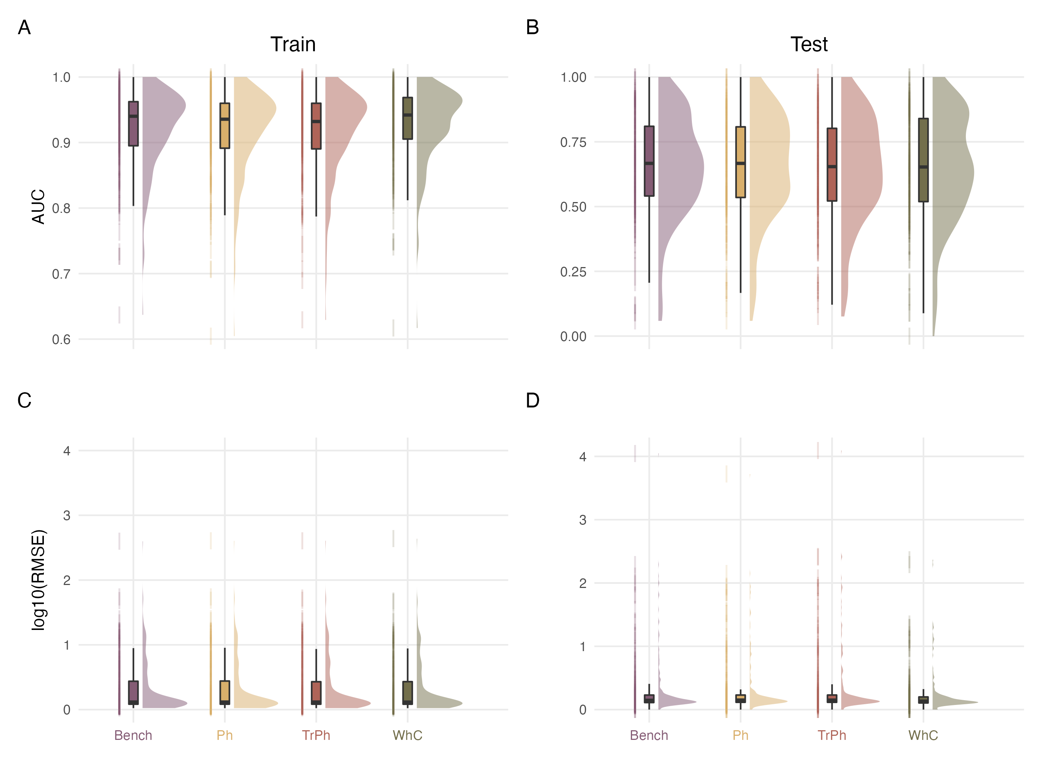

Figure 17: Comparison of explanatory (left column; Train set) and predictive (right column; Test set) performance capacities of the different model structures fitted on presence/absence (top panels) or abundance (bottom panels) data

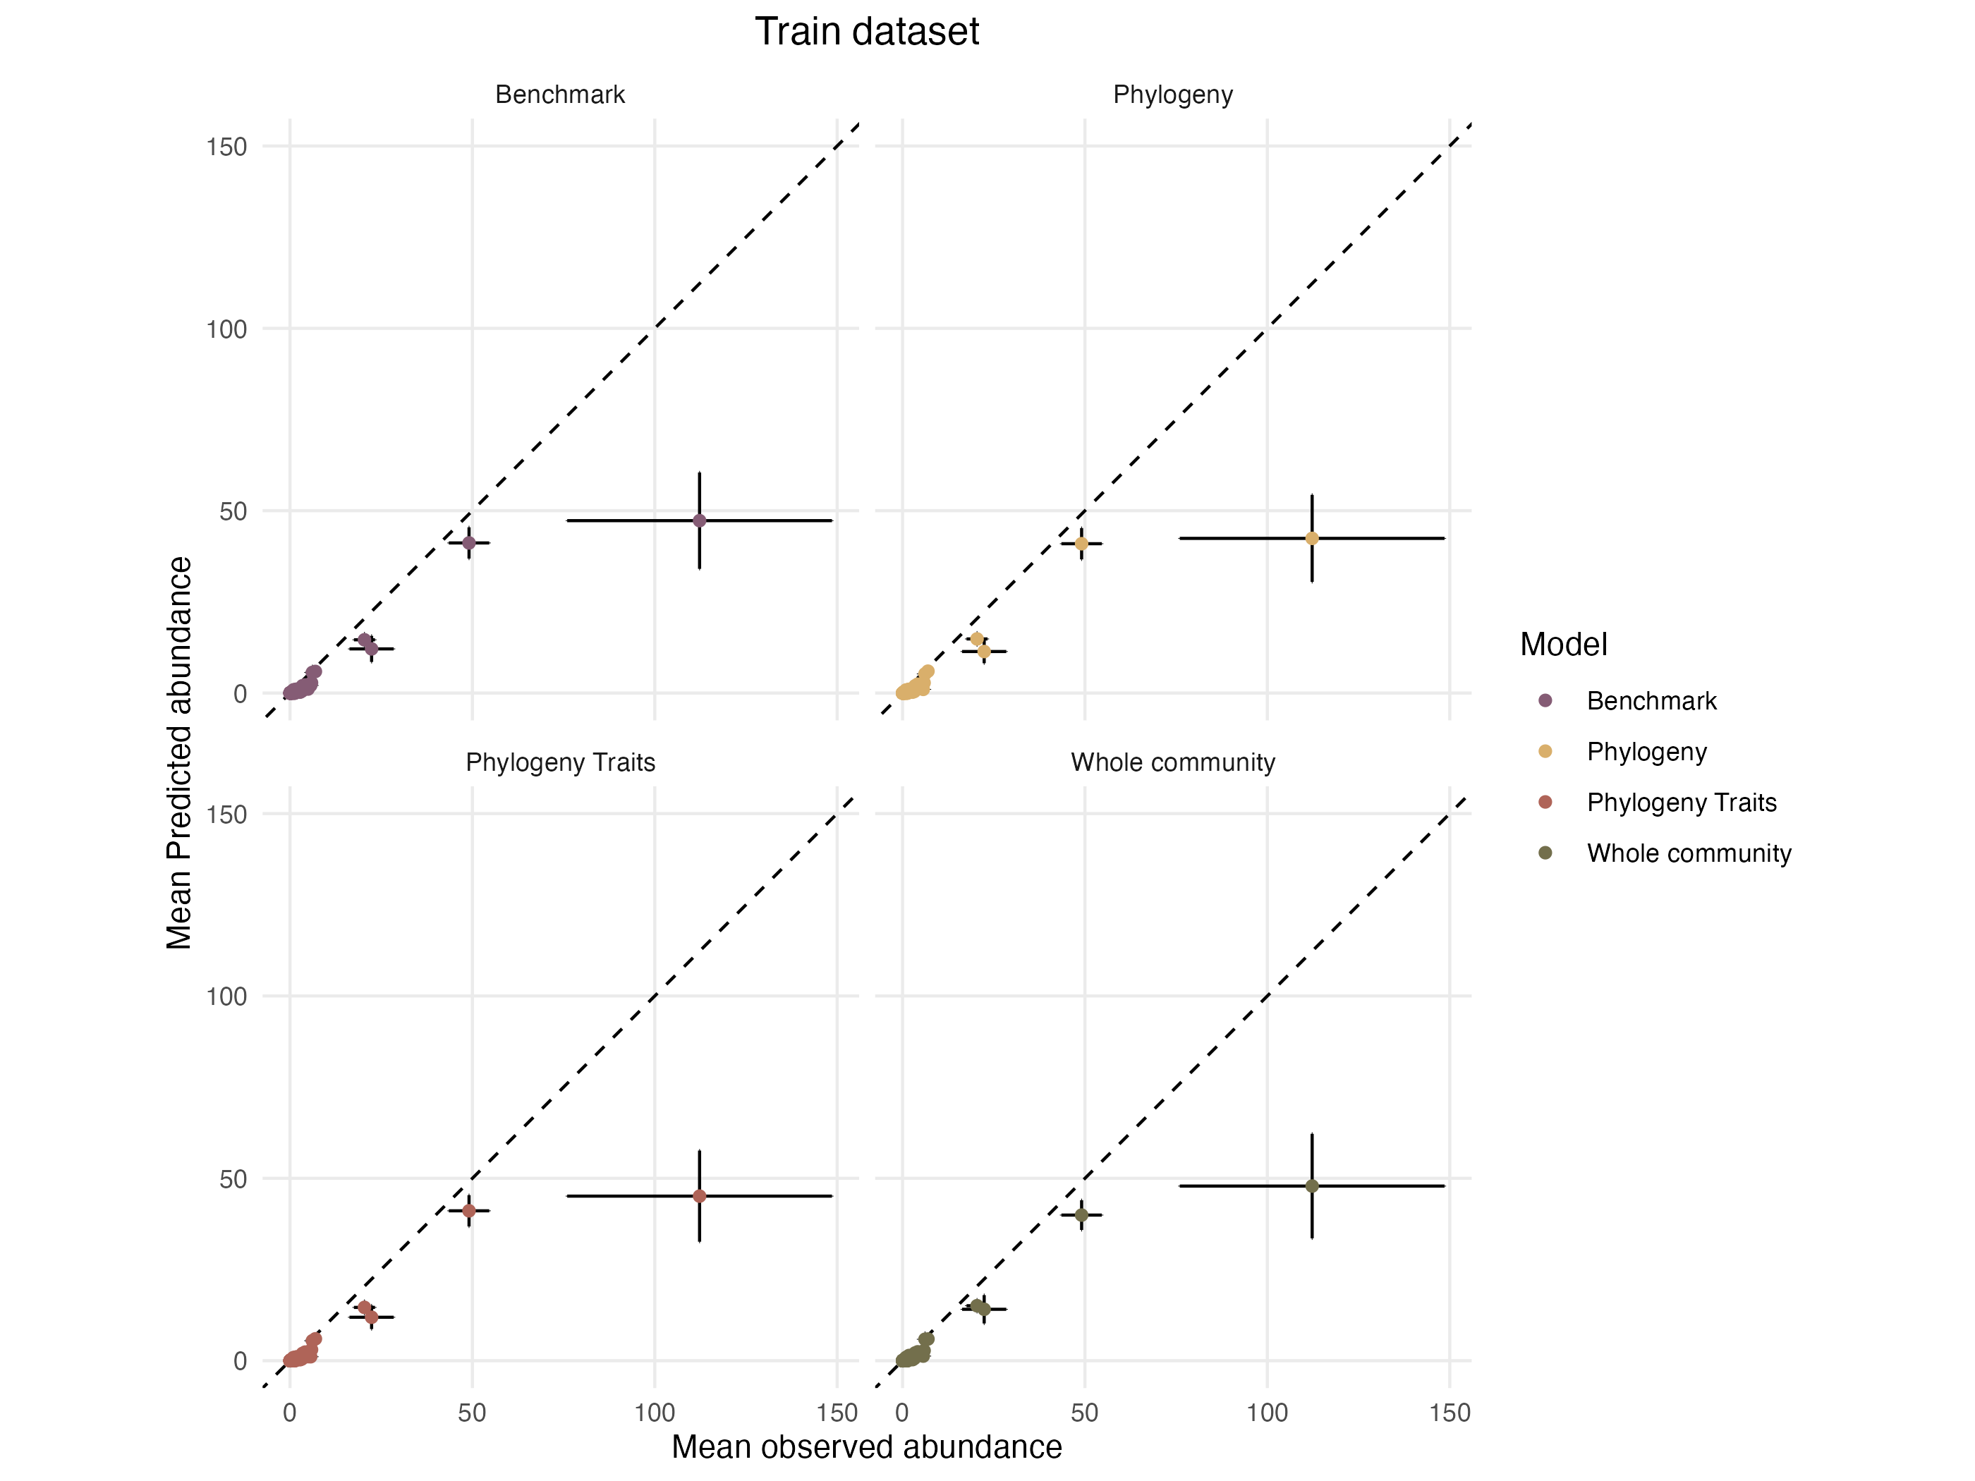

Figure 18: Mean predicted abundances as a function of mean observed abundances in the training dataset. Each species is represented by a dot, the error bars on each point indicates the standard error around the mean relatively to each axis.

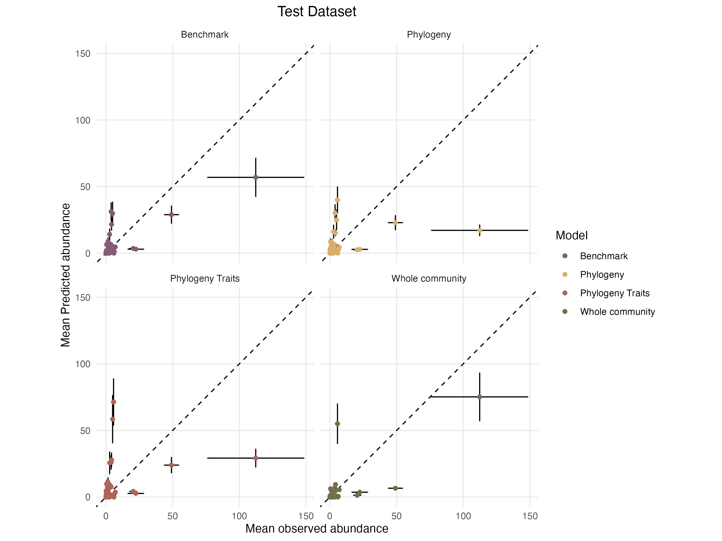

Figure 19: Mean predicted abundances as a function of mean observed abundances in the training dataset. Each species is represented by a dot, the error bars on each point indicates the standard error around the mean relatively to each axis.

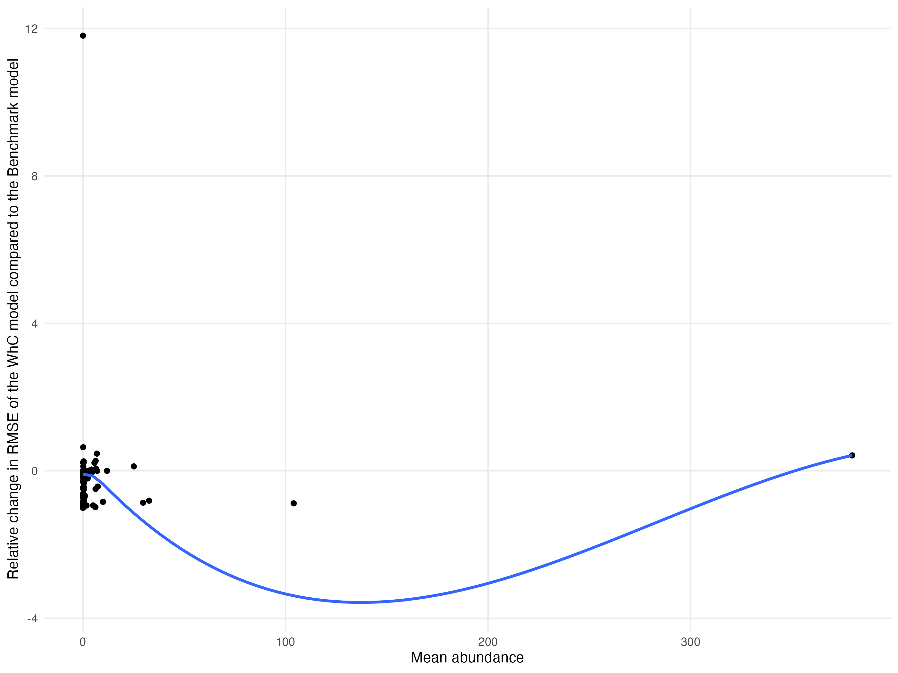

Figure 20: Relationship between the relative improvement in RMSE for the WhC model compared to Bench model and the mean abundance of species in the training dataset. Each dot represents a species. The blue line represents a fit obtained from a LOESS regression.

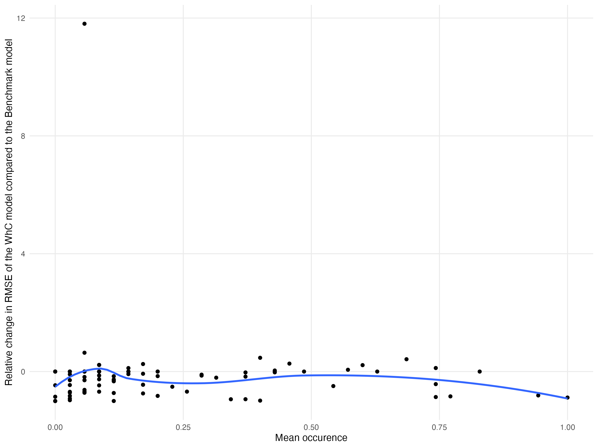

Figure 21: Relationship between the relative improvement in RMSE for the WhC model compared to Bench model and the mean occurrence of species in the training dataset. Each dot represents a species. The blue line represents a fit obtained from a LOESS regression.

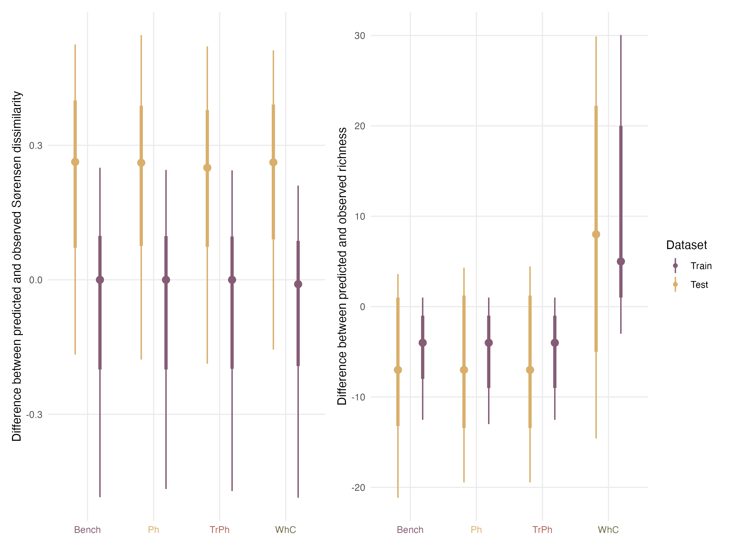

Figure 22: Comparison of model performances with regards to their ability to predict community structures when fitted with presence/absence data for the train (purple) and test (yellow) dataset. The left column indicates for each model the difference between the pairwise dissimilarities computed on the observed assemblages and those computed on the predicted community. The right column presents the differences in species richness between the observed and predicted assemblages.

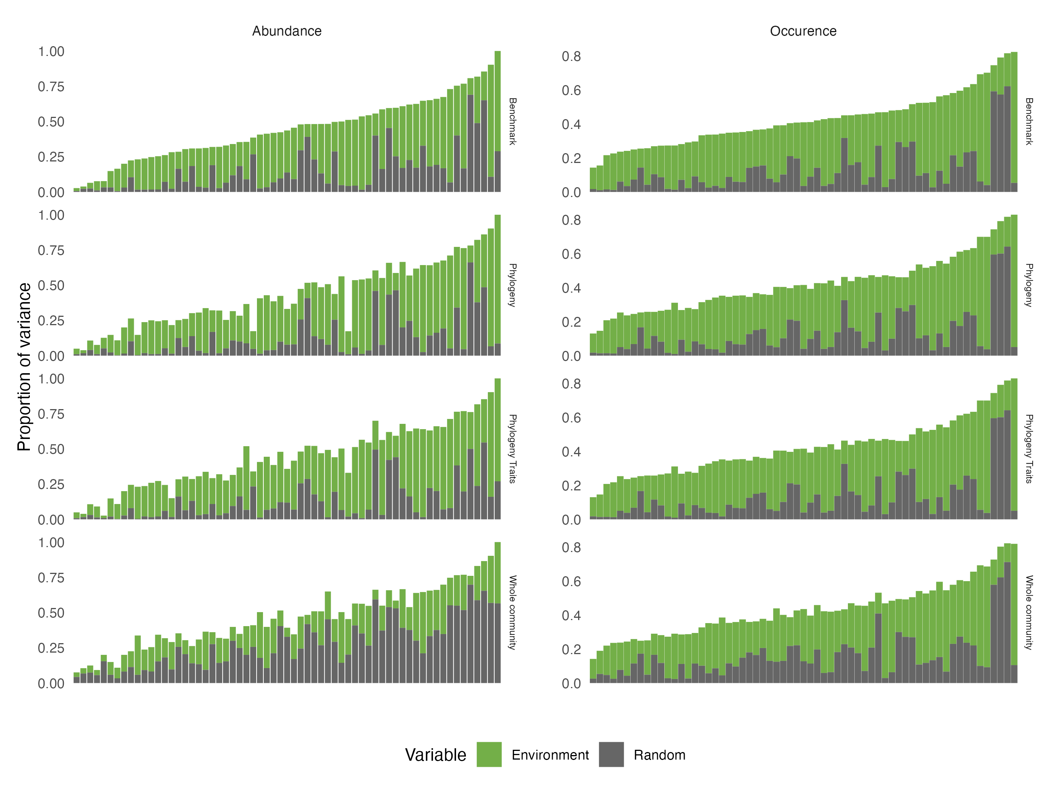

Figure 23: Comparison across the four alternative model structures of the total amount of variance of each species (along the x-axis) that is explained by (1) the environmental variables (Environment) and (2) the three random effects (Random). Results are presented for the models fitted with abundance (left) and presence/absence (right) data. Species are ordered by increasing order of total variance explained by the benchmark model.

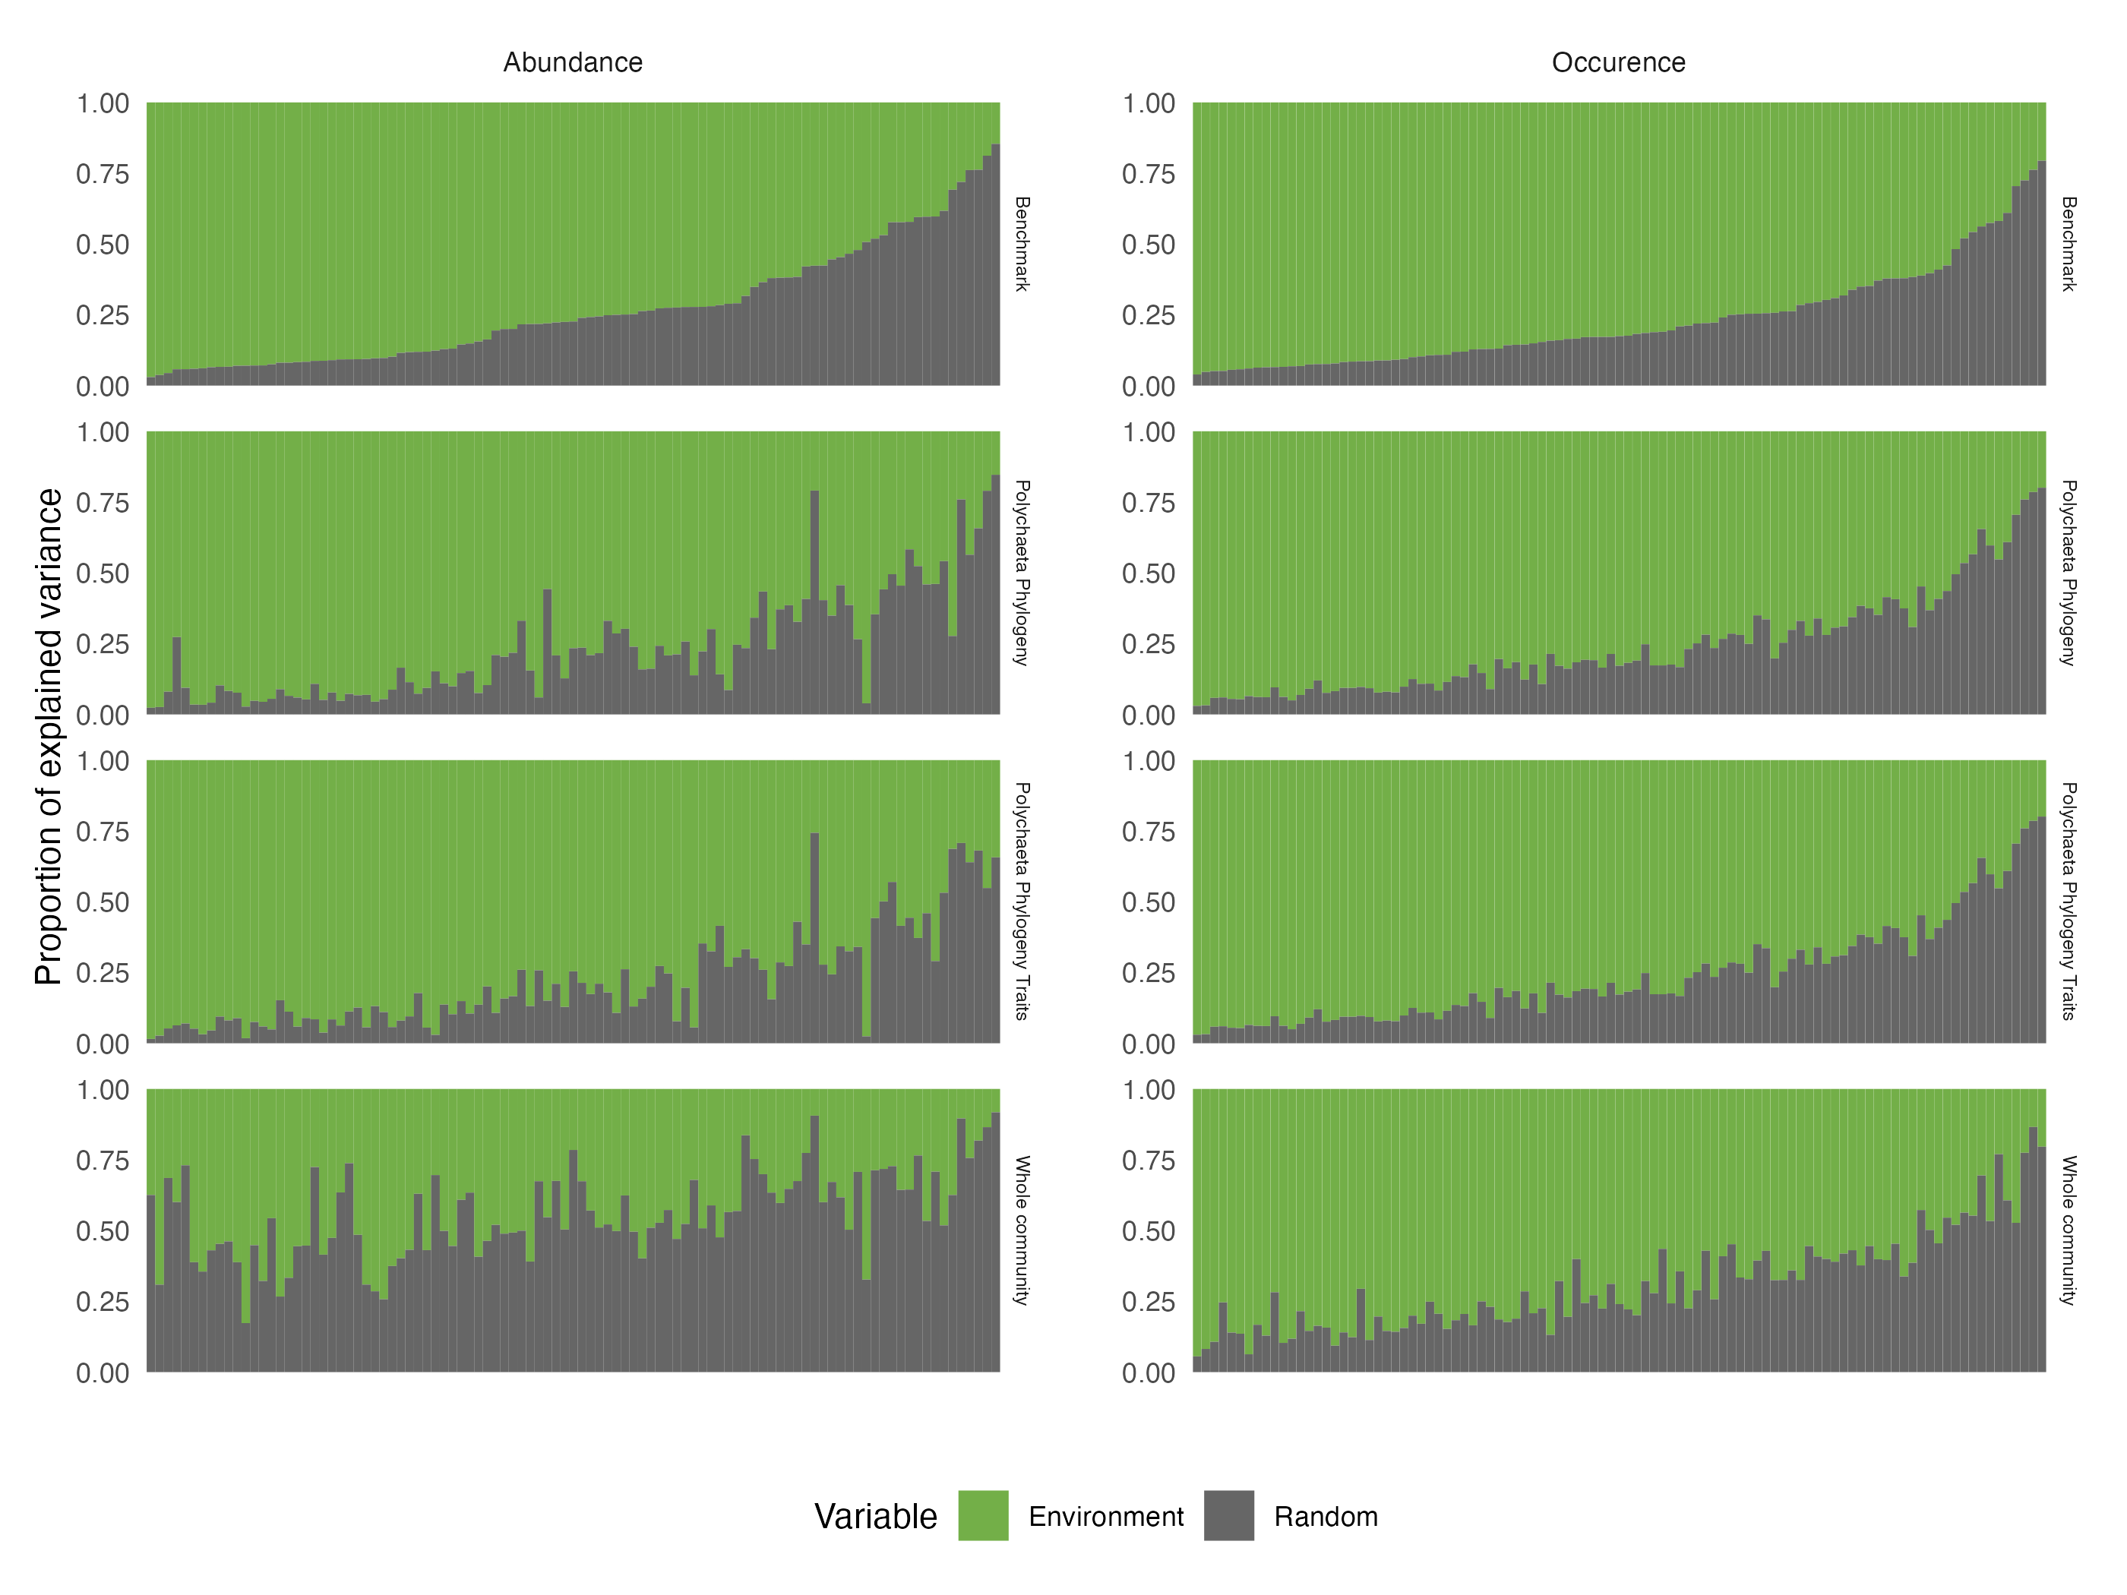

Figure 24: Comparison across the four alternative model structures of the fraction of variance of each species (along the x-axis) that is explained by (1) the environmental variables (Environment) and (2) the three random effects (Random). Results are presented for the models fitted with abundance (left) and presence/absence (right) data. Species are ordered by decreasing order of variance explained by the environment for the benchmark model.

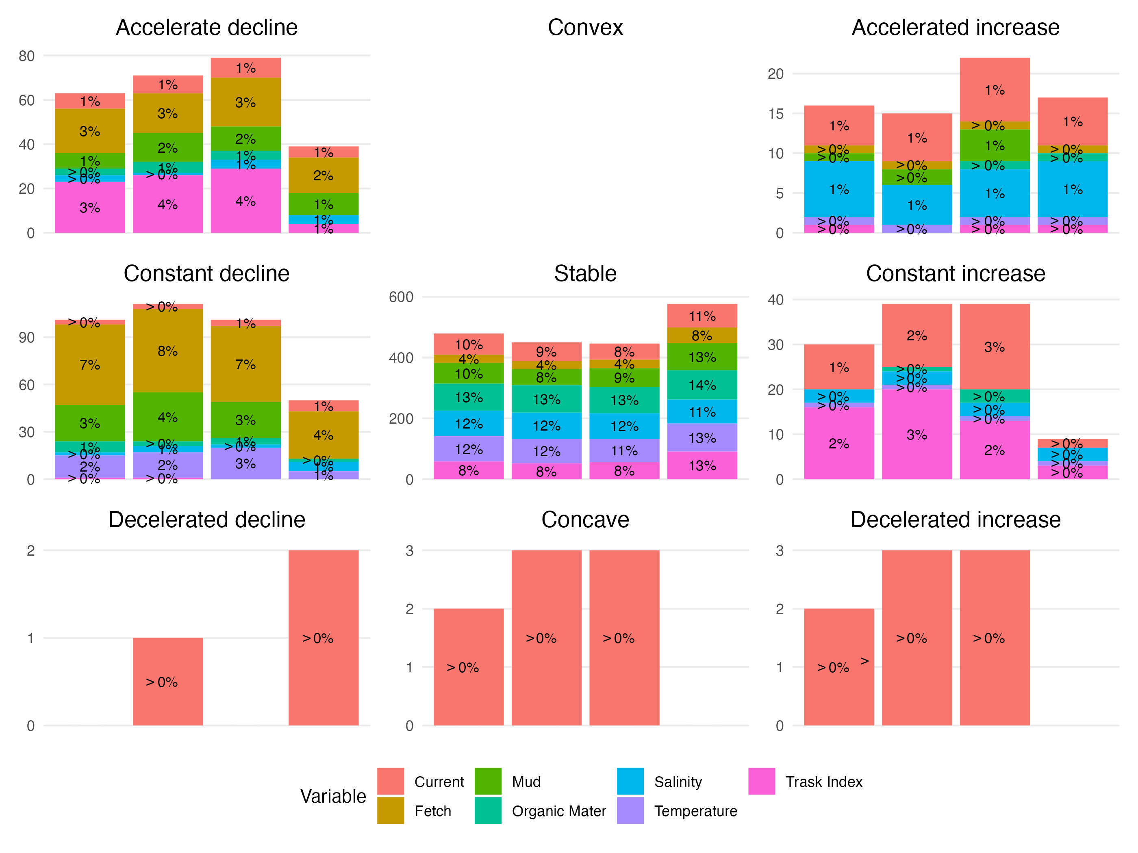

Figure 25: Same figure as Fig. 4 in the main text for models fitted on abundance data. Number (y-axis) and proportion (indicated above individual bars, rounded to the nearest integer) of response curves (i.e. one for each species-predictor combination) according to the nomenclature (nine shapes highlighted by the black curve in each panel) defined by Rigal et al. (2020). Results are presented for different model structures: from left to right the Benchmark (Bench), the phylogeny (Ph), the traits & phylogeny (TrPh), and the whole community (WhC) models. Each bar is coloured by the relative contribution of each environmental covariate to this particular shape. For illustrative purposes, note that the scale of variation on the y-axis differs across panels.

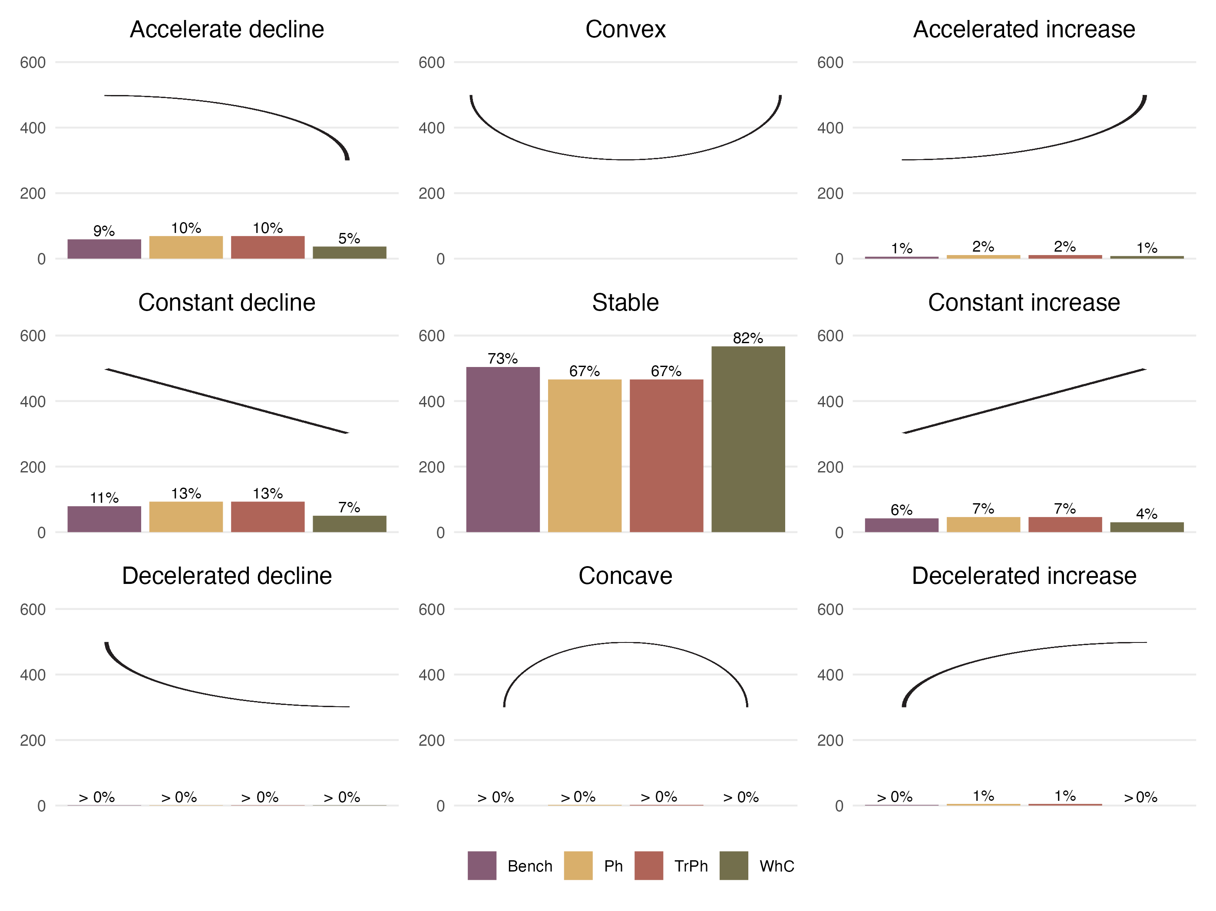

Figure 26: Same figure as Fig. 4 in the main text but for models fitted to presence/absence data. Number (y-axis) and proportion (indicated above individual bars, rounded to the nearest integer) of response curves (i.e. one for each species-predictor combination) according to the nomenclature (nine shapes highlighted by the black curve in each panel) defined by Rigal et al. (2020). Results are presented for the different structures: purple for the Benchmark (Bench), yellow for phylogeny (Ph), red for traits & phylogeny (TrPh), and green for whole community (WhC) model.

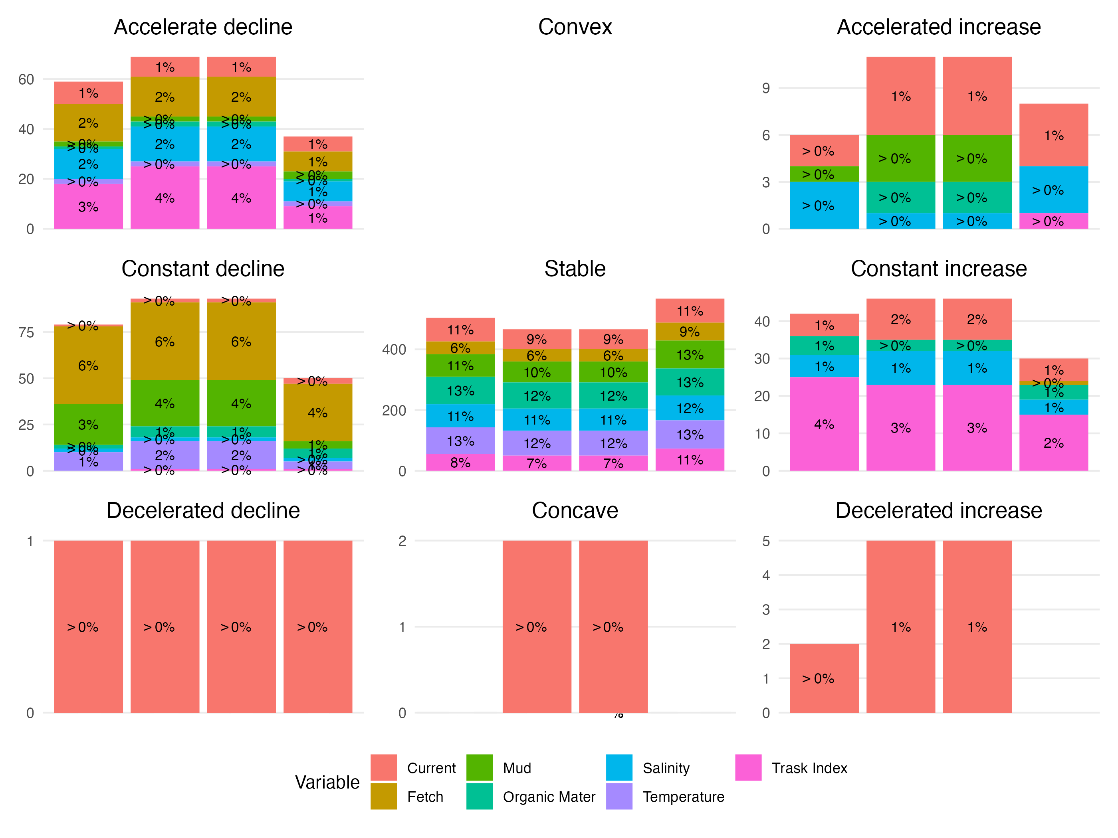

Figure 27: Same figure as +Fig. 25 but for models fitted on presence/absence data. Number (y-axis) and proportion (indicated above individual bars, rounded to the nearest integer) of response curves (i.e. one for each species-predictor combination) according to the nomenclature (nine shapes highlighted by the black curve in each panel) defined by Rigal et al. (2020) for different presence/absence model structures. Each bar is coloured by the relative contribution of each environmental covariate to this particular shape. For illustrative purposes, note that the scale of variation on the y-axis differs across panels.

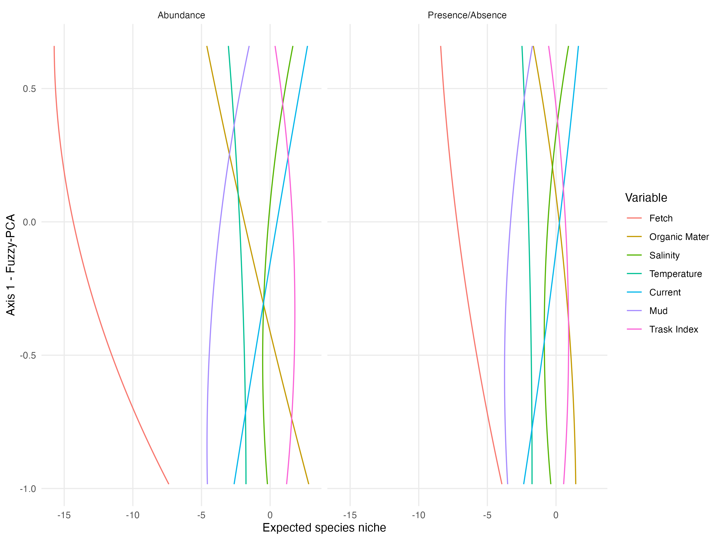

Figure 28: Relationship between species’ position along the first axis of the fuzzy PCA (sessile microphagous-mobile macrophagous gradient) and the different environmental variables used in the models (fitted with abundance data in the left panel, and with presence/absence data in the right panel). Relationships are derived from the regression coefficients estimated for the PhTr model ( $γ$ coefficients in HMSC; Ovaskainen & Abrego (2020)).The lines are fitted quadratic regressions representing the average response across the different species. As an example of interpretation, the red lines in both graphs indicate that sessile microphagous species are more negatively influenced (lower abundance, low probability for presence) by fetch than macrophagous mobile species.

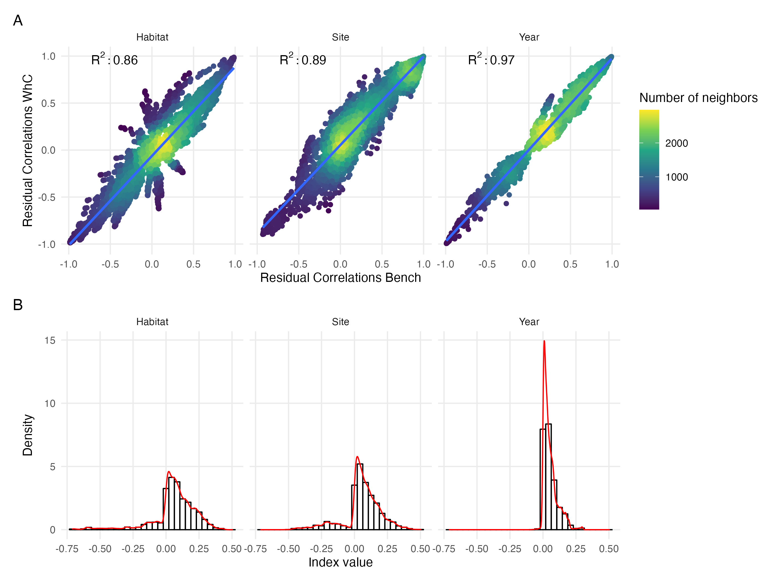

Figure 29: Same figure as Fig. 5 in the main text but for models fitted on presence/absence data. (A) Comparison of residual correlations associated with the three random effects estimated by the Whole Community Model (y-axis) and the Benchmark model (x-axis). The colour scale highlights the density of points in each scatter plot. (B) Distribution of the index measuring change in sign (sign change left to the zero line, no change to the right) and magnitude (higher departure from the zero line indicate higher difference) between residual correlations estimated by the whole community model and the benchmark model for the three random effects (Habitat, Site, Year).

# References

Boyé, A. (2019). Diversité taxinomique et fonctionnelle des habitats benthiques dans l’espace et dans le temps: Une perspective régionale et décennale. PhD thesis.

Boyé, A., Thiébaut, Éric, Grall, J., Legendre, P., Broudin, C., Houbin, C., *et al.* (2019). Trait-based approach to monitoring marine benthic data along 500 km of coastline. *Diversity and Distributions*, 25, 1879–1896.

Brooks, S.P. & Gelman, A. (1998). General methods for monitoring convergence of iterative simulations. *Journal of Computational and Graphical Statistics*, 7, 434–455.

Lazure, P. & Dumas, F. (2008). An external–internal mode coupling for a 3D hydrodynamical model for applications at regional scale (MARS). *Advances in Water Resources*, 31, 233–250.

Lecornu, F. & Roeck, Y.-H.D. (2009). PREVIMER - coastal observations and forecasts. *La Houille Blanche*, 95, 60–63.

Ovaskainen, O. & Abrego, N. (2020). *Joint species distribution modelling: With applications in r*. Ecology, biodiversity and conservation. Cambridge University Press.

Rigal, S., Devictor, V. & Dakos, V. (2020). A method for classifying and comparing non-linear trajectories of ecological variables. *Ecological Indicators*, 112, 106113.

1. All performance measures can theoretically be compared between models. For instance, we here measured differences between models using a measure of relative change in RMSE or AUC relative to the Bench model using Eq. 1. Other measures could be correlations between model predictions.
2. See Ryo *et al.* (2021).
3. To ease model comparison and interpretation, we propose to summarize the information contained in species response curves using the framework initially proposed by Rigal *et al.* (2020) for classifying species temporal trajectories based on their trend, acceleration, direction and velocity. Applied to regression coefficients, it allows to classify the response of species to each environmental variable into several shapes that are easy to interpret, to link with ecological theory, and to compare across models.
4. For jSDM assessment, pairwise dissimilarities can be computed on the observed site-by-species matrix and on the predicted one. Comparing these values (e.g. through correlation analysis or simply through differences) will inform on how well the model reproduces/predict beta diversity patterns. Alternatively, pairwise dissimilarities can be computed between the observed taxa composition of a sample and its predicted one. These dissimilarities then become a metric to assess model performance based on species-composition predictions.
5. For jSDMs comparisons, pairwise dissimilarities computed between the observed taxa composition of a sample and its predicted one can be compared across models (e.g. through correlations) to assess to what extent differences between predicted and observed taxa composition are congruent across different models. Alternatively, comparing correlations between pairwise dissimilarities computed on the observed site-by-species matrix and on the predicted one will inform on which model best predict beta diversity patterns.
6. Species interaction networks can be reconstructed under certain conditions using the residual correlation matrices estimated by jSDM (see Momal *et al.* (2020)). The comparison between these reconstructed interaction networks and already known interaction networks (based on trophic data, experimental data, expert knowledge or qualitative information on species interactions) can serve as a means of model validation.
7. Comparing modelled species trait-environment responses (e.g., signs, shape of response curves) with expected responses (e.g. from theory, experiments or expert knowledge) can also serve to validate qualitatively the models.